Friday, December 05, 2008
11:13 PM

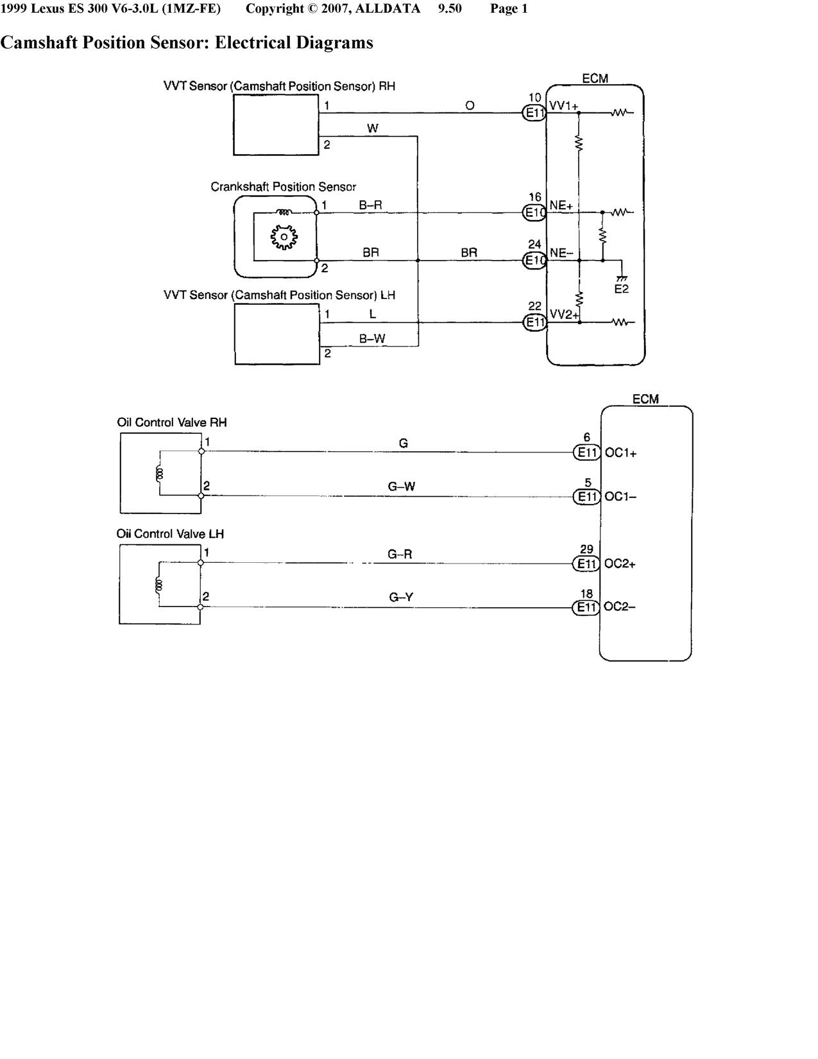

Friday, December 05, 2008
11:23 PM

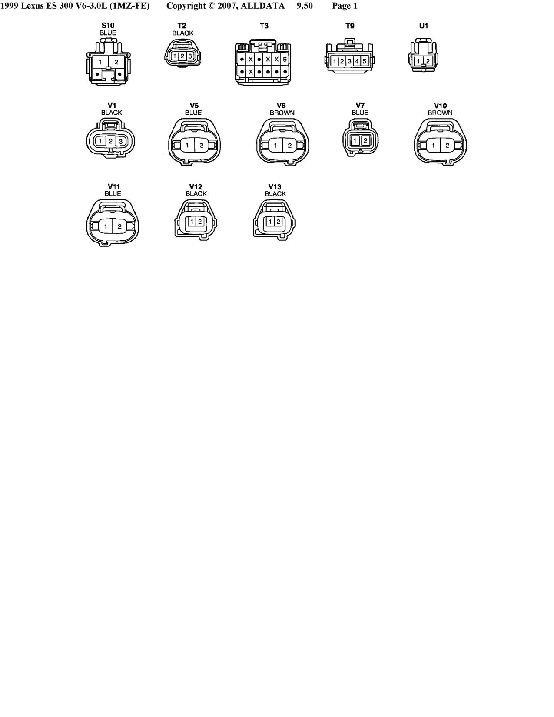

Friday, December 05, 2008
11:25 PM

