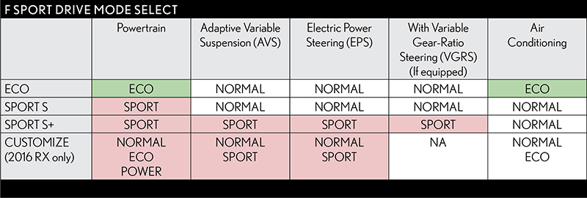
In some F SPORT and F models, Drive Mode Select offers four settings: ECO, NORMAL, SPORT S, and SPORT S+.
In the 4-mode systems, ECO and NORMAL function similar to the 3-mode systems, while SPORT S and SPORT S+ replace the single SPORT mode and differ slightly:
- In 3-mode systems, SPORT mode modifies powertrain operation and Electric Power Steering (EPS).
- In 4-mode systems, SPORT S modifies only the powertrain operation (throttle and shifting), and NOT steering.
SPORT S in F SPORT models modifies the throttle and transmission logic for more aggressive, non-linear throttle control and quicker automatic transmission shift timing:
- Engine drive power is enhanced at intermediate throttle positions for a highly responsive acceleration feel.
- Automatic transmission shift timing is changed for quicker, more precise shifting in sporty driving situations.
SPORT S+ brings out more sporty characteristics of the suspension and steering, while maintaining the SPORT S powertrain settings:
- Electric Power Steering (EPS) assist is reduced, for a sportier steering feel with more feedback
- Adaptive Variable Suspension (AVS) damping force is increased.
- In vehicles equipped with Variable Gear-Ratio Steering (VGRS), the gear ratio is changed to help emphasize steering responsiveness.
The CUSTOMIZE mode allows drivers to create a personalized drive mode with their preferred powertrain, AVS, EPS, and air conditioning settings (2016 RX only):
- Powertrain settings include NORMAL, ECO, and POWER.
- Adaptive Variable Suspension (AVS) settings include NORMAL and SPORT.
- Air conditioning settings include NORMAL and ECO.
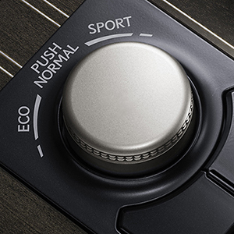
Drive Mode Select modifies powertrain and chassis settings to alter the throttle and transmission operation, steering response, air conditioning performance and, on certain models, adaptive damper settings.
Lexus varies the available Drive Mode Select settings by model and grade to make the most of the characteristics of each Lexus vehicle:
- Basic Drive Mode Select offers three settings: ECO, NORMAL and SPORT.
- Some F SPORT models offer four settings: ECO, NORMAL, SPORT S and SPORT S+ (CT F SPORT and NX F SPORT only have three settings – ECO, NORMAL and SPORT).
- LS models equipped with Adaptive Variable Suspension (AVS) have a 5-mode system: ECO, COMFORT, NORMAL, SPORT S, and SPORT S+.
- 2016 RX 350 and RX 450h models with Adaptive Variable Suspension (AVS) will have a new CUSTOMIZE mode that allows the driver to create a personalized drive mode with preferred powertrain, AVS, Electric Power Steering (EPS) and air conditioning settings.
The systems controlled by Drive Mode Select can also vary on a single model. For example, SPORT S+ modifies powertrain and Electric Power Steering (EPS) on both the RC 350 F SPORT and RC F, but then differs according to each vehicle’s special systems:
- RC 350 F SPORT: SPORT S+ modifies the response of the Adaptive Variable Suspension (AVS) and the Variable Gear-Ratio Steering (VGRS) if the vehicle is equipped with this option.
- RC F: SPORT S+ changes the Vehicle Dynamics* Integrated Management (VDIM) settings for an even more sporty drive
Drive Mode Select is operated by turning the selector dial. It’s a “momentary” type of dial that returns to a home position after each twist:
- NORMAL is the default setting. Return to NORMAL from any other setting by pushing the dial once.
- On LS models equipped with AVS, select the COMFORT mode by twisting the dial once to the left. This setting adjusts AVS dampers for the most comfortable ride.
- On AVS-equipped models, select ECO mode by twisting the dial twice to the left.
- Select SPORT setting by twisting the dial right.
- On models equipped with SPORT S and SPORT S+, twist the dial right once for SPORT S and twice for SPORT S+.

