Last Modified: 06-07-2019 | 6.8:8.0.48 | Doc ID: RM100000000Q44U
Model Year Start: 2016 | Model: ES350 | Prod Date Range: [07/2015 - ]
Title: 2GR-FE FUEL: FUEL SYSTEM: PRECAUTION; 2016 - 2018 MY ES350 [07/2015 - ]

PRECAUTION
1. BEFORE WORKING ON FUEL SYSTEM
(a) When disconnecting a fuel line, fuel will spray. So observe the following precautions:
(1) Do not smoke or work near fire when handling the fuel system.
(2) Keep fuel away from rubber or leather parts.
2. DISCHARGE FUEL SYSTEM PRESSURE
CAUTION:
- Perform the following procedure to prevent fuel from spraying before removing any fuel system parts.
- Pressure will still remain in the fuel lines even after performing the following procedure. When disconnecting a fuel line, cover it with a shop rag or a piece of cloth to prevent fuel from spraying or coming out.
(a) Remove the rear seat cushion assembly (See page ).
(b) Remove the rear floor service hole cover.
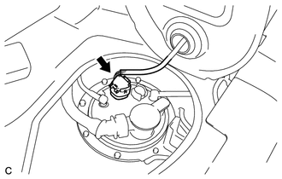
(c) Disconnect the fuel pump connector.
(d) Start the engine.
(e) After the engine has stopped on its own, turn the engine switch off.
(f) Crank the engine again and make sure that the engine does not start.
HINT:
DTC P0171/74 (fuel problem) may be stored.
(g) Disconnect the cable from the negative (-) battery terminal.
NOTICE:
When disconnecting the cable, some systems need to be initialized after the cable is reconnected (See page ).
(h) Loosen the fuel tank cap, then discharge the pressure in the fuel tank completely.
(i) Connect the fuel pump connector.
(j) Install the rear floor service hole cover with new butyl tape.
(k) Install the rear seat cushion assembly (See page ).

