2000 LEXUS GS300 3.0L 2997cc L6 FI [2JZGE] : Emission : Oxygen Sensor | Price | Core | Total
 | $60.79 | $0.00 | $60.79
   | 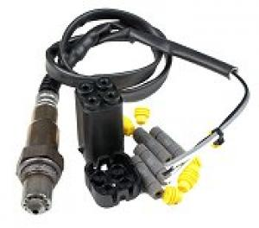
    BOSCH Part # 15733 {Oxygen Sensor - Universal Type - Downstream Sensor}
    O2 sensor located in front manifold/exhaust pipe.; 4 Wire; Heated; Check / Replace Interval: 100,000 Miles
    O2 sensor located in rear manifold/exhaust pipe.; 4 Wire; Heated; Check / Replace Interval: 100,000 Miles
 | $74.79 | $0.00 | $74.79
   | 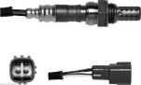
    DENSO Part # 2344622 {OEM-Type 12.8" Length}
    FRONT LOWER; Located at Cylinder. 1-3
 | $78.79 | $0.00 | $78.79
   | 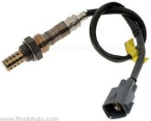
    STANDARD MOTOR PRODUCTS Part # SG979 {DOWNSTREAM SENSOR}
    Downstream Sensor; Front
 | $81.89 | $0.00 | $81.89
   | 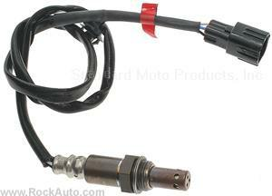
    STANDARD MOTOR PRODUCTS Part # SG974 {DOWNSTREAM SENSOR}
    Upstream Sensor; Front
 | $83.79 | $0.00 | $83.79
   | 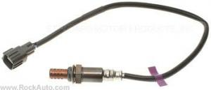
    STANDARD MOTOR PRODUCTS Part # SG1003 {UPSTREAM SENSOR}
    Upstream Sensor; Rear
 | $86.79 | $0.00 | $86.79
   | 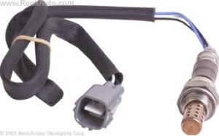
    BECK/ARNLEY Part # 1564096
    DIRECT FIT EXH Manual. SIDE, CYLINDERS 1,2,3,UPPER
 | $86.89 | $0.00 | $86.89
   | 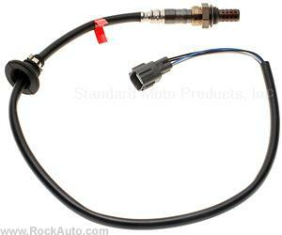
    STANDARD MOTOR PRODUCTS Part # SG1029 {DOWNSTREAM SENSOR}
    Downstream Sensor; Rear
 | $93.79 | $0.00 | $93.79
   | 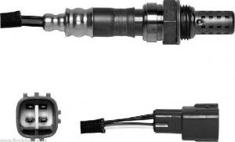
    DENSO Part # 2344048
    FRONT UPPER; Located at Cylinder. 1-3
 | $96.99 | $0.00 | $96.99
  DELPHI Part # ES20157
  Rear; Cylinder 1,2,3
 | $97.99 | $0.00 | $97.99
   | 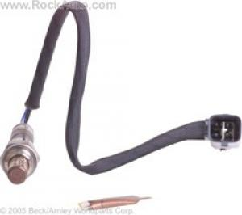
    BECK/ARNLEY Part # 1564169
    DIRECT FIT,Pre Catalytic Converter; Cylinder. 4,5,6
 | $98.79 | $0.00 | $98.79
   | 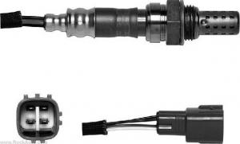
    DENSO Part # 2344603
    Rear
 | $99.79 | $0.00 | $99.79
   | 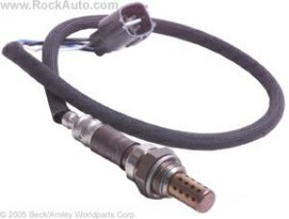
    BECK/ARNLEY Part # 1564151
    DIRECT FIT, FRONT, Cylinder 4,5 & 6
 | $101.79 | $0.00 | $101.79
  DELPHI Part # ES20086
  Rear; Cylinder 4,5,6
 | $103.79 | $0.00 | $103.79
   | 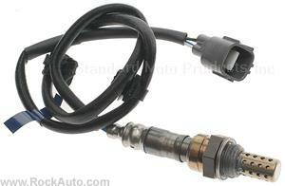
    STANDARD MOTOR PRODUCTS Part # SG1019 {UPSTREAM SENSOR}
    Upstream Sensor; Front
 | $104.79 | $0.00 | $104.79
   | 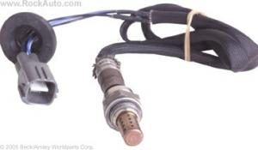
    BECK/ARNLEY Part # 1564088
    DIRECT FIT,Post Catalytic Converter; Cylinder. 4,5,6
 | $106.89 | $0.00 | $106.89
  DELPHI Part # ES20156
  Front; Cylinder 1,2,3
 | $109.99 | $0.00 | $109.99
   | 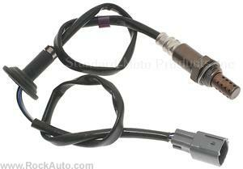
    STANDARD MOTOR PRODUCTS Part # SG1004 {DOWNSTREAM SENSOR}
    Downstream Sensor; Rear
 | $111.79 | $0.00 | $111.79
  ACDELCO Part # 2131418 {#88929845}
  SENSOR,Heated OXY(Position 1) IN EXH MANIFOLD/CROSSOVER-Cylinder 1,2,3-4 WIRE
 | $113.79 | $0.00 | $113.79
   | 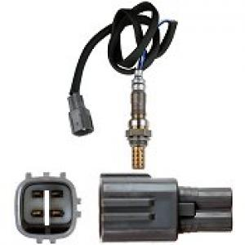
    BOSCH Part # 15244 {Oxygen Sensor - Original Equipment Type - Upstream Sensor}
    O2 sensor located in front manifold/exhaust pipe.; 4 Wire; Heated; Check / Replace Interval: 100,000 Miles
 | $159.79 | $0.00 | $159.79
  ACDELCO Part # 2131536 {replaces 213-1539 #2131539, 89003346, 89003349}
  SENSOR KIT,OXY UNIVERSAL-FRONT
  SENSOR KIT,OXY UNIVERSAL-REAR
 | $128.79 | $0.00 | $128.79
  ACDELCO Part # 2133025 {#19107369}
  SENSOR,Heated OXY(Position 1) IN EXH MANIFOLD/CROSSOVER-Cylinder 4,5,6-4 WIRE
  - Stocked in outlying warehouse--shipping delayed up to 1 business day
 | $131.79 | $0.00 | $131.79
  ACDELCO Part # 2131607 {#2131456, 89034249}
  SENSOR,Heated OXY(Position 3) POST CONVERTER-Cylinder 4,5,6-4 WIRE
  - Stocked in outlying warehouse--shipping delayed up to 1 business day
 | $107.89 | $0.00 | $107.89
   | 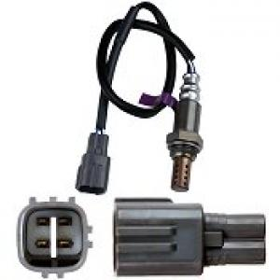
    BOSCH Part # 15247 {Oxygen Sensor - Original Equipment Type - Upstream Sensor}
    O2 sensor located in rear manifold/exhaust pipe.; 4 Wire; Heated; Check / Replace Interval: 100,000 Miles
    * Non-stock item--shipping delayed up to 4 business days
 | $113.79 | $0.00 | $113.79
   | 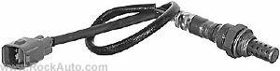
    AIRTEX Part # 5S3543
    (Above Rear Converter)
    * Non-stock item--shipping delayed up to 2 business days
 | $114.79 | $0.00 | $114.79
   | 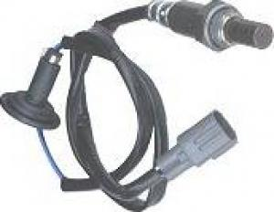
    BOSCH Part # 13558 {Oxygen Sensor - Original Equipment Type - Downstream Sensor}
    O2 sensor located in rear manifold/exhaust pipe.; 4 Wire; Heated; Check / Replace Interval: 100,000 Miles
    * Non-stock item--shipping delayed up to 4 business days
 | $115.79 | $0.00 | $115.79
   | 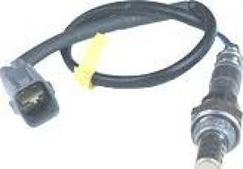
    BOSCH Part # 13544 {Oxygen Sensor - Original Equipment Type - Downstream Sensor}
    O2 sensor located in front manifold/exhaust pipe.; 4 Wire; Heated; Check / Replace Interval: 100,000 Miles
    * Non-stock item--shipping delayed up to 4 business days
 | $120.79 | $0.00 | $120.79
  ACDELCO Part # 2132998 {#19107342}
  SENSOR,Heated OXY(Position 3) POST CONVERTER-Cylinder 1,2,3-4 WIRE
  * Non-stock item--shipping delayed up to 3 business days
 | $121.79 | $0.00 | $121.79
   | 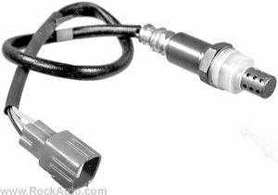
    AIRTEX Part # 5S3581
    (In Manifold - Cylinder's 4, 5, 6)
    * Non-stock item--shipping delayed up to 2 business days
 | $124.99 | $0.00 | $124.99
   | 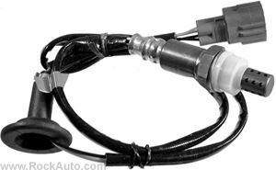
    AIRTEX Part # 5S3547
    (After Converter)
    * Non-stock item--shipping delayed up to 2 business days
 | $126.79 | $0.00 | $126.79
   | 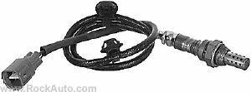
    AIRTEX Part # 5S3541
    (Front Manifold)
    * Non-stock item--shipping delayed up to 2 business days

