Last Modified: 2-23-2009 | 5.7 U | From: 200607
Model Year: 2007 | Model: GS350 | Doc ID: RM0000011BQ00YX
Title: AUDIO / VISUAL: AUDIO AND VISUAL SYSTEM: TERMINALS OF ECU (2007 GS350 GS430)

TERMINALS OF ECU
1. CHECK MULTI-DISPLAY
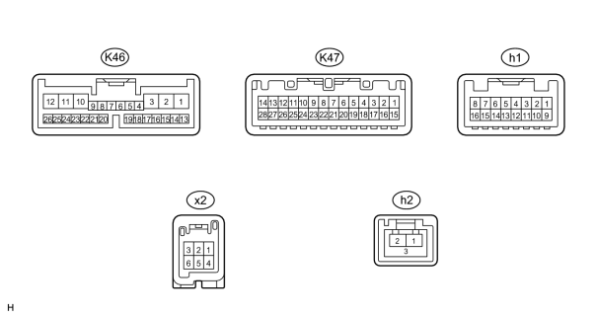
(a) Disconnect the K46 display connector.
(b) Measure the resistance and voltage of the wire harness side connector.
Symbols (Terminal No.) | Wiring Color | Terminal Description | Condition | Specified Condition
+B1 (K46-1) - GND1 (K46-10) | O - W-B | Battery | Always | 10 to 14 V
ACC (K46-2) - GND1 (K46-10) | GR - W-B | Accessory (ON) | Engine switch off | Below 1 V
ACC (K46-2) - GND1 (K46-10) | GR - W-B | Accessory (ON) | Engine switch on (ACC) | 10 to 14 V
IG (K46-3) - GND1 (K46-10) | B - W-B | Ignition (ON) | Engine switch off | Below 1 V
IG (K46-3) - GND1 (K46-10) | B - W-B | Ignition (ON) | Engine switch on (IG) | 10 to 14 V
GND1 (K46-10) - Body ground | W-B - Body ground | Ground | Always | Below 1 Ω
• If the result is not as specified, there may be a malfunction on the wire harness side.
(c) Reconnect the K46 display connector.
(d) Measure the voltage of the connector.
Symbols (Terminal No.) | Wiring Color | Terminal Description | Condition | Specified Condition
TC (K46-7) - GND1 (K46-10) | BR - W-B | Diagnosis ON signal | Engine switch on (IG) | 9 to 14 V
ILL- (K46-11) - GND1 (K46-10) | L - W-B | Illumination signal | Light control switch OFF | Below 1 V
ILL- (K46-11) - GND1 (K46-10) | L - W-B | Illumination signal | Light control switch ON | 10 to 14 V
ILL+ (K46-12) - GND1 (K46-10) | G - W-B | Illumination signal | Light control switch OFF | Below 1 V
ILL+ (K46-12) - GND1 (K46-10) | G - W-B | Illumination signal | Light control switch ON | 10 to 14 V
REV (K46-13) - GND1 (K46-10) | R - W-B | Reverse signal | See "Vehicle Signal Check" Mode | -
SPD (K46-14) - GND1 (K46-10) | V - W-B | Speed signal from combination meter | See "Vehicle Signal Check" Mode | -
PKB (K46-23) - GND1 (K46-10) | Y - W-B | Parking brake signal | See "Vehicle Signal Check" Mode | -
TSW- (K47-5) - GND1 (K46-10) | W-B - W-B | Telephone relation switch signal | Always | Below 1 V
MACC (K47-9) - GND1 (K46-10)*2 | O - W-B | Microphone amplifier power supply | Engine switch off | Below 1 V
MACC (K47-9) - GND1 (K46-10)*2 | O - W-B | Microphone amplifier power supply | Engine switch on (IG) | 5 V
MIN- (K47-10) - GND1 (K46-10) | R - W-B | Microphone voice signal | See "Microphone & Voice Recognition Check" | -
MIN+ (K47-11) - GND1 (K46-10) | G - W-B | Microphone voice signal | See "Microphone & Voice Recognition Check" | -
CGND (K47-14) - Body ground | W - Body ground | Ground | Always | Below 1 V
IVO- (K47-21) - GND1 (K46-10) | BR - W-B | Voice guidance signal | Voice guidance is provided | Waveform synchronized with sounds is output
IVO+ (K47-22) - GND1 (K47-10) | Y - W-B | Voice guidance signal | Voice guidance is provided | Waveform synchronized with sounds is output
SLD (K47-23) - GND1 (K46-10) | Shielded - W-B | Shielded ground | Always | Below 1 V
VV+ (x2-1) - GND1 (K46-10)*1 | W - W-B | DVD image signal | DVD is played on radio receiver | Pulse generation (refer to waveform 2)
VV- (x2-4) - GND1 (K46-10)*1 | B - W-B | Signal ground | Always | Below 1 V
CA+ (K47-13) - GND1 (K46-10) | B - W-B | Television camera power supply | Engine switch on (IG), shift lever reverse position | Approx. 6 V
CGND (K46-14) - Body ground | W - Body ground | Ground | Always | Below 1 V
V+ (K47-27) - CGND (K47-14) | R - W | Television camera image signal | Engine switch on (IG), shift lever reverse position | Pulse generation (refer to waveform 1)
V- (K47-28) - CGND (K47-14) | Shielded - W | Shielded ground | Always | Below 1 V
HINT:
*1: for DVD Changer Models
*2: w/o LEXUS Link System
• If the result is not as specified, the multi-display may have a malfunction.
2. CHECK RADIO RECEIVER
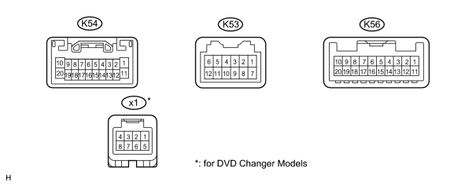
(a) Disconnect the K54 receiver connector.
(b) Measure the resistance and voltage of the wire harness side connector.
Symbols (Terminal No.) | Wiring Color | Terminal Description | Condition | Specification
B (K54-1) - GND (K54-20) | SB - BR | Battery | Always | 10 to 14 V
GND (K54-20) - Body ground | BR - Body ground | Ground | Always | Below 1 Ω
ACC (K54-11) - GND (K54-20) | GR - BR | Accessory (ON) | Engine switch off | Below 1 V
ACC (K54-11) - GND (K54-20) | GR - BR | Accessory (ON) | Engine switch on (ACC) | 10 to 14 V
• If the result is not as specified, there may be a malfunction on the wire harness side.
(c) Reconnect the K54 receiver connector.
(d) Measure the voltage on the connectors.
Symbols (Terminal No.) | Wiring Color | Terminal Description | Condition | Specification
ILL+ (K54-2) - GND (K54-20) | G - BR | Illumination signal | Engine switch on (IG), light control switch OFF | Below 1 V
ILL+ (K54-2) - GND (K54-20) | G - BR | Illumination signal | Engine switch on (IG), light control switch TAIL or ON | 10 to 14 V
MUTE (K54-7) - GND (K54-20) | SB - BR | Mute signal | Audio system is playing → changing mode | Above 3.5 V → Below 1 V
R+ (K54-8) - GND (K54-20) | R - BR | Sound signal (right) | Audio system is playing | Waveform synchronized with sound is output
L+ (K54-9) - GND (K54-20) | B - BR | Sound signal (left) | Audio system is playing | Waveform synchronized with sound is output
R- (K54-18) - GND (K54-20) | G - BR | Sound signal (right) | Audio system is playing | Waveform synchronized with sound is output
L- (K54-19) - GND (K54-20) | W - BR | Sound signal (left) | Audio system is playing | Waveform synchronized with sound is output
ILL- (K54-12) - GND (K54-20) | W - BR | Illumination signal | Engine switch off | Below 1 V
ILL- (K54-12) - GND (K54-20) | W - BR | Illumination signal | Engine switch on (IG) | Pulse generation
TX+ (K56-9) - GND (K54-20) | L - BR | AVC-LAN communication signal | Engine switch on (ACC) | 2 to 3 V
TX- (K56-10) - GND (K54-20) | LG - BR | AVC-LAN communication signal | Engine switch on (ACC) | 2 to 3 V
TXM+ (K53-9) - GND (K54-20) | L - BR | AVC-LAN communication signal | Engine switch on (ACC) | 2 to 3 V
TXM- (K53-10) - GND (K54-20) | LG - BR | AVC-LAN communication signal | Engine switch on (ACC) | 2 to 3 V
ATX+ (K54-5) - GND (K54-20) | L - BR | AVC-LAN communication signal | Engine switch on (ACC) | 2 to 3 V
ATX- (K54-15) - GND (K54-20) | LG - BR | AVC-LAN communication signal | Engine switch on (ACC) | 2 to 3 V
ANT (K54-13) - GND (K54-20) | O - BR | Power source of antenna | Radio switch is ON and AM or FM | 10 to 14 V
SWG (K56-6) - GND (K54-20) | LG - BR | Steering pad switch ground | Always | Below 1 V
SW1 (K56-7) - GND (K54-20) | Y - BR | Steering pad switch signal | Steering pad switch not pushed | 4 V or more
SW1 (K56-7) - GND (K54-20) | Y - BR | Steering pad switch signal | Steering pad switch SEEK+ switch pushed | Below 2.5 V
SW1 (K56-7) - GND (K54-20) | Y - BR | Steering pad switch signal | Steering pad switch SEEK- switch pushed | Approx. 0.9 V
SW1 (K56-7) - GND (K54-20) | Y - BR | Steering pad switch signal | Steering pad switch Vol+ switch pushed | Approx. 1.5 V
SW1 (K56-7) - GND (K54-20) | Y - BR | Steering pad switch signal | Steering pad switch Vol+ switch pushed | Approx. 0.9 V
SW2 (K56-8) - GND (K54-20) | O - BR | Steering pad switch signal | Steering pad switch not pushed | 4 V or more
SW2 (K56-8) - GND (K54-20) | O - BR | Steering pad switch signal | Steering pad switch MODE switch pushed | Below 2.5 V
SW2 (K56-8) - GND (K54-20) | O - BR | Steering pad switch signal | Steering pad switch DISP switch pushed | Below 2.5 V
NTSC (x1-1) - GND (K54-20)* | W - BR | DVD image signal | DVD played | Pulse generation  (see waveform1)
GND (x1-2) - GND (K54-20)* | B - BR | Ground | Always | Below 1 V
SLD (x1-3) - GND (K54-20) | Shielded - BR | Shielded ground | Always | Below 1 V
HINT:
*: for DVD changer models
• If the result is not as specified, the receiver may have a malfunction.
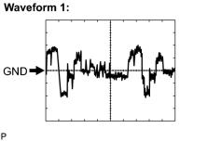 | (e) Using an oscilloscope, check the waveform.
  Waveform 1 (reference)  Item | Content
  Symbols (Terminal No.) | NTSC (x1-1) - Body ground
  Tool | 200 mV/DIV., 10 μs/DIV.
  Condition | DVD displayed on multi-display
3. CHECK STEREO COMPONENT AMPLIFIER (for CD Changer Models)
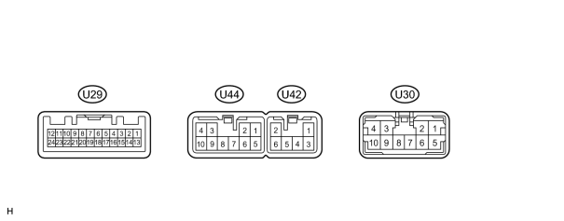
(a) Disconnect the U29 and U42 amplifier connectors.
(b) Measure the resistance and voltage of the connectors.
Symbols (Terminal No.) | Wiring Color | Terminal Description | Condition | Specified Condition
GND (U42-2) - Body ground | W-B - Body ground | Ground | Always | Below 1 Ω
GND2 (U42-6) - Body ground | W-B - Body ground | Ground | Always | Below 1 Ω
+B (U42-1) - GND (U42-2) | SB - W-B | Battery | Always | 10 to 14 V
+B2 (U42-3) - GND (U42-2) | SB - W-B | Battery | Always | 10 to 14 V
ACC (U29-12) - GND (U42-2) | GR - W-B | Accessory (ON) | Engine switch off | Below 1 V
ACC (U29-12) - GND (U42-2) | GR - W-B | Accessory (ON) | Engine switch on (ACC) | 10 to 14 V
• If the result is not as specified, there may be a malfunction on the wire harness.
(c) Reconnect the U29 and U42 amplifier connectors.
(d) Measure the voltage of the connectors.
Symbols (Terminal No.) | Wiring Color | Terminal Description | Condition | Specified Condition
CTR+ (U44-3) - GND (U42-2) | Y - W-B | Sound signal | Audio system is playing | Waveform synchronized with sound is output
CTR- (U44-9) - GND (U42-2) | B - W-B | Sound signal | Audio system is playing | Waveform synchronized with sound is output
FL+ (U30-2) - GND (U42-2) | P - W-B | Sound signal | Audio system is playing | Waveform synchronized with sound is output
FL- (U30-6) - GND (U42-2) | V - W-B | Sound signal | Audio system is playing | Waveform synchronized with sound is output
FR+ (U30-8) - GND (U42-2) | LG - W-B | Sound signal | Audio system is playing | Waveform synchronized with sound is output
FR- (U30-7) - GND (U42-2) | L - W-B | Sound signal | Audio system is playing | Waveform synchronized with sound is output
RL+ (U30-3) - GND (U42-2) | B - W-B | Sound signal | Audio system is playing | Waveform synchronized with sound is output
RL- (U30-9) - GND (U42-2) | Y - W-B | Sound signal | Audio system is playing | Waveform synchronized with sound is output
RR+ (U30-4) - GND (U42-2) | R - W-B | Sound signal | Audio system is playing | Waveform synchronized with sound is output
RR- (U30-10) - GND (U42-2) | W - W-B | Sound signal | Audio system is playing | Waveform synchronized with sound is output
WFL+ (U44-1) - GND (U42-2) | W - W-B | Sound signal | Audio system is playing | Waveform synchronized with sound is output
WFL- (U44-5) - GND (U42-2) | R - W-B | Sound signal | Audio system is playing | Waveform synchronized with sound is output
WFR+ (U44-2) - GND (U42-2) | G - W-B | Sound signal | Audio system is playing | Waveform synchronized with sound is output
WFR- (U44-6) - GND (U42-2) | W - W-B | Sound signal | Audio system is playing | Waveform synchronized with sound is output
II1+ (U29-15) - GND (U42-2) | Y - W-B | Voice guidance signal | Voice guidance is proved | Waveform synchronized with sound is output
II1- (U29-14) - GND (U42-2) | BR - W-B | Voice guidance signal | Voice guidance is proved | Waveform synchronized with sound is output
SPD (U29-11) - GND (U42-2) | V - W-B | Speed signal | Engine switch on (IG), drive wheels are turned slowly | Pulse generation
MUTE (U29-1) - GND (U42-2) | O - W-B | Mute signal | Audio system is playing → change mode | Above 3.5 V → Below 1 V
TX+ (U29-8) - GND (U42-2) | LG - W-B | AVC-LAN communication signal | Engine switch on (ACC) | 2 to 3 V
TX- (U29-7) - GND (U42-2) | L - W-B | AVC-LAN communication signal | Engine switch on (ACC) | 2 to 3 V
R+ (U29-5) - GND (U42-2) | R - W-B | Sound signal (right) | Audio system playing | Waveform synchronized with sound is output
R- (U29-4) - GND (U42-2) | G - W-B | Sound signal (right) | Audio system playing | Waveform synchronized with sound is output
L+ (U29-3) - GND (U42-2) | B - W-B | Sound signal (left) | Audio system playing | Waveform synchronized with sound is output
L- (U29-2) - GND (U42-2) | W - W-B | Sound signal (left) | Audio system playing | Waveform synchronized with sound is output
SLD (U29-6) - GND (U42-2) | Shielded - Body ground | Shielded ground | Always | Below 1 V
• If the result is not as specified, the amplifier may have a malfunction.
4. CHECK STEREO COMPONENT AMPLIFIER (for DVD Changer Models)
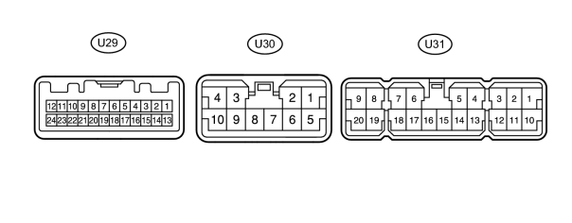
(a) Disconnect the U31 amplifier connector.
(b) Measure the resistance and voltage of the connector.
Symbols (Terminal No.) | Wiring Color | Terminal Description | Condition | Specified Condition
GND (U31-16) - Body ground | W-B - Body ground | Ground | Always | Below 1 Ω
GND2 (U31-15) - Body ground | W-B - Body ground | Ground | Always | Below 1 Ω
+B (U31-1) - GND (U31-16) | SB - W-B | Battery | Always | 10 to 14 V
+B2 (U31-10) - GND (U31-16) | SB - W-B | Battery | Always | 10 to 14 V
ACC (U29-12) - GND (U31-16) | GR - W-B | Accessory (ON) | Engine switch off | Below 1 V
ACC (U29-12) - GND (U31-16) | GR - W-B | Accessory (ON) | Engine switch on (ACC) | 10 to 14 V
• If the result is not as specified, there may be a malfunction on the wire harness.
(c) Reconnect the U31 amplifier connector.
(d) Measure the voltage of the connectors.
Symbols (Terminal No.) | Wiring Color | Terminal Description | Condition | Specified Condition
MUTE (U29-1) - GND (U31-16) | O - W-B | Mute signal | Audio system is sounding → Changing mode | Above 3.5 V → Below 1 V
L- (U29-2) - GND (U31-16) | W - W-B | Sound signal (left) | Audio system is playing | Waveform synchronized with sounds is output
L+ (U29-3) - GND (U31-16) | B - W-B | Sound signal (left) | Audio system is playing | Waveform synchronized with sounds is output
R- (U29-4) - GND (U31-16) | G - W-B | Sound signal (right) | Audio system is playing | Waveform synchronized with sounds is output
R+ (U29-5) - GND (U31-16) | R - W-B | Sound signal (right) | Audio system is playing | Waveform synchronized with sounds is output
TX- (U29-7) - GND (U31-16) | L - W-B | AVC-LAN communication signal | Engine switch is on (ACC) | 2 to 3 V
TX+ (U29-8) - GND (U31-16) | LG - W-B | AVC-LAN communication signal | Engine switch is on (ACC) | 2 to 3 V
SPD (U29-11) - GND (U31-16) | V - W-B | Speed signal | Engine switch is on (IG), drive wheels are turned slowly | Pulse generation
FL+ (U31-8) - GND (U31-16) | P - W-B | Sound signal | Audio system is playing | Waveform synchronized with sounds is output
FR- (U31-20) - GND (U31-16) | L - W-B | Sound signal | Audio system is playing | Waveform synchronized with sounds is output
RL- (U31-17) - GND (U31-16) | Y - W-B | Sound signal | Audio system is playing | Waveform synchronized with sounds is output
RR- (U31-18) - GND (U31-16) | W - W-B | Sound signal | Audio system is playing | Waveform synchronized with sounds is output
FL- (U31-19) - GND (U31-16) | V - W-B | Sound signal | Audio system is playing | Waveform synchronized with sounds is output
FR+ (U31-9) - GND (U31-16) | LG - W-B | Sound signal | Audio system is playing | Waveform synchronized with sounds is output
RL+ (U31-6) - GND (U31-16) | B - W-B | Sound signal | Audio system is playing | Waveform synchronized with sounds is output
RR+ (U31-7) - GND (U31-16) | R - W-B | Sound signal | Audio system is playing | Waveform synchronized with sounds is output
WF1+ (U31-5) - GND (U31-16) | P - W-B | Sound signal | Audio system is playing | Waveform synchronized with sounds is output
WF1- (U31-14) - GND (U31-16) | V - W-B | Sound signal | Audio system is playing | Waveform synchronized with sounds is output
WF2+ (U31-4) - GND (U31-16) | L - W-B | Sound signal | Audio system is playing | Waveform synchronized with sounds is output
WF2- (U31-13) - GND (U31-16) | LG - W-B | Sound signal | Audio system is playing | Waveform synchronized with sounds is output
CTR+ (U31-3) - GND (U31-16) | Y - W-B | Sound signal | Audio system is playing | Waveform synchronized with sounds is output
CTR- (U31-12) - GND (U31-16) | B - W-B | Sound signal | Audio system is playing | Waveform synchronized with sounds is output
SL+ (U30-1) - GND (U31-16) | LG - W-B | Sound signal | Audio system is playing | Waveform synchronized with sound is output
SL- (U30-5) - GND (U31-16) | L - W-B | Sound signal | Audio system is playing | Waveform synchronized with sound is output
SR+ (U30-2) - GND (U31-16) | B - W-B | Sound signal | Audio system is playing | Waveform synchronized with sound is output
SR- (U30-6) - GND (U31-16) | Y - W-B | Sound signal | Audio system is playing | Waveform synchronized with sound is output
WFL+ (U30-3) - GND (U31-16) | W - W-B | Sound signal | Audio system is playing | Waveform synchronized with sound is output
WFL- (U30-9) - GND (U31-16) | R - W-B | Sound signal | Audio system is playing | Waveform synchronized with sound is output
WFR+ (U30-4) - GND (U31-16) | G - W-B | Sound signal | Audio system is playing | Waveform synchronized with sound is output
WFR- (U30-10) - GND (U31-16) | W - W-B | Sound signal | Audio system is playing | Waveform synchronized with sound is output
• If the result is not as specified, the amplifier may have a malfunction.
5. CHECK NETWORK GATEWAY ECU
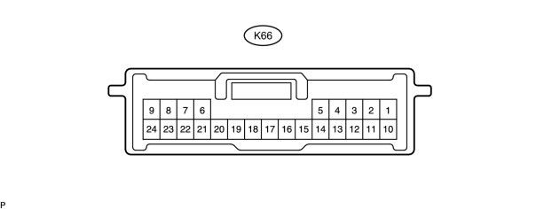
(a) Measure the voltage of the connector.
Symbols (Terminal No.) | Wiring Color | Terminal Description | Condition | Specified Condition
GTX+ (K66-6) - Body ground | L - Body ground | AVC-LAN communication signal | Engine switch on (ACC) | 2 to 3 V
GTX- (K66-21) - Body ground | LG - Body ground | AVC-LAN communication signal | Engine switch on (ACC) | 2 to 3 V

