Disclaimer: This write-up is for guidance only. Your car may differ. Mine is a Lexus 2006 GS300 with automatic transmission. Use all necessary caution to deal with the hazards associated with handling the airbag. These things have blown and hurt people. Do some research on this before attempting this procedure, especially regarding controlling any static charges that may ignite the airbag.

TO TEST OPERATION OF AIRBOX DOOR: Open the glove box, pull out the shelf, remove the rectangular cover in the back wall to access the airbox. With the ignition on, turn on the climate control system with or without starting the engine. Push the “recirculate” button on the right side of the climate control panel to change from the fresh air setting to the recirculate setting, confirming that the settings are changing by the indicator lights changing. The air box flap behind the glovebox should open and close fully, exposing and then concealing the HVAC air filter. If it does not open and close fully, then the door is not operating and the procedure below may help you resolve the problem.

This test also shows how the thing got broken in the first place. If someone tries to replace the filter by just pushing up the door instead of opening it with the recirculate button, then the mechanism in forced and something breaks or becomes detached.

I even put a sticker on my airbox access cover in the glovebox instructing anyone trying to replace the filter to go through this process.

REMOVE THE SIDE DASH PANEL: Use a tool or pry your fingers under the rear edge and pull this cover straight out to release the spring clips 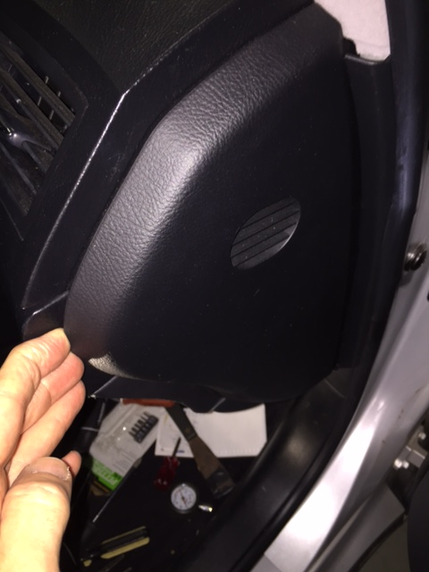

REMOVE THE WOOD GRAIN COVER AND THEN THE SIDE CONSOLE COVER: Remove the small black plastic trim between the radio and the wood grain cover. I used an angle hose remover pick, but it comes out easily, so a bent paperclip would probably work. Just pull it out on each end at a time 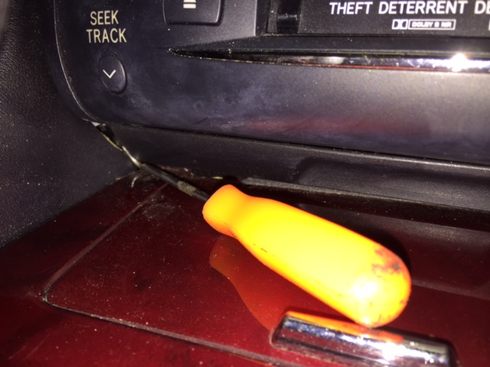Unscrew the shift knob counterclockwise, open the rear console box, get your fingers under the two rear wings of the wood grain console cover and lift against the spring clips to rotate the rear of the wood grain cover upwards. You can leave the shift lever in Park and just let the cover hold itself up against the shift lever shaft without removing it. This gives access to the one screw holding the right side black stitched vinyl console cover—unscrew this 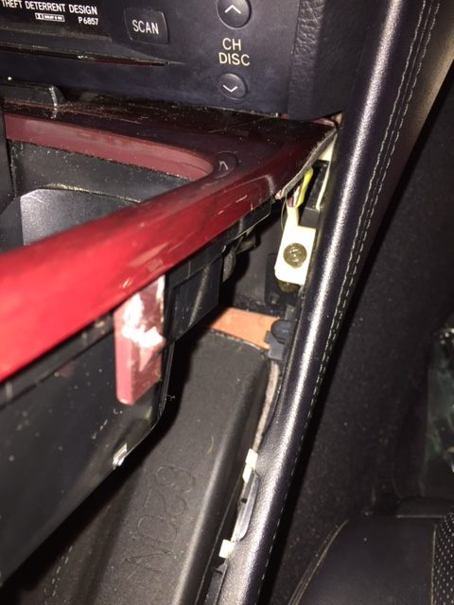Pull the rear of this cover outward, then pull it to the rear to remove it.

ORIENT YOURSELF TO THE PASSENGER SIDE PANELS TO BE REMOVED. The glove box is the top most of the three panels to be removed. When it is opened you can readily identify the air bag, which is the vinyl square piece below the glove box. The lower cover in the next and lowest cover beneath the air bag, and it is not vinyl, but rather a relatively smooth hard plastic panel containing the courtesy footwell light. They are removed starting with the lower cover and working your way up.

REMOVE THE LOWER COVER: This is the lowest plastic panel under the air bag. Slide your fingers between its rear left corner and the console carpet, pull down to get the first clip detached, then work along the rear edge of it to get the rest of the clips. The clips are pretty strong. Pull the panel rearward to remove the two front tabs. You can remove the wiring harness, but I just let mine hang, sliding it up to the front as far as possible to take the strain off.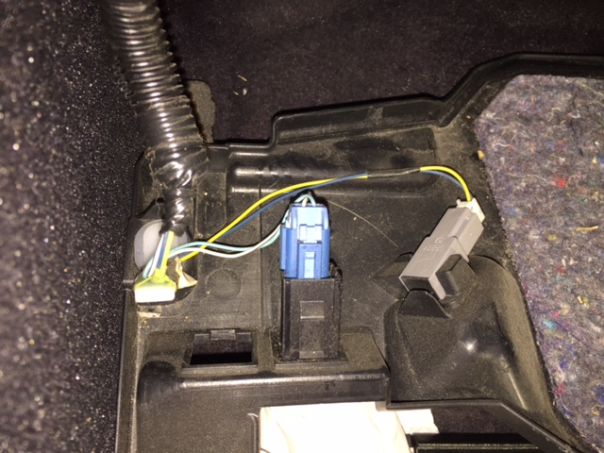

REMOVE THE PASSENGER AIRBAG AT YOUR OWN RISK: Though necessary to complete this job, please proceed using airbag handling caution. There are three 10mm bolts, two across the bottom exposed when the lower cover was removed and one a little higher and further to the right exposed when the right console cover was removed. This picture shows the two bolts on the right side. Remove all three bolts.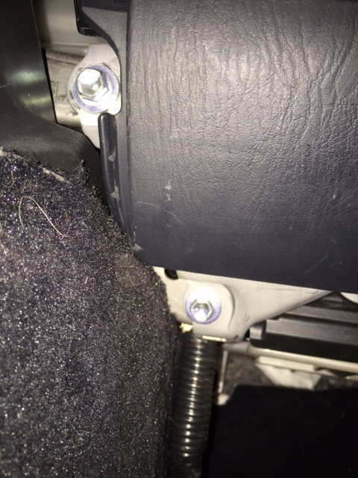Pull to the rear against two spring clips, one on each upper side. The airbag might then be placed with the lower cover out of the way without removing the wiring harness if you place it to remove any strain on the wires.

REMOVE THE GLOVE BOX: There are four screws holding the glove box in place. Two are on the right side and exposed where the side dash panel was removed. One is in the upper left inside of the glove box easily seen when you open the glove box door. One is on a tab on the lower left under the glove box door best seen when the glove box door is closed, it is the uppermost screw in this picture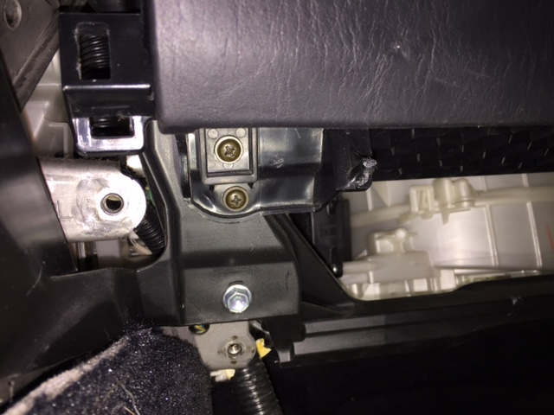With the screws removed, the glove box pulls straight out, some force is required because it has a couple of spring tabs at its top edge. The wiring harness can be removed, or you might just be able to let it hang like the airbag.

REMOVE THE PASSENGER FLOOR AIR VENT: Remove the one screw holding this vent in place, shown in this picture on the white plastic tab.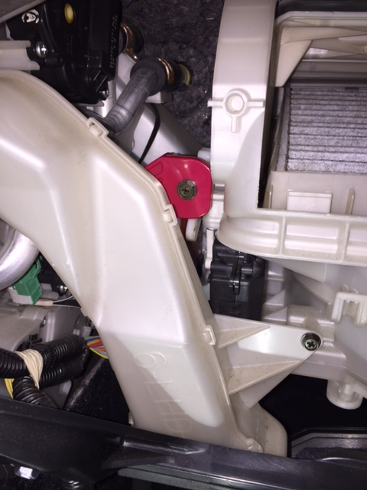Slide it to the right to detach it from the central plenum, and let it drop to the floor.

REMOVE THE RED CONTROL BOX: One screw and it can drop down and out of the way. 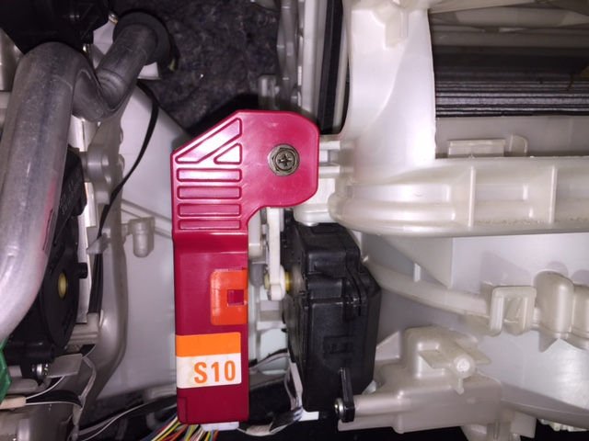

FIX THE PROBLEM: This is what you are trying to get to. These pictures show mine repaired. The servo arm rotates and pushes the air box door lever back and forth to open and close the door. 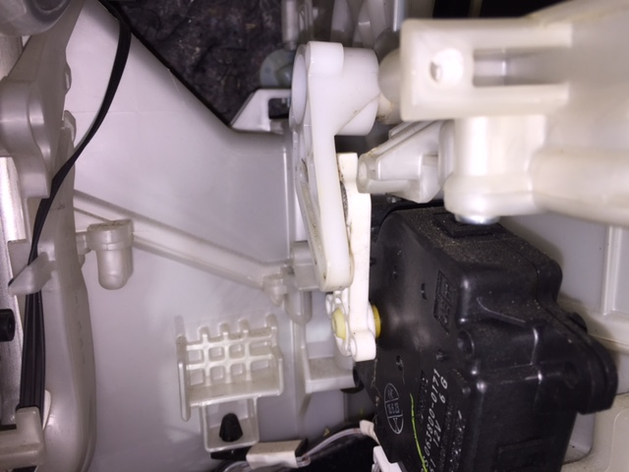 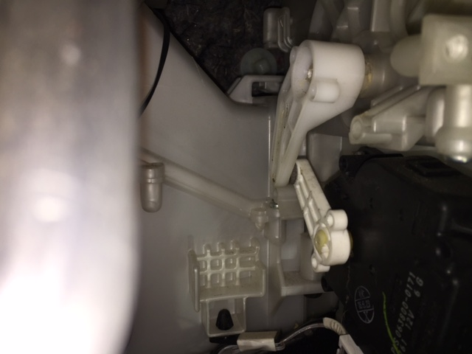The arms were not broken on mine, I just had to use a heat gun to realign the air box door lever and reconnect to the servo to restore operation. Take some time to look at what you have. Your situation may require replacing parts. I looked up the parts and for my 2006 GS300, possibly other models as well, the airbox door and lever are available as part 8702030020 which is the DAMPER ASSEMBLY, HEATER AIR (about $30-$40 at discount parts suppliers) and 8710630480 SERVO SUB-ASSEMBLY, DAMPER (about $120 at discount parts suppliers). Double check these part numbers to be sure they fit your year model. The servo looks easy to replace, I do not know how complicated the damper door is to replace because I did not have to do mine.

Despite the simplicity of the fix on mine, it has been working fine for several months. It makes a big difference on how effective the climate control system operates, especially regarding how well the system is able to stay at a set temperature.

