LOCATION | SPEAKER NAME | QUANTITY | SIZE | IMPEDANCE | RATED INPUT POWER
*1 | Front No. 2 Speaker Assembly | 2 | 9 cm (3.5 in.) | 4 Ω | 20 W
*2 | Front No. 3 Speaker Assembly | 1 | 9 cm (3.5 in.) | 4 Ω | 20 W
*3 | Front No. 1 Speaker Assembly | 2 | 18 cm (7 in.) | 4 Ω | 20 W
*4 | Rear No. 2 Speaker Assembly | 2 | 2.5 cm (0.9 in.) | 4 Ω | 20 W
*5 | Rear Speaker Assembly | 2 | 16 cm (6.2 in.) | 4 Ω | 20 W
*6 | Rear No. 3 Speaker Assembly | 1 | 25 cm (9.8 in.) | 2.5 Ω | 32 W
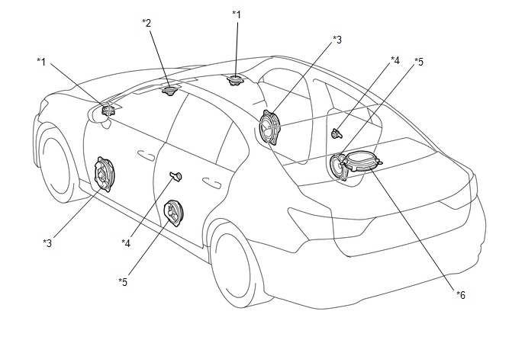

LOCATION | SPEAKER NAME |  | QUANTITY | SIZE | IMPEDANCE | RATED INPUT POWER
*1 | Front No. 2 Speaker Assembly | Tweeter | 2 | 9 cm (3.5 in.) | 8.1 Ω | 4 W
*1 | Front No. 2 Speaker Assembly | Speaker
*2 | Front No. 3 Speaker Assembly | Tweeter | 1 | 9 cm (3.5 in.) | 4 Ω | 4 W
*2 | Front No. 3 Speaker Assembly | Speaker
*3 | Front No. 1 Speaker Assembly |  | 2 | 17 cm x 25 cm (6.6 in. x 9.8 in.) | 5.2 Ω | 9 W
*4 | Rear No. 2 Speaker Assembly |  | 2 | 2.5 cm (0.9 in.) | 4 Ω | 0.5 W
*5 | Rear Speaker Assembly |  | 2 | 17 cm (6.6 in.) | 4.6 Ω | 18 W
*6 | Rear Header Speaker Assembly | Tweeter | 2 | 9 cm (3.5 in.) | 8.1 Ω | 4 W
*6 | Rear Header Speaker Assembly | Speaker
*7 | Rear No. 3 Speaker Assembly |  | 1 | 25 cm (9.8 in.) | 5.8 Ω | 4 W
(d) Steering Pad Switch Assembly
