

Metal-tech, Cage LLC
2700 E 9th St Suite 200, Newberg OR 97132
metaltech4x4.com 800-839-0684
info@metaltech4x4.com

GX470 Sliders
Installation Guide
Your sliders should contain:

1 Left side slider
1 Right side slider
2 7/16 U-bolts
1 Bolt Kit

SAFETY! Use the appropriate safety devices during your installation. SAFETY!
SAFETY! Wear safety glasses at all times. SAFETY!

- NOTE: If you don’t need instructions, at least note the few key steps that have an asterisk by them. These will save you frustration later!

Thank you for your purchase of OPOR sliders for your GX470. We have taken great pride in their development and manufacturing. We also wheel what we make and look forward to the opportunity to see you on the trail! Before you begin your installation take a moment to read through this write up. There are a few key things noted that will make the installation go smoothly.
We welcome your feedback on our products and your experience with Metal-tech. You can reach us toll free at 800-839-0684 Mon-Sat 8 AM to 6 PM PST. Or via e-mail at info@metaltech4x4.com

- Remove old parts and prep for the new:
  - Remove stock sliders or other inferior sliders – If installed on truck.
  - Lay each slider next to your truck and visualize where each mount will go on the frame. This will help you get an idea as to where each bolt will go into the frame.
  - Clean out the 12 8mm x 1.25mm factory tapped hole on the frame for the top of the front foot. Once cleaned of visual debris carefully chase the threads with an 8mm x 1.25mm tap. If a tap is not available you can use a bolt, do not use excessive force.
- TIP: Make a thread chaser tool. If you use a bolt use a small cutting disk on a moto-tool like a Dremel to cut a line perpendicular to the threads, but no deeper than the threads. This makes a bolt more efficient at cleaning out old threads.)
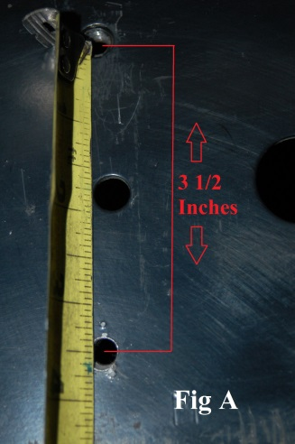
  - Drilling new/bigger holes is necessary for both lower bolts on the front and middle foot of the slider.

    - The FRONT foot needs a ½” hole to sink the provided 3/8 rivet nut. If hole is not already present measure 3 ½” down from center of top hole using the side of the larger hole as a guide to mark were hole should be. (See Fig A)
    - Drill a new or enlarge existing hole to ½ diameter and install 3/8 rivet nut using the provided hardware as a tool. The bolt that threads into the rivet nut gets a washer and a nut slightly bigger than the bolt to make the tool.(See Fig B)
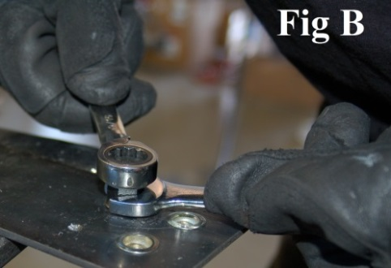
    - The MIDDLE foot requires a 5/8 hole drilled in the bottom of the frame to sink the ½” rivet nut. This unfortunatly takes the mounting of the slider marking hole location removing the slider then drilling the for presice hole placement. Then repeate above steps with ½ bolt and provided harware as tool.

  - Unclip the KDSS/X-REAS lines and loosen/remove the bolts holding lines and the pump to the frame, you will need 1/4 inch of gap between the lines and the frame for the feet of the sliders. (Loosening the pump may not be necessary on all models)
  - Once the rivet nuts are in place you are ready for installation.
- Installation

  - Where the rear foot will attach to the frame. Place the provided U-bolt around the frame from the backside (in between the frame and muffler/gas tank) sliding it up and rotating it into place.
  - With a helper lift the slider into place, pull the X-REAS/KDSS lines away from the frame and slide the feet of the slider into place.
  - DO NOT USE EXCESSIVE FORCE ON THE X-REAS/KDSS LINES SO THEY DO NOT KINK.
  - The MIDDLE foot needs a ½-13x5.5” bolt and washer placed from inside through to outside of the frame then through the foot of the slider. Starting from the top hole on the center foot, install the ½ washer, lock washer and nut on the bolt going through the frame then install the remaining hardware.
  - Tighten the lower center foot mounting hardware first after leveling then the rest of the hardware.
  - Verify slider is not touching the body. Loosen bolts slightly to adjust, and then retighten if needed.
  - Repeat for the other side
- Install Metal-Tech sticker on your truck and enjoy!

