AUDIO QUICK REFERENCE GUIDE
Models:
’01 -- ’07 All Lexus
Introduction: Lexus has developed a quick reference guide to be used by technicians when troubleshooting typical audio system concerns. This guide is intended only as a supplement to the diagnostics already available in the Repair Manual
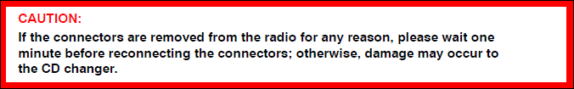
Repair Procedure

No Sound (Display is normal)
- Check the source of the problem occurs (AM, FM, or CD).
If condition ONLY occurs in CD mode, go to step 3 of “CD Skips/CD Does NOT
Play/CD Does NOT Eject/CD Will NOT Accept”.
- Confirm speaker operation.
Adjust the sound settings.
- Check each speaker individually using the Balance/Fade settings
B. System with external amplifier: Enter Diagnostic mode and check for codes
under P440 and P190.

How to enter Diagnostic mode:

Cars without navigation system: On the radio, while pressing the disc
button 3 times, press and hold presets “1” and “6”.

Cars with navigation system: Press and hold the info switch on the
navigation display while cycling the tail lights ON and OFF three times.

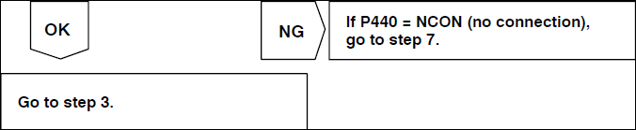

Step 3. Check if sound is heard from at least one speaker.
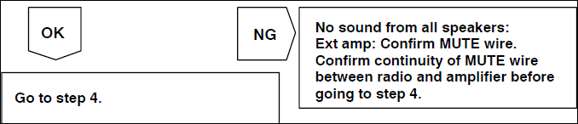

Step 4. Measure speaker resistance.
Disconnect the radio connector or amplifier connector for external amplifier systems.
Measure resistance across + and -- speaker circuits.
OK = 1.5 to 9.5 ohm (for external amplifier systems)
OK = 3.5 to 4.5 ohm (for radio with internal amplifier)

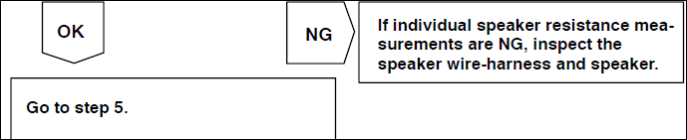

Step 5. Check for speaker short to ground.
Measure resistance across both + and -- speaker circuits to ground.
OK = Infinite
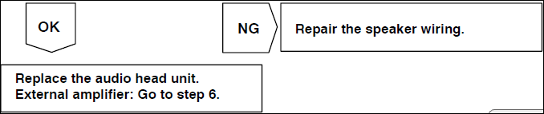

6. Verify proper communication.
A. Disconnect radio and amp connectors.
B. Check continuity (TX+ and TX--) from audio head unit to amplifier.
C. Confirm NO continuity to ground on TX+ and TX--.
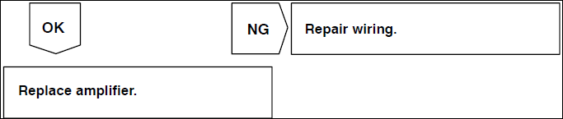

CD Skips/CD Does NOT Play/CD Does NOT Eject/CD Will NOT Accept


Analyse whether these issues or symptoms when they have happened (for example: rough roads, after ## minutes, hot/cold days, or error code).
Inspect the CDs ( OEM Music CDs with Label or off the shelf CDs and music burned at home

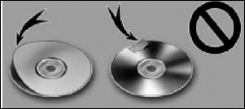

Check & Inspect for Scratches & Cracks
- Fingerprints
- Dust and/or dirt
- 8 cm diameter CDs
- CD Digital Audio logo (Confirm the CD has this logo. Lexus CD player may NOT
be able to play CDs that do NOT have this logo.)


3. Test CD Player.
- For CDs that skip and/or will NOT play, use the CD Test Disk. Use the below link to burn a custom CD test tone.
- http://www.audiocheck.net/audiocheck_testtoneCD.php

- For CDs that will NOT eject, test the operation of the eject mechanism using the
Personal OEM CD.

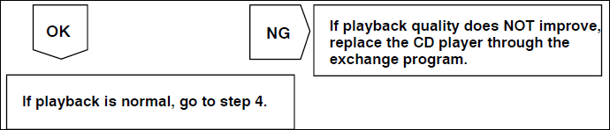

CD player operates normally

Speaker Noise/Rattle Noise
- Analyse whether these issues or symptoms when they have happened (for example: rough roads, after ## minutes, hot/cold days, or error code).
- Confirm the condition.
A. Remove the door trim panel, if necessary.
B. Confirm if noise occurs in AM/FM mode or CD mode.
- Repair the door trim panel as needed.
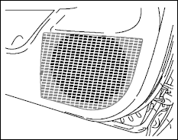
A. Confirm rattle noise is gone in the area where the vibration is occurring.
B. Reinstall the door trim and confirm the area where the vibration is occurring. Use
the NVH kit also called as Noise Vibration Hush Kit (P/N 08231--00810) on the trim panel area that is vibrating.
4. Repair loose parts.
Check the wiring harness, water shield, clips, and/or other parts that are vibrating.
Use the NVH kit (P/N 08231--00810) on parts that are vibrating.

5. Replace the speaker.
A. Unbolt the speaker and remove from the door/body panel.
B. If the noise is still coming from the speaker, replace the speaker.

Poor Reception (AM/FM)
Note:- Sometimes a noise filter may exist in the antenna plug, which plugs into the radio,
the antenna cable will normally show an open circuit when checking continuity.
- Gather detailed information.
Ask the customer when and where the problem occurs (for example: certain area
only, AM/FM or both, or which stations are affected).
- Check for aftermarket accessories, such as Rear Seat Entertainment (RSE) system,
metallic window tint, and/or FM modulator.
Disconnect the component and recheck reception.
- Check all antenna connections.
A. Confirm secure antenna connection(s) at the back of the radio.
B. Confirm secure antenna connections at the mast antenna or glass
antenna connector.
- Check the signal using a test antenna.
Disconnect the vehicle antenna and connect a test antenna at the back of the radio
(drive the vehicle outside).
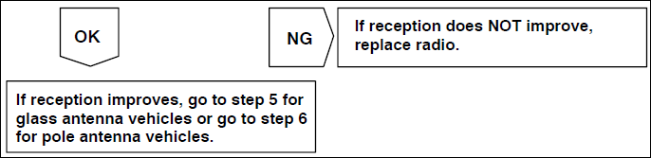
- Inspect the glass antenna for open/cut patterns.

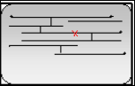

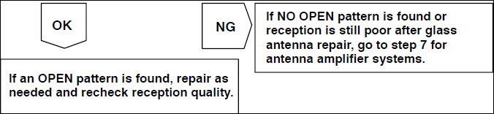

- Install test antenna at pole antenna connection.
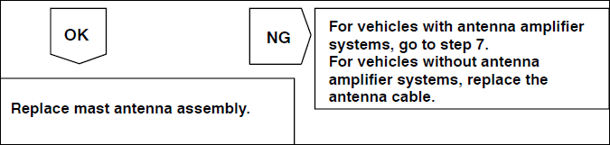 7.

- Inspect the antenna amplifier (if equipped).
If antenna amp is NOT powered, inspect ANT+B wiring from radio and confirm
12V output to the antenna amplifier.
If an antenna amp is receiving power:
- For vehicles where the amplifier is part of the antenna cable, replace the
antenna cable.
- For vehicles where the amplifier is separate, plug the antenna cable directly
into the antenna.
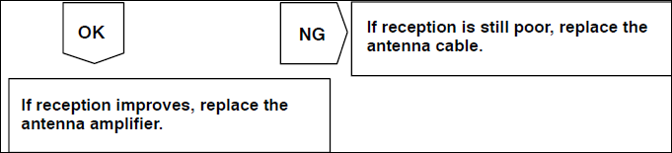

Replacing the Antenna Amplier the best source would be junkyard as new ones are qute expensive. I hope this helps the GX owners to a certain amount of defects the first Generations have faced.

Good Day

