NOTICE:
The booster terminal can only be used to rescue this vehicle and can not be used to rescue another vehicle with a discharged battery.
HINT:
The following problems indicate that the auxiliary battery is discharged:
- No display appears on the instrument panel when the power switch is turned on (IG).
- The hybrid system does not start.
- The headlights are dim.
- The sound from the horn is weak.
(1) Engage the parking brake.
(2) Turn the power switch off and remove the key from the interior detection area.
(3) Remove the engine room relay block and junction block assembly cover.
(4) Open the booster terminal cover.
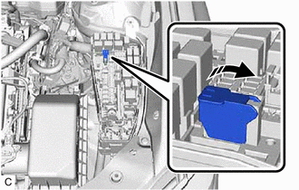
(5) Using booster cables, connect the 12 V auxiliary battery of the rescue vehicle to the auxiliary battery of the stalled vehicle as shown in the illustration.
Connecting Sequence | Connecting Location
1 | Booster terminal of stalled vehicle
2 | Positive (+) auxiliary battery terminal of rescue vehicle
3 | Negative (-) auxiliary battery terminal of rescue vehicle
4 | Position shown in the illustration on stalled vehicle
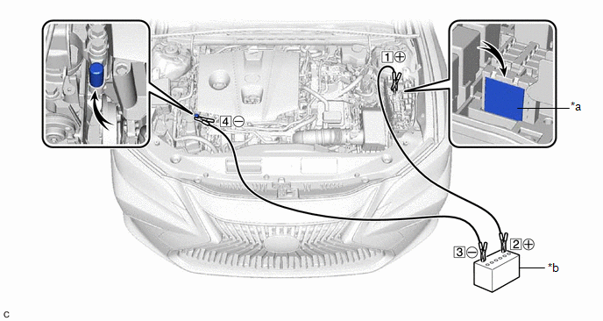
*a | Booster Terminal | *b | Auxiliary Battery of Rescue Vehicle
(6) Start the engine of the rescue vehicle and run the engine at a speed slightly higher than usual.
(7) Turn the power switch on (READY).
NOTICE:
Immediately disconnect the booster cables in the reverse order of connection after the hybrid system has started. Do not leave the booster cables connected because they are not designed for recharging purposes.

