 | 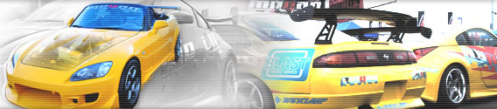


Top of Form
Bottom of Form
Top of Form
Cat-Back Systems - OE-RS
Bottom of Form
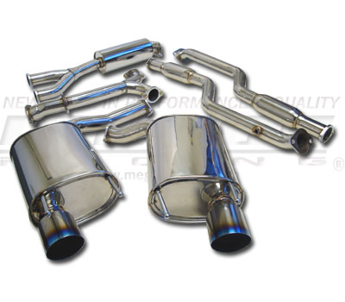
  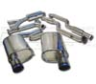 | 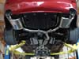 | 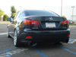 | 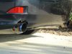
Lexus IS250/350 06+
Model Number : MR-CBS-LI0625
- Dual titaninum 4" tips
- 2.5" piping
- Resonators included
- Direct bolt on
- T304 stainless steel
- Gains torque and power
- Total is 6 pieces set up, including 2 axle backs, y pipe, mid pipe and 2 front pipes.
fits IS250/IS350
MSRP: $950.00 per set.

..: copyrights 2006 Megan Racing Inc :..

