2UR-GSE ENGINE CONTROL: ECM: REMOVAL
DISCONNECT CABLE FROM NEGATIVE BATTERY TERMINAL
CAUTION:
Wait at least 90 seconds after disconnecting the cable from the negative (-) battery terminal to disable the SRS system.
NOTICE:
When disconnecting the cable, some systems need to be initialized after the cable is reconnected.
REMOVE COOL AIR INTAKE DUCT SEAL.
REMOVE ENGINE ROOM SIDE COVER LH.
REMOVE V-BANK COVER SUB-ASSEMBLY.
REMOVE ENGINE ROOM ECU COVER.
Remove the 3 bolts and the ECM cover.

NOTICE:
Remove all water from on and around the ECM cover.
Perform the inspection indoors to avoid rain.
Be sure to prevent water intrusion to the ECM (connectors and screw holes).
REMOVE ECM
Disconnect the ECM connectors.
Using a screwdriver, disconnect the connector holder.
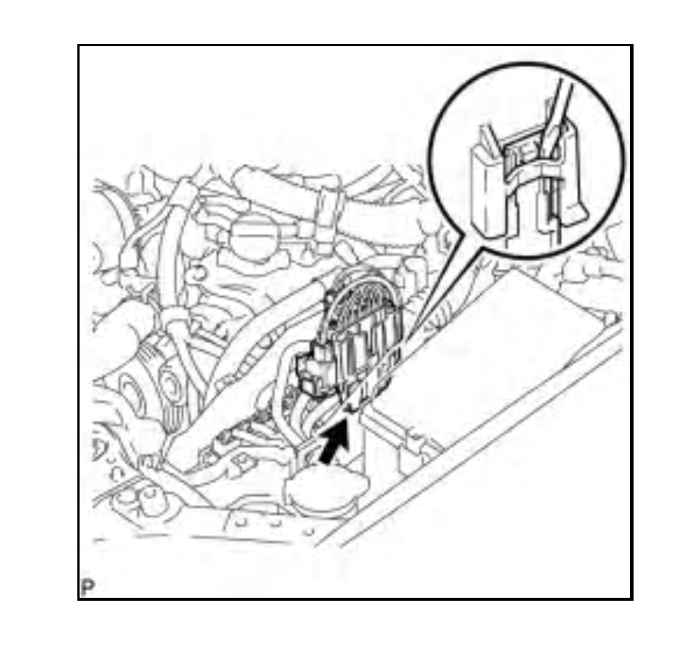

Disconnect the 6 ECM connectors.
Remove the 2 nuts and ECM from the ECM box.
