LEXUS LS2ND GENERATION
1995-2000
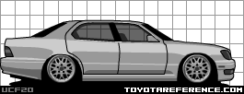
LS400 4.0L 95-00
Chassis Code: UCF20
Engine Code: 1UZ-FE
*1997 Coach Edition available in Black Onyx,
Cashmere Beige, Moonstone Pearl, Silver Jade
or exclusive Opal White Pearl
*2000 Platinum Series available in Black Onyx,
Millennium Silver, Crystal White with Silver body
cladding and exclusive Burnished Gold Metallic.

