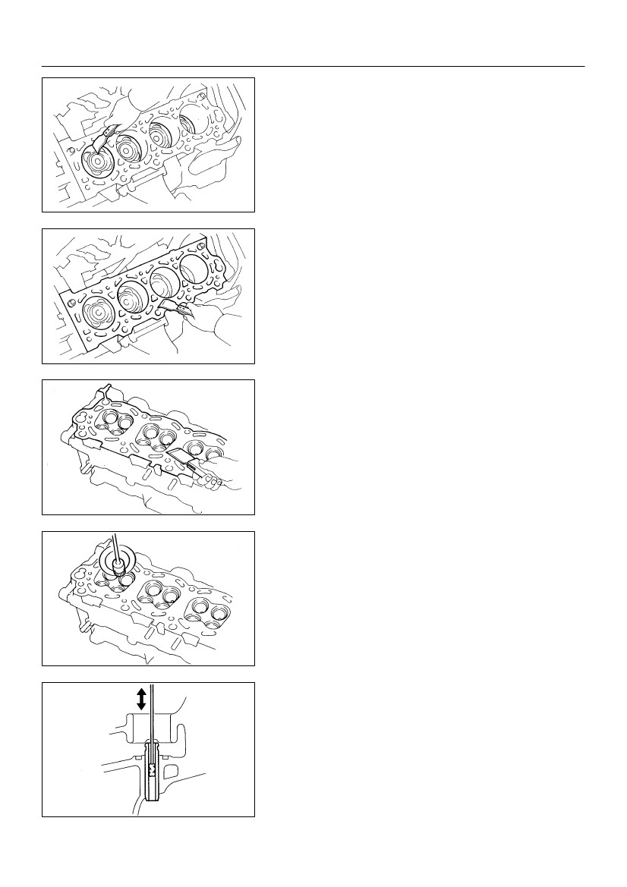
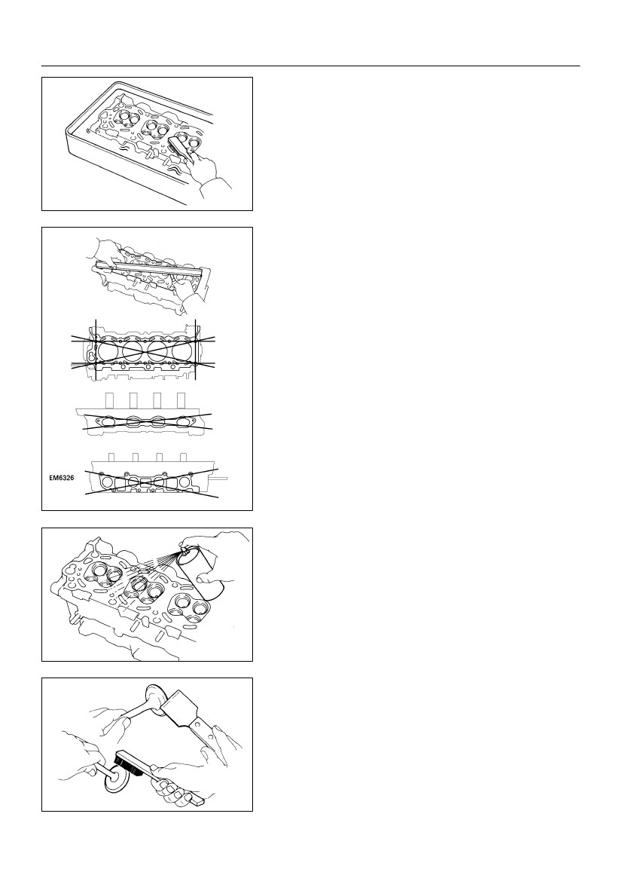
EM–44
ENGINE MECHANICAL
–
CYLINDER HEAD
EM09S–02
INSPECTION
1.
(a)
CLEAN TOP SURFACES OF PISTONS AND CYL-
INDER BLOCK
Turn the crankshaft, and bring each piston to top dead
center (TDC). Using a gasket scraper, remove all the car-
bon from the piston top surface.
A03194
(b)
Using a gasket scraper, remove all the gasket material
from the cylinder block surface.
(c) Using compressed air, blow carbon and oil from the bolt
holes.
CAUTION:
Protect your eyes when using high pressure compressed
air.
A03193
2.REMOVE GASKET MATERIAL
Using a gasket scraper, remove all the gasket material from the
cylinder block contact surface.
NOTICE:
Be careful not to scratch the cylinder block contact sur-
face.
EM6323
3.CLEAN COMBUSTION CHAMBERS
Using a wire brush, remove all the carbon from the combustion
chambers.
NOTICE:
Be careful not to scratch the cylinder block contact sur-
face.
EM6324
4.CLEAN VALVE GUIDE BUSHINGS
Using a valve guide bushing brush and solvent, clean all the
guide bushings.
P21861
2000 LEXUS LS400 (RM717U)
Author :
Date :
1226
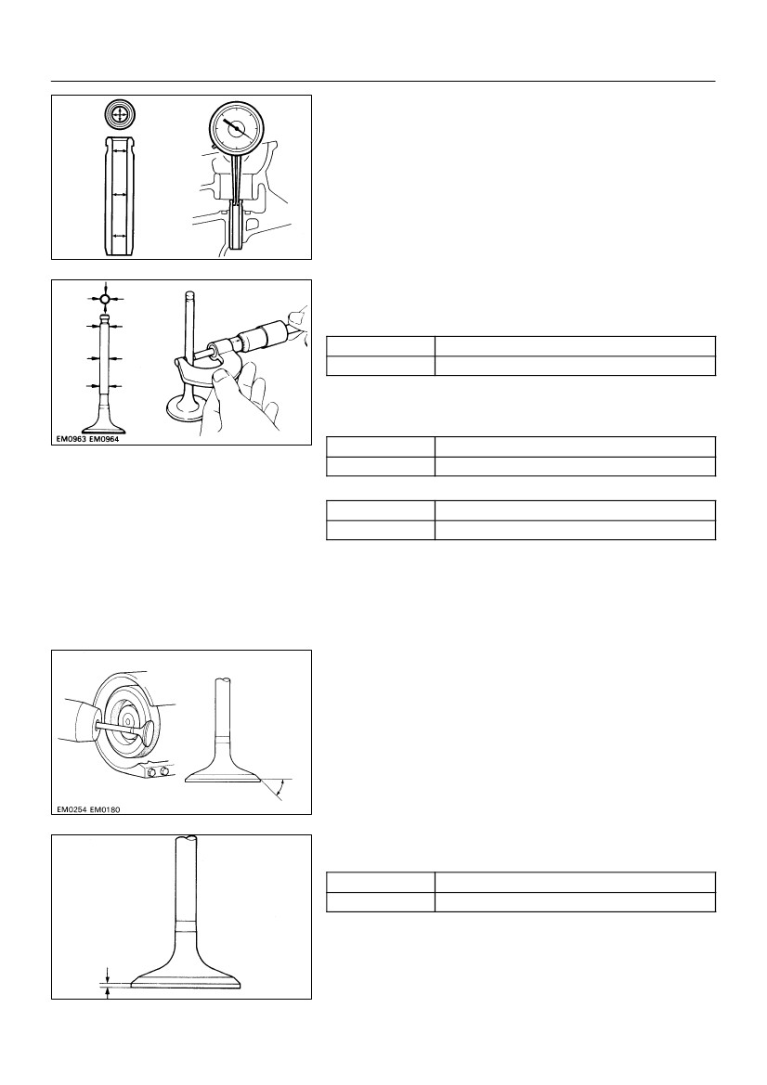
EM–45
ENGINE MECHANICAL
–
CYLINDER HEAD
5.CLEAN CYLINDER HEAD
Using a soft brush and solvent, thoroughly clean the cylinder
head.
EM6325
6.INSPECT FOR FLATNESS
Using a precision straight edge and feeler gauge, measure the
surfaces contacting the cylinder block and the manifolds for
warpage.
Maximum warpage: 0.10 mm (0.0039 in.)
If warpage is greater than maximum, replace the cylinder head.
A02876
A02877
A02878
A02879
7.INSPECT FOR CRACKS
Using a dye penetrant, check the combustion chamber, intake
ports, exhaust ports and cylinder block surface for cracks.
If cracked, replace the cylinder head.
EM6327
8.
(a)
(b)
CLEAN VALVES
Using a gasket scraper, chip off any carbon from the valve
head.
Using a wire brush, thoroughly clean the valve.
EM0580
2000 LEXUS LS400 (RM717U)
Author :
Date :
1227
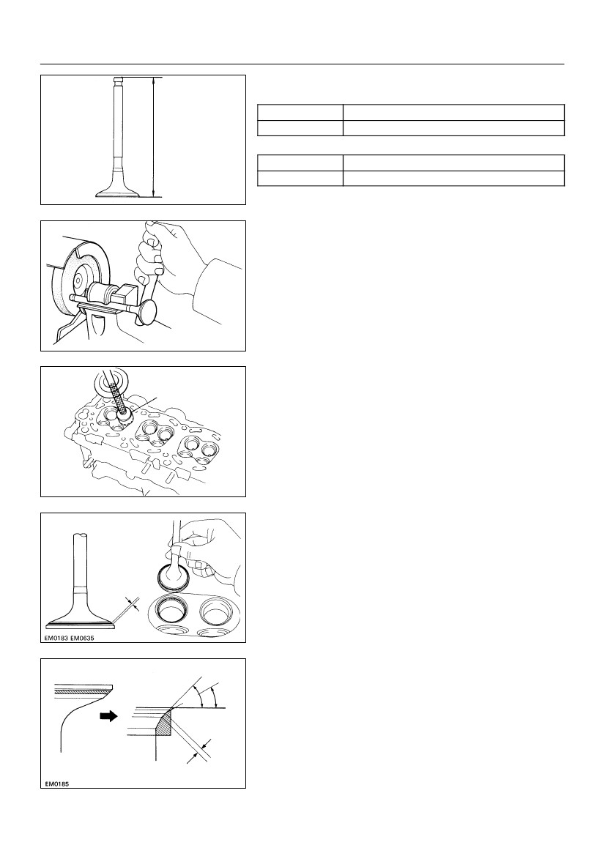
EM–46
ENGINE MECHANICAL
–
CYLINDER HEAD
9.
(a)
INSPECT VALVE STEMS AND GUIDE BUSHINGS
Using a caliper gauge, measure the inside diameter of the
guide bushing.
Bushing inside diameter:
5.510 – 5.530 mm (0.2169 – 0.2177 in.)
P21862
(b)
Using a micrometer, measure the diameter of the valve
stem.
Valve stem diameter:
Intake
Exhaust
5.470 – 5.485 mm (0.2154 – 0.2159 in.)
5.465 – 5.480 mm (0.2152 – 0.2157 in.)
(c)
Subtract the valve stem diameter measurement from the
guide bushing inside diameter measurement.
Standard oil clearance:
Intake
Exhaust
0.025 – 0.060 mm (0.0010 – 0.0024 in.)
0.030 – 0.065 mm (0.0012 – 0.0026 in.)
Z00052
Maximum oil clearance:
Intake
Exhaust
0.08 mm (0.0031 in.)
0.10 mm (0.0039 in.)
If the clearance is greater than maximum, replace the valve and
guide bushing. (See Page EM–54)
10.
(a)
(b)
INSPECT AND GRIND VALVES
Grind the valve enough to remove pits and carbon.
Check that the valve is ground to the correct valve face
angle.
Valve face angle: 44.5°
44.5°
Z00054
(c)
Check the valve head margin thickness.
Margin thickness:
Standard
Minimum
1.0 mm (0.039 in.)
0.5 mm (0.020 in.)
If the margin thickness is less than minimum, replace the valve.
Margin Thickness
EM0181
2000 LEXUS LS400 (RM717U)
Author :
Date :
1228
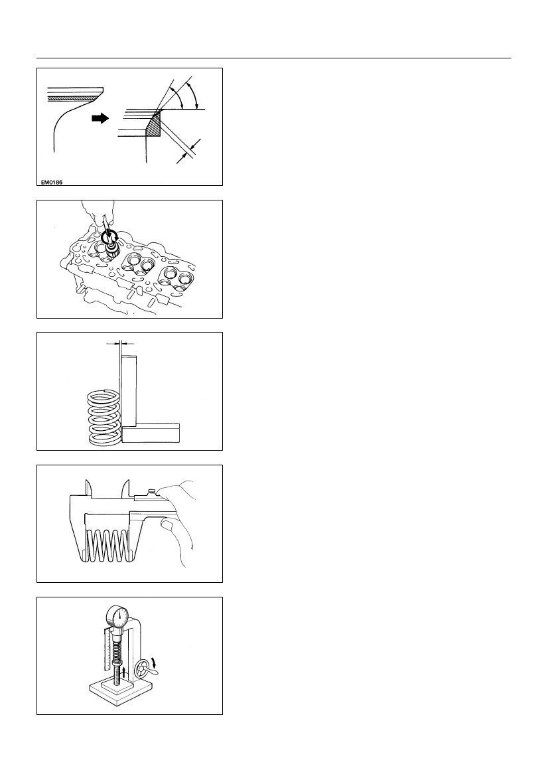
EM–47
ENGINE MECHANICAL
–
CYLINDER HEAD
(d)
Check the valve overall length.
Standard overall length:
Intake
95.05 mm (3.7421 in.)
95.10 mm (3.7441 in.)
Exhaust
Overall Length
Minimum overall length:
Intake
Exhaust
94.55 mm (3.7224 in.)
94.60 mm (3.7244 in.)
EM2534
If the overall length is less than minimum, replace the valve.
(e) Check the surface of the valve stem tip for wear.
If the valve stem tip is worn, resurface the tip with a grinder or
replace the valve.
NOTICE:
Do not grind off more than minimum.
EM0255
45° Carbide Cutter
11.
(a)
INSPECT AND CLEAN VALVE SEATS
Using a 45° carbide cutter, resurface the valve seats. Re-
move only enough metal to clean the seats.
EM6330
(b)
Width
Z00055
45°
30°
Check the valve seating position.
Apply a light coat of prussian blue (or white lead) to the
valve face. Lightly press the valve against the seat. Do not
rotate valve.
(c) Check the valve face and seat for the following:
SIf blue appears 360° around the face, the valve is
concentric. If not, replace the valve.
SIf blue appears 360° around the valve seat, the
guide and face are concentric. If not, resurface the
seat.
SCheck that the seat contact is in the middle of the
valve face with the following width:
1.0 – 1.4 mm (0.039 – 0.055 in.)
If not, correct the valve seats as follows:
SIf the seating is too high on the valve face, use 30°
and 45° cutters to correct the seat.
1.0 – 1.4 mm
Z03988
2000 LEXUS LS400 (RM717U)
Author :
Date :
1229
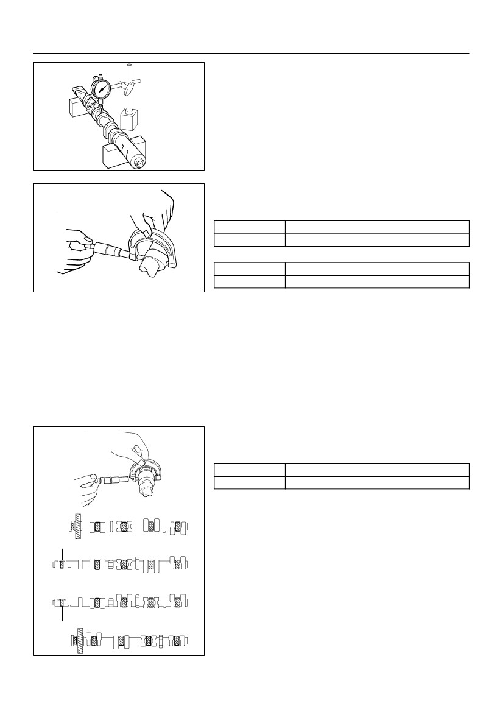
EM–48
ENGINE MECHANICAL
–
CYLINDER HEAD
60°
45°
S
If the seating is too low on the valve face, use 60°
and 45° cutters to correct the seat.
1.0 – 1.4 mm
Z03989
(d)
(e)
Hand–lap the valve and valve seat with an abrasive com-
pound.
After hand–lapping, clean the valve and valve seat.
EM6331
Deviation
12.
(a)
INSPECT VALVE SPRINGS
Using a steel square, measure the deviation of the valve
spring.
Maximum deviation: 2.0 mm (0.079 in.)
If the deviation is greater than maximum, replace the valve
spring.
EM0988
Using vernier calipers, measure the free length of the
valve spring.
Free length: 54.05 – 54.15 mm (2.1279 – 2.1319 in.)
If the free length is not as specified, replace the valve spring.
(b)
EM0801
(c)
Using a spring tester, measure the tension of the valve
spring at the specified installed length.
Installed tension:
204 – 226 N (20.8 – 23.0 kgf, 45.9 – 50.7 lbf)
at 35.0 mm (1.378 in.)
If the installed tension is not as specified, replace the valve
spring.
EM0281
2000 LEXUS LS400 (RM717U)
Author :
Date :
1230
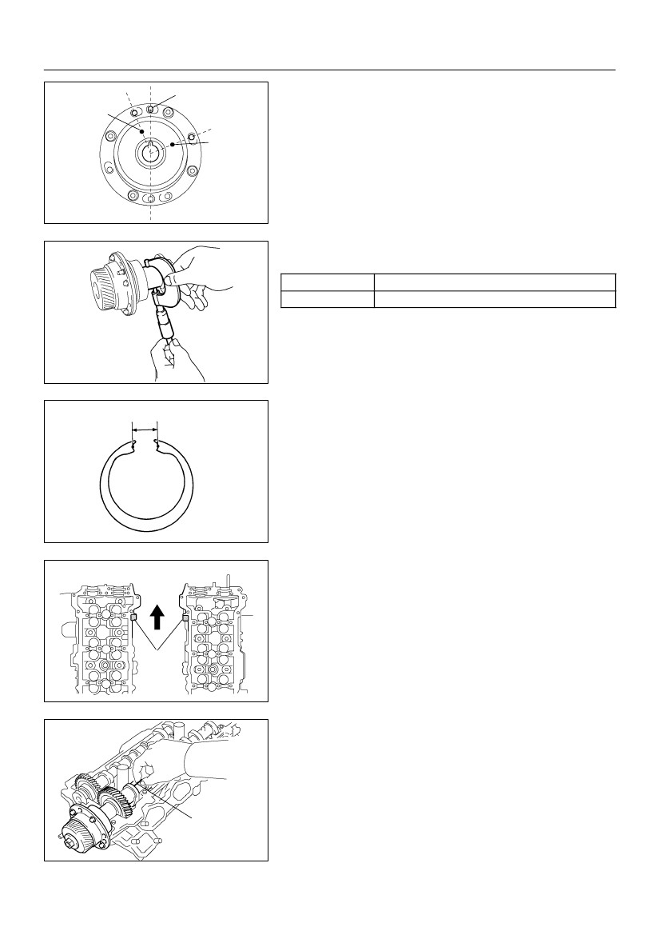
EM–49
ENGINE MECHANICAL
–
CYLINDER HEAD
13.
(a)
(b)
INSPECT CAMSHAFT FOR RUNOUT
Place the camshaft on V–blocks.
Using a dial indicator, measure the circle runout at the
center journal.
Maximum circle runout: 0.08 mm (0.0031 in.)
If the circle runout is greater than maximum, replace the cam-
shaft.
A03202
14. INSPECT CAM LOBES
Using a micrometer, measure the cam lobe height.
Standard cam lobe height:
Intake
Exhaust
42.610 – 42.710 mm (1.6776 – 1.6815 in.)
42.630 – 42.730 mm (1.6783 – 1.6823 in.)
Minimum cam lobe height:
Intake
EM2011
42.46 mm (1.6717 in.)
42.48 mm (1.6724 in.)
Exhaust
If the cam lobe height is less than minimum, replace the cam-
shaft.
15. INSPECT CAMSHAFT JOURNALS
Using a micrometer, measure the journal diameter.
Journal diameter:
Intake camshaft (A)
Others
30.984 – 31.000 mm (1.2198 – 1.2205 in.)
26.954 – 26.970 mm (1.0612 – 1.0618 in.)
If the journal diameter is not as specified, check the oil clear-
ance.
A
A
EM2538
A02880
A03222
2000 LEXUS LS400 (RM717U)
Author :
Date :
1231
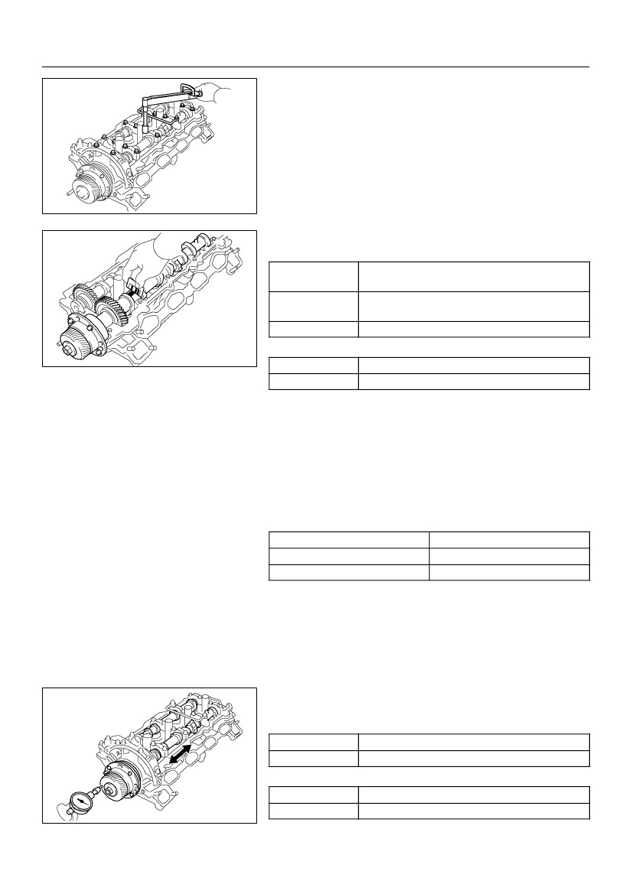
EM–50
ENGINE MECHANICAL
–
CYLINDER HEAD
Red Painted
Mark
Knock Pin
Green
Painted
Mark
16. INSPECT CAMSHAFT TIMING TUBE JOURNALS
HINT:
There are 2 size of the camshaft timing tube journal diameter,
green and red painted mark accordingly. The mark is painted
on the face of the camshaft timing tube.
A03217
Using a micrometer, measure the journal diameter.
Journal diameter:
Green painted mark
Red painted mark
39.958 – 39.964 mm (1.5731 – 1.5734 in.)
39.964 – 39.970 mm (1.5734 – 1.5736 in.)
If the journal diameter is not as specified, check the oil clear-
ance.
A03203
EM3322
17. INSPECT CAMSHAFT GEAR SPRING
Using vernier calipers, measure the free distance between the
spring ends.
Free distance: 18.2 – 18.8 mm (0.712 – 0.740 in.)
If the free distance is not as specified, replace the gear spring.
18. INSPECT CAMSHAFT BEARINGS
Check that bearings for flaking and scoring.
If the bearings are damaged, replace the bearing caps and cyl-
inder head as a set.
19.
INSPECT CAMSHAFT TIMING TUBE AND CAMSHAFT
JOURNAL OIL CLEARANCE
LH Cylinder Head
RH Cylinder Head
Front
Mark
A or B
A03216
HINT:
There are 2 size of the camshaft timing tube journal oil clear-
ance, Marked ”A” and ”B” accordingly. The mark is stamped on
the top of the cylinder heads.
(a) Install the camshaft timing tube. (See page EM–58)
(b) Clean the bearing caps and camshaft journals.
(c) Place the camshafts on the cylinder head.
(d)
Lay a strip of Plastigage across each of the camshaft jour-
nals.
Plastigage
A03204
2000 LEXUS LS400 (RM717U)
Author :
Date :
1232
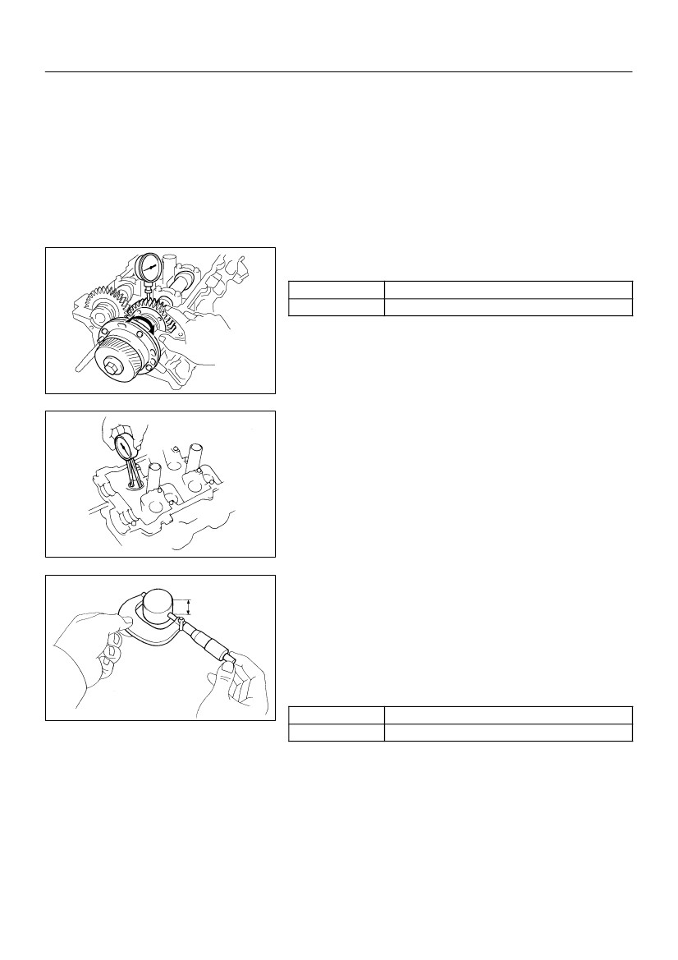
EM–51
ENGINE MECHANICAL
–
CYLINDER HEAD
(e)
Install the bearing caps. (See page EM–58)
Torque: 16 N·m (160 kgf·cm, 12 ft·lbf)
NOTICE:
Do not turn the camshaft.
(f)Remove the bearing caps.
A03205
(g)
Measure the Plastigage at its widest point.
Standard Oil clearance:
0.036 – 0.050 mm (0.0014 – 0.0020 in.)
Camshaft timing tube
Mark ”A”
Camshaft timing tube
Mark ”B”
Others
0.038 – 0.052 mm (0.0015 – 0.0021 in.)
0.030 – 0.067 mm (0.0012 – 0.0026 in.)
Maximum oil clearance:
A03206
Camshaft timing tube
Others
0.085 mm (0.0033 in.)
0.10 mm (0.0039 in.)
If the oil clearance is greater than maximum, replace the cam-
shaft. If necessary, replace the bearing caps and cylinder head
as a set.
(h) Completely remove the plastigage.
(i)Remove the camshafts.
(j)Remove the camshaft timing tube.
20. IF NECESSARY REPLACE CAMSHAFT TIMING TUBE
Select a camshaft timing tube according to mark on the cylinder
head.
Cylinder Head
Mark ”A”
Mark ”B”
Camshaft timing tube
Green painted mark
Red painted mark
21.
(a)
(b)
INSPECT CAMSHAFT THRUST CLEARANCE
Install the camshaft timing tube. (See page EM–58)
Install the camshaft. (See page EM–58)
(c)
Using a dial indicator, measure the thrust clearance while
moving the camshaft back and forth.
Standard thrust clearance:
Intake
Exhaust
0.060 – 0.100 mm (0.0024 – 0.0039 in.)
0.040 – 0.090 mm (0.0016 – 0.0035 in.)
Maximum thrust clearance:
Intake
A03207
0.13 mm (0.0051 in.)
0.12 mm (0.0047 in.)
Exhaust
2000 LEXUS LS400 (RM717U)
Author :
Date :
1233
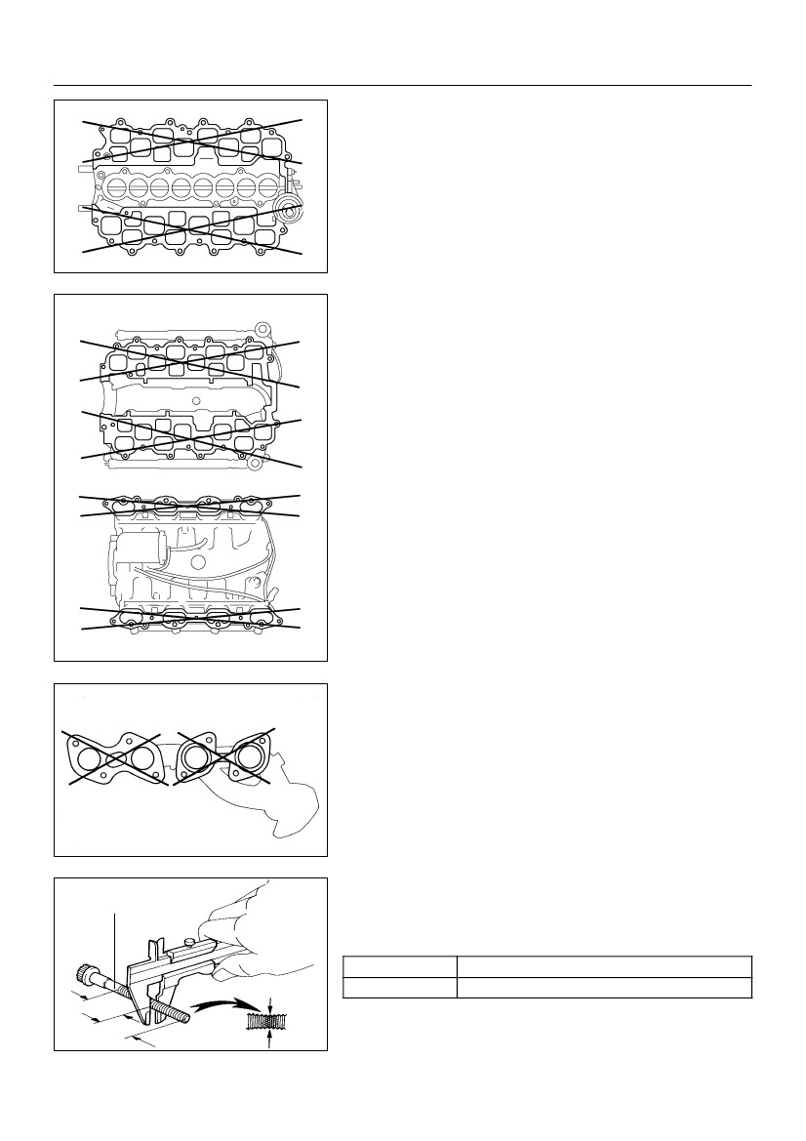
EM–52
ENGINE MECHANICAL
–
CYLINDER HEAD
If the thrust clearance is greater than maximum, replace the
camshaft. If necessary, replace the bearing caps and cylinder
head as a set.
(d) Remove the camshafts.
(e) Remove the camshaft timing tube.
22. INSPECT CAMSHAFT GEAR BACKLASH
(a) Install the camshaft timing tube. (See page EM–58)
(b) Install the camshafts without installing the exhaust cam
sub–gear and front bearing cap. (See page EM–58)
(c)
Using a dial indicator, measure the backlash.
Backlash:
Standard
Maximum
0.020 – 0.200 mm (0.0008 – 0.0079 in.)
0.30 mm (0.0188 in.)
If the backlash is greater then maximum, replace the cam-
shafts.
(d) Remove the camshafts.
A03208
23.
(a)
INSPECT VALVE LIFTERS AND LIFTER BORES
Using a caliper gauge, measure the lifter bore diameter
of the cylinder head.
Lifter bore diameter:
31.000 – 31.016 mm (1.2205 – 1.2211 in.)
A03209
(b)
12.3 – 12.7 mm
(c)
Using a micrometer, measure the lifter diameter at the
valve lifter center line, 12.3 – 12.7 mm (0.484 – 0.500 in.)
from the valve lifter head.
Lifter diameter:
30.966 – 30.976 mm (1.2191 – 1.2195 in.)
Subtract the lifter diameter measurement from the lifter
bore diameter measurement.
Standard oil clearance:
Standard
Maximum
0.024 – 0.050 mm (0.0009 – 0.0020 in.)
0.07 mm (0.0028 in.)
A03201
If the oil clearance is greater than maximum, replace the lifter.
If necessary, replace the cylinder head.
2000 LEXUS LS400 (RM717U)
Author :
Date :
1234
EM–53
ENGINE MECHANICAL
–
CYLINDER HEAD
24.
(a)
INSPECT INTAKE MANIFOLD
Upper intake manifold:
Using a precision straight edge and feeler gauge, mea-
sure the surface contacting the lower intake manifold for
warpage.
Maximum warpage: 0.15 mm (0.0059 in.)
If warpage is greater than maximum, replace the upper intake
manifold.
A02881
Upper Intake Manifold Side
(b)
Lower intake manifold:
Using a precision straight edge and feeler gauge, mea-
sure the surface contacting the cylinder head and upper
intake manifold for warpage.
Maximum warpage: 0.15 mm (0.0059 in.)
If warpage is greater than maximum, replace the lower intake
manifold.
Cylinder Head Side
A02882
25. INSPECT EXHAUST MANIFOLD
Using a precision straight edge and feeler gauge, measure the
surface contacting the cylinder head for warpage.
Maximum warpage: 0.50 mm (0.0197 in.)
If warpage is greater than maximum, replace the manifold.
P21864
Measuring Point
26. INSPECT CYLINDER HEAD BOLTS
Using vernier calipers, measure the thread outside diameter of
the bolt.
Outside diameter:
Standard
Minimum
9.770 – 9.960 mm (0.3846 – 0.3921 in.)
9.60 mm (0.3780 in.)
If the diameter is less than minimum, replace the bolt.
2.5 mm
(0.98 in.)
2000 LEXUS LS400 (RM717U)
A02825
Author :
Date :
1235

