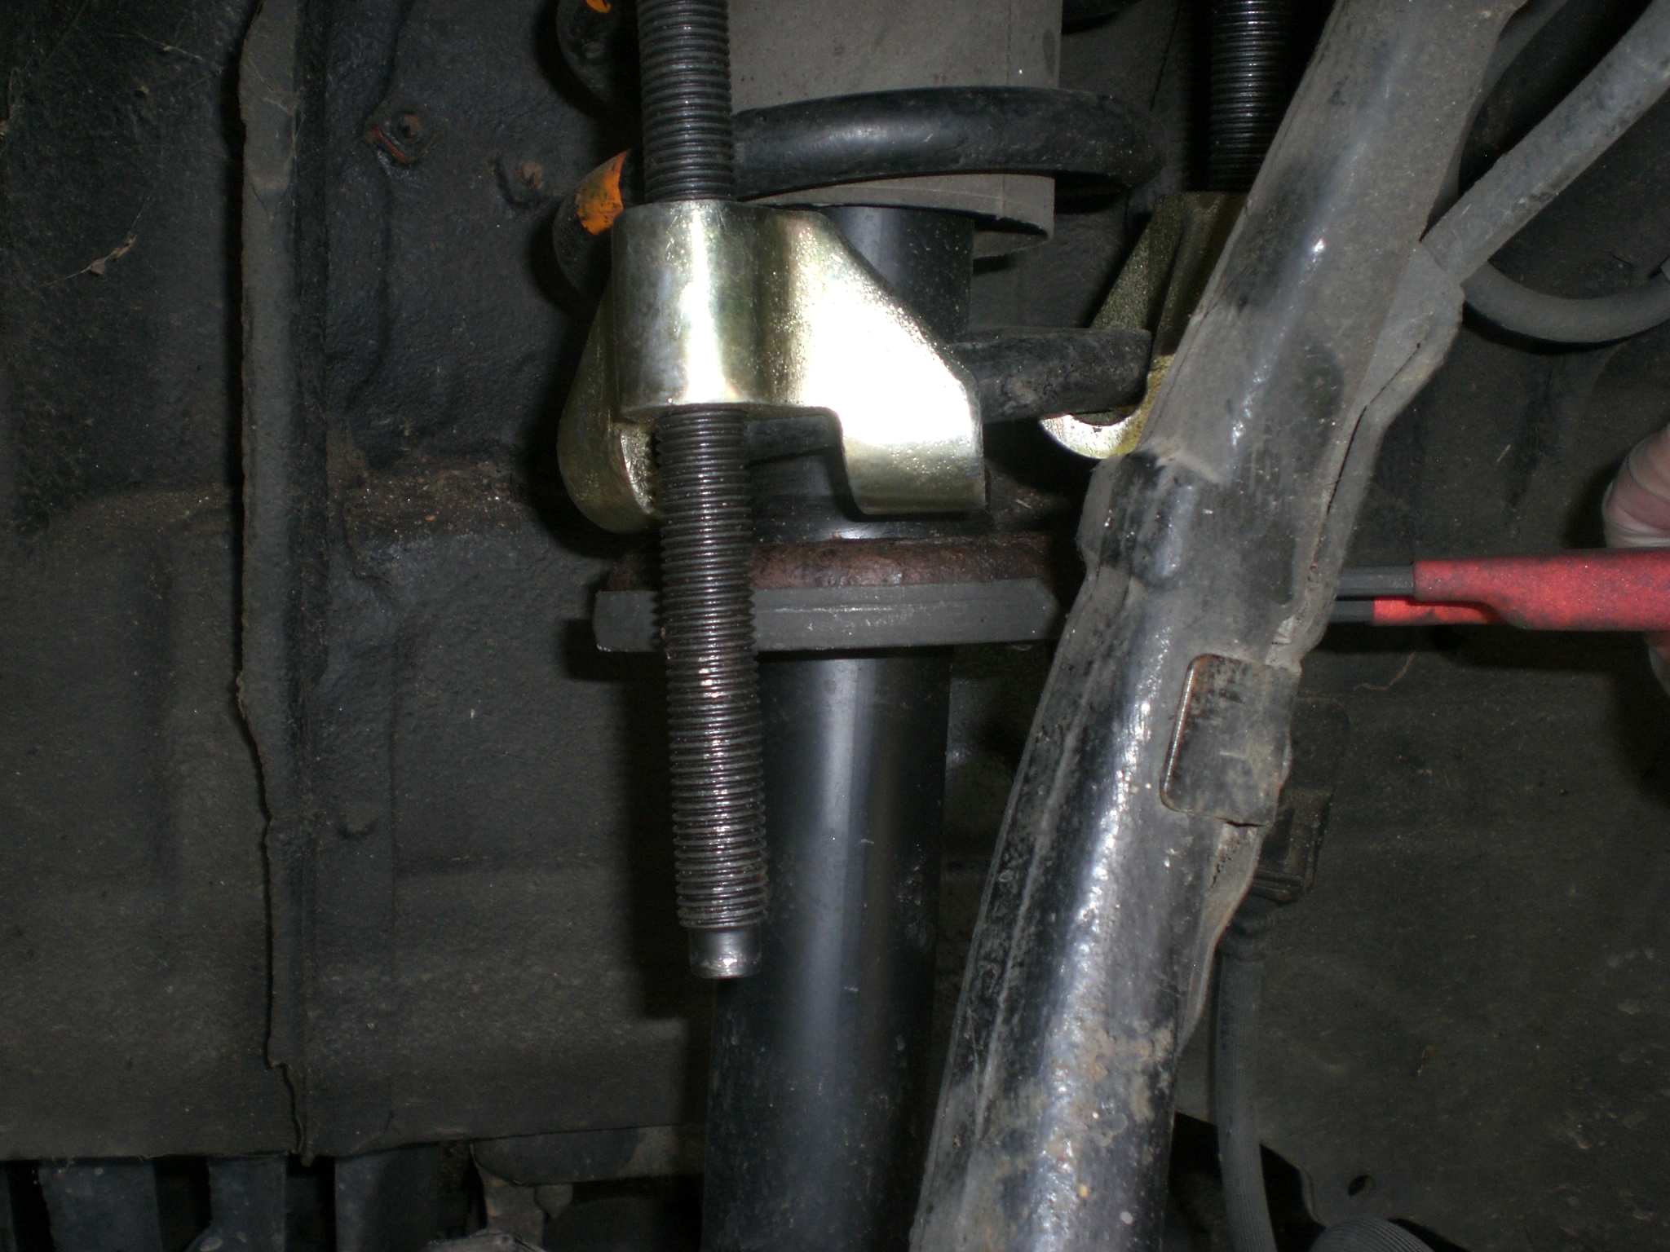
Filter wrench clamped to flange in preparation for lowering

6. Back at normal working height, the damper mount should now be perpendicular to the bracket and in-line with the bolt.

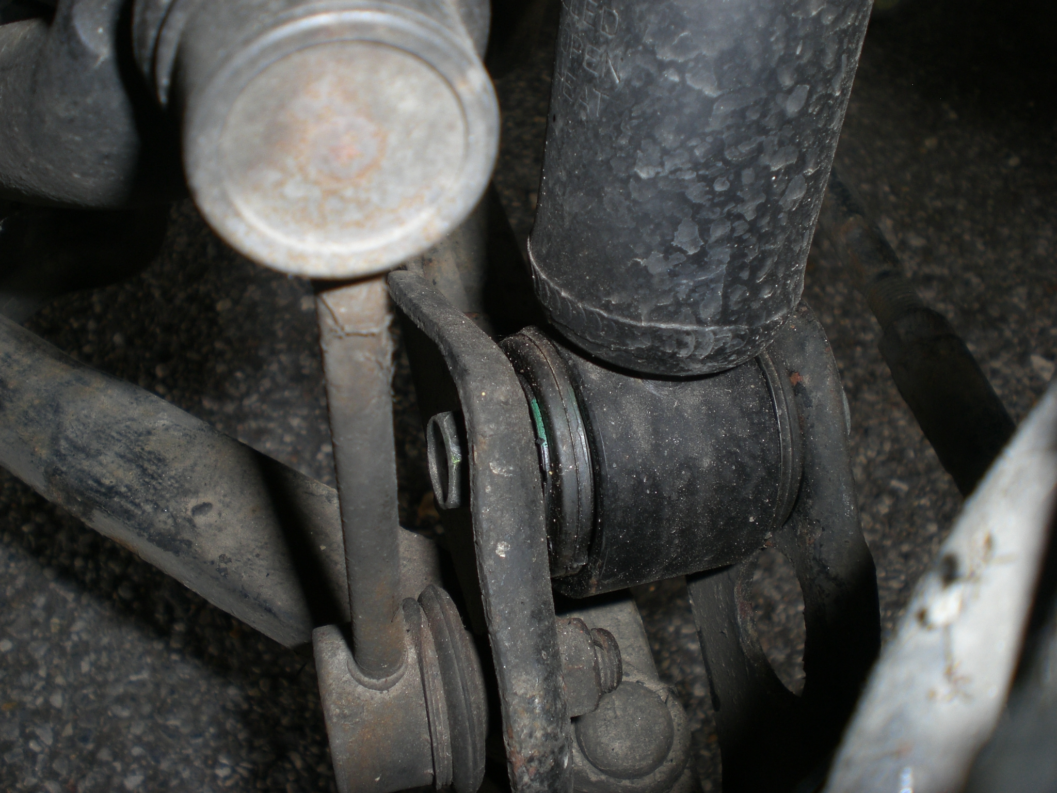
Damper mount much straighter in bracket

7. Raise the car at the jacking point, remove the hub support block and re-fit the wheel.

8. Inspect the spring compressors for thread wear. If they are damaged in any way, dispose of them.

9. Have a cup of tea.

