This press pack accompanied the UK launch of the second generation Lexus LS430 in October 2003. Some changes were made to the model range during its time on sale, which can be tracked using the Timeline feature available on the second generation LS430 archive web page. Additional assets and information relating to the LS430 range may be obtained from the Lexus press office if required.

THE NEW LEXUS LS430: THE ADVANCE TO AUTOMOTIVE PERFECTION

Key points
- New Lexus LS430 design concept gives a smoother exterior profile and supreme aerodynamic performance
- On sale in the UK from 1 November
- Enhancements to performance, comfort and safety
- 4.3-litre V8 engine combined with new Super ECT-i six-speed automatic transmission with sequential shift mode delivers stronger performance and lower fuel consumption
- Driving dynamics and smoother ride delivered by refinements to the air suspension and chassis
- Ten SRS airbags, including European-first driver and passenger knee airbags
- Advanced technology features, including AFS (Adaptive Front-lighting System) headlights, Lexus rear view camera, power door closing, Bluetooth connectivity and voice recognition functions
- DVD-based Lexus Navigator system with touch-screen activation and Electronic Traffic Avoidance (ETA)
- Smart key entry system
- Electrically adjustable front and rear seats
- Air conditioned front seats
- Rear seats with vibro-massage function
- Integrated rear seat cool box
- Strong cost of ownership profile compared to all key market rivals
- On the road price £56,850
- Insurance group 17E

The new Lexus LS430, the third generation of Lexus’s flagship, represents an important step closer to the goal of every luxury car manufacturer; automotive perfection. This is not an idle boast, the new LS430 builds on Lexus’s experience of more than a decade as a luxury market leader by achieving even greater levels of quality, performance, safety and refinement and integrating advanced technology that is both effective and simple to use.

Continuous improvement has always been at the heart of Lexus’s operations and that principle was fully embraced in the strategy to create the new LS430. The design team identified three key factors: more stylish exterior design; perceptible changes to the driving performance; and the adoption of more advanced technology features. In all these respects, the new LS430 succeeds in moving the industry benchmark even higher.

The exterior design is a dynamic evolution of the LS430’s established shape, expressed most strongly in changes to the shape of the bonnet, the new front grille and the adoption of the new AFS headlamp units. The overall effect is to give the car a lower and wider front-end appearance and more muscular bonnet profile.

Some of the most important changes are actually hard to detect with the human eye. More precise body stamping accuracy has been achieved and this combines with smoother bodywork and underfloor profiling and flush glazing to achieve an impressive coefficient of drag (Cd) of 0.25 – among the lowest of any luxury car. For the motorist, this quality is reflected in the almost complete elimination of wind noise and greater stability in high speed driving.

The LS430’s flanks feature a smooth combination of curves and straight lines and are distinguished by new five-spoke 18-inch alloy wheels, perfectly in proportion with the car’s dimensions. At the back there is a new rear trim design which carries through the wider and lower themes of the front. The three-stage rear lamps now use fast-reacting LED units. A final flourish is provided by the twin exhausts, the tailpipes now moved into view on either side, beneath the bumper section.

Driving dynamics and performance have been further improved. The latest powertrain technology delivers improved fuel consumption and low emissions. The double overhead camshaft, 32-valve, 4.3-litre V8 engine develops 278bhp at 5,600rpm and 417Nm of torque at 3,500rpm. It can power the Lexus from rest to 62mph in 6.3 seconds, yet already complies with the stringent Euro IV emissions standards, due to come into force in 2005.

One of the most significant features of the LS430 is the new Super ECT-i, an electronically controlled six-speed automatic transmission with sequential shift mode, equipped with gear ratios that are both closer and cover a wider range than before. The transmission also uses Artificial Intelligence (AI) programmes that learn a driver’s style and match revs and gear change patterns accordingly. A link between the computerised engine management system and the transmission allows for a momentary reduction in torque to render gear changes almost imperceptible.

The standard-fit electronically modulated air suspension uses nine different adaptive programmes and produces world-leading stability and ride quality. The car’s 53:47 front to rear weight ratio and the development of the suspension have produced an exceptional ride and driving dynamics that are well-suited to European conditions.

Mono-tube shock absorbers have been employed for the first time in LS430, using oil and high pressure gas as damping mediums. Their quality helps ensure natural, linear responses to steering input, optimum grip and a flat, composed ride.

In the cabin, Lexus engineers have gone beyond even the quality of the previous generation LS430 to deliver the finest fit and finish. Their craftsmanship has reduced the tolerance level for interior fittings to one millimetre, a degree of precision previously considered unattainable. The comfort of driver and passengers is assured by the climate control seats, fitted as standard. These enable the temperature of the front seats to be adjusted individually using a Thermal Control Chip (TCC) control on the dashboard. Blowers mounted in the seat can direct cool air through the upholstery, while fast-acting carbon heating elements can provide warmth on demand. Outer rear seats with a soothing vibro-massage function are also provided as standard.

The LS430 breaks new ground in its level of safety provision with a complement of 10 airbags featuring the latest Supplemental Restraint System (SRS) technology. These include the first European driver and passenger double knee airbag, which deploys from the underside of the instrument panel at the same time as the front airbags to reduce injuries from contact with the steering column and lower dashboard structures.

There is a wealth of advanced technology features which add in equal measure to the LS430’s driving dynamics, efficiency, safety and comfort. A key priority in their development has been to surpass anything offered by the competition, while keeping them simple and logical for the customer to operate.

The Adaptive Front-lighting System (AFS) substantially improves night time visibility by controlling the lighting direction of each headlamp in line with steering input and the speed of the vehicle. Lighting performance is also enhanced by the use of high intensity discharge headlamps with automatic levelling and integral cleaning system.

Parking manoeuvres are rendered simpler and safer with the introduction of the Lexus rear view camera. This projects an image onto the LS430’s dashboard display screen and provides visible guidelines for accurate steering into parking spaces. The same seven-inch screen displays information from the satellite navigation system. There is less need for the driver to take his attention off the road, as the new LS430 uses voice recognition technology that responds to around 300 different commands for the navigation, audio and air conditioning systems. Bluetooth technology allows the cable-free use of mobile telephones and personal data equipment.

The new LS430 sustains Lexus’s commitment to impeccable build quality. The car is built at the Tahara plant in Japan, a facility which made history by winning the J.D. Power and Associates Platinum Award in both 2002 and 2003.

THE HISTORY OF LEXUS: INNOVATION AND A PASSION FOR PERFECTION

Twenty years ago, in August 1983, a top secret meeting was held in Japan that was to change the world of luxury motoring. Toyota Motor Corporation Chairman Eiji Toyoda challenged his senior executives with a simple question: “Can we build the best luxury car in the world?”

The response was a resounding and historically significant “yes”, followed by a clear resolution that the challenge must be taken up. By the end of 1984, “Project F1” (Flagship Number One) was well under way. Chief engineers Shoji Jimbo and Ichiro Suzuki, together with a rapidly growing team of managers, engineers and specialists, worked on achieving perfection in every area.

By July 1985, the first of 450 running prototypes was built. As well as being a milestone for the project, it was also a clear representation of its scale, being the work of 60 designers, 24 engineering teams, 1,400 engineers and 220 support workers.

At the beginning, the design of the LS400 was honed for the USA, the world’s largest premium car market. A study team, headed by Shoji Jimbo, had already attended focus groups and interviewed both customers and dealers across America to develop an understanding of the character and demands of the market.

A separate design team moved to Southern California, working closely with colleagues from Calty Design, Toyota’s American studio. They looked at lifestyles and developed design concepts which took into account the likes and dislikes of the American luxury car buyer. In addition, development of the new car was carried out around the world, with high speed tests on German Autobahns, traction control testing in Sweden, laboratory and dynamic testing in Japan and long distance road evaluation in the USA.

“IT’S NOT A CAR, IT’S AN INVENTION”
This “relentless pursuit of perfection” culminated in 1989 in the launch of the famous “L” badge: Lexus became the world’s first all-new luxury marque in a generation. Among the launch slogans, one proclaimed: “The Lexus LS400. It’s not a car, it’s an invention.” Those words proved both accurate and prophetic.

Lexus’s arrival among the world’s established luxury car markers was distinguished not only by the quality of the LS400, it also introduced a wholly new concept of customer service. From the outset, Lexus set new standards by offering customers exclusivity, intelligent design, integrity and attention to detail.

The first production Lexus LS400 “premium luxury sedan” left the production line in Tahara, Japan, in May 1989 and the first cars reached customers in September. By the end of the first month, no fewer than 2,919 LS400s had been sold. This figure was augmented by more than 1,200 of the smaller Lexus ES250, a 2.5-litre executive “affordable luxury sedan”, sold exclusively in the USA.

From the moment it entered the market, the LS400 was hailed as one of the finest cars ever made. Lexus quickly carved a niche for itself and from 1991 became the USA’s number one luxury import marque, outselling both BMW and Mercedes-Benz. By the mid-1990s, with the addition of new models such as the ES300 and stylish SC300 sports coupe, Lexus had become a household name and earned a reputation for setting new standards in customer satisfaction.

A typical example of the level of service provided came just a few months after the LS400’s launch. Although aware of only one customer complaint regarding faulty cruise control and some comments on the distortion of a brake light housing, Lexus dealers personally contacted all 8,000 LS400 owners to check those specific items. Rather than provoking a negative response, the word spread rapidly among motorists about this remarkable degree of customer care.

These standards of customer satisfaction were – and continue to be – reflected in Lexus’s unprecedented domination of the world-famous J.D. Power and Associates awards. The first time Lexus became eligible for the Initial Quality Study award, in 1990, the marque took the top position by a significant margin.

The following year it achieved a clean sweep, named best overall marque and LS400 best luxury car in the IQS awards, as well being best overall marque in both the Sales Satisfaction Index (SSI) and Customer Satisfaction Index (CSI). Lexus has also held the number one spot for eight consecutive years in the J.D. Power Vehicle Dependability Index for long term reliability performance.

Since 1990, Lexus has won more than 30 individual premier awards from J.D. Power and Associates. Most recently the 2003 J.D. Power IQS awards in the USA registered a quality rating for Lexus 25 per cent better than its nearest competitor and 50 per cent higher than the industry average. The Tahara factory, which produces the LS and GS models, received the unprecedented accolade of successive Platinum Awards for quality in 2002 and 2003.

LEXUS ARRIVES IN EUROPE – AND DIVERSIFIES
Lexus was launched in Europe in late 1990 with a new LS400 model. Although sales volumes were lower than in the USA, Lexus rapidly gained a loyal clientele.

The new GS300 luxury performance saloon was launched in 1993 and the following year an all-new, second generation LS400 made its debut, offering even greater levels of refinement, performance and customer satisfaction. Lexus swept the board in the J.D. Power surveys, with the LS, GS and SC models in the top three places and Lexus top rated in every customer satisfaction study for which it was eligible.

Now it was time for Lexus to branch out and present new cars in new areas of the marketplace. First came a series of exciting sports saloons, the GS and IS series. Then for the 1999 model year, Lexus followed up the success of the USA’s top-selling LX470 sport-utility vehicle with a new compact SUV that would redefine the market.

The Lexus RX300 offered the commanding driving position and off-road abilities of an SUV without sacrificing the smooth ride, handling and convenience features associated with a luxury car. It continues to be a runaway success, creating an all-new market segment on both sides of the Atlantic. With a new model launched in 2003, RX remains North America’s best-selling SUV, beating both established domestic and imported brands. Lexus has also become the foremost luxury marque in the USA, outperforming Mercedes-Benz, BMW, Audi, Lincoln, Cadillac and all other competitors.

Since 1990, when Lexus recorded 1,158 LS400 sales, volumes have grown more than 20 times over. For most of its first decade in Europe, the Lexus range comprised just two models: the LS400 and, from 1993, the GS300 executive sports saloon. Together they achieved annual sales between two and three thousand units.

Sales performance was transformed from 1999 with the successive launches of the IS200 sports saloon, the LS430, GS430, RX300, IS300 saloon and SportCross and the SC430 coupe-cabriolet. Together these cars established for the first time a true family of new Lexus models that met a vast range of luxury motoring demands.

As well as generating increased sales, this development of the range increased awareness of Lexus and put it on the wish list of more people considering future purchases. Higher revenues for dealers have enabled them to invest in dedicated Lexus Centres and the means to provide the levels of customer service the marque represents.

“The entire Lexus range is being continually refined in line with our ‘kaizen’ philosophy. As with the development of the original IS, with the IS300 and SportCross derivatives, the GS and LS saloons and the further refinement of our SC430, each new generation adds another dimension to the Lexus marque,” says Lexus Europe Director Stuart McCullough. “These successful new models are also introducing many new customers to the Lexus philosophy of class-leading customer service, something that will ensure the continuing growth of Lexus across Europe in the years to come.”

Lexus’s status in providing the best customer service is witnessed in recent J.D. Power surveys in the UK, where it has received the top Gold Award for three consecutive years. In 2003, it reached new heights by scoring 861 points out of a possible 1,000, based on drivers’ responses to questions on quality, reliability, appeal, cost of ownership and service satisfaction. In the corresponding German study, the IS200 was the most successful car in 2002 and Lexus the best brand overall in 2003.

A DEDICATED, GLOBAL LEXUS MARQUE
The worldwide development of Lexus enters an important new phase in 2005 when it will be introduced as a separate, distinct brand in Japan. By the end of 2004, around 180 Lexus outlets will be in place. Initial sales levels are expected to reach between 50,000 and 60,000 cars a year.

This move is another phase in the strategy of building an infrastructure for Lexus that is separate from Toyota in areas such as engineering, styling and presentation to the public. Just as Lexus has its own standards of quality and refinement, so it is also developing its own design language. Already Lexus is the world’s fifth largest premium car manufacturer, a powerful position from which it will work towards the ultimate goal of being a truly global marque.

THE NEW LEXUS LS430: STYLISH AND ADVANCED EXTERIOR DESIGN

The exterior of the new LS430 represents a stylish and advanced evolution of the distinctive design Lexus created for its luxury saloon. The new car can easily be identified by the shape of the bonnet with its more pronounced, muscular profile, the new front grille and the distinctive AFS headlamp units.

The space between the headlamps has been increased and the grille has been modified with a stronger profile to compliment the shape of the bonnet. The bonnet and the headlamps are now positioned lower and the use of strong horizontal lines and the rearward slant of the grille create a more dynamic side view.

The appearance of the car’s flanks is enhanced by a smoother combination of straight lines and subtle curves and the introduction of new five-spoke 18-inch alloy wheels, perfectly in proportion with the vehicle’s dimensions. The styling of the rear end and the new rear trim give the car a wider, lower appearance. The three-section rear lamps now use fast response LED technology for the tail and stop lights. A final flourish is provided by the twin exhaust pipes, now brought into sight on each side below the bumper section.

The UK LS430 with standard air suspension has a coefficient of drag (Cd) of 0.25, which is among the lowest for any passenger car. That has been achieved by a series of production and design refinements, including greater accuracy in body stamping, flush glazing and smoother profiles for the bodywork and the underfloor. The benefits of this can be appreciated in the almost complete elimination of wind noise and even greater stability in high speed driving.

The capacity of the load compartment is among the best in class at 552 litres. This has been achieved through attention to details in design, including moving the fuel tank further forward. Link-type bootlid hinges are used, designed not to impact on luggage or other items as the lid is closed, and there are two courtesy lamps – one in the bootlid, the other deep in the load area – to make night-time loading and unloading even easier.

NEW PAINT TECHNOLOGIES IMPROVE APPEARANCE AND EXTEND CHOICE
A smoother finish has been achieved by using paints with a high solid content and fewer volatile organic compounds (VOCs), which can evaporate and affect quality. A lead-free cathodic-deposit primer is used, which helps guarantee the long life of the bodywork and is kinder to the environment.

There are four new colours in a range of 10 different paint finishes. These include Palladio Silver, which has been created using multi-layered coating with base colours that have different characteristics. The result is a particularly smooth and eye-catching platinum-like finish.

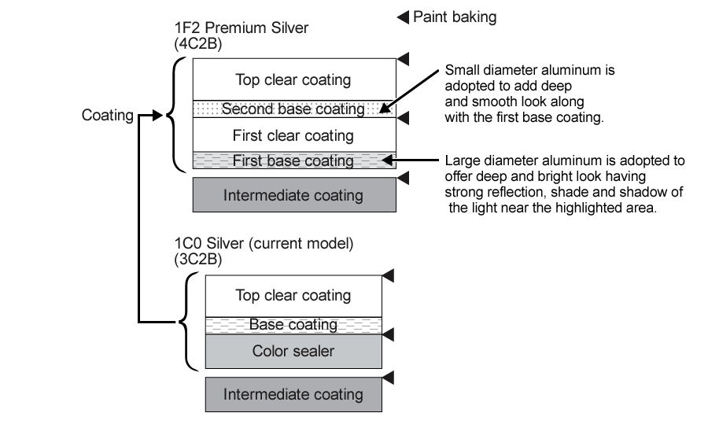

Also new to the palette for LS430 are Calanques White, Nazcan Bronze and Boreal Green. The new Aleutian Grey, introduced originally for the new RX300, uses a synthetic mica content to achieve a rich, multi-coloured metallic effect.

DESIGNED AND BUILT TO THE FINEST TOLERANCES
In building the new LS430, Lexus used a supercomputer to digitise the precise surface design of the bodywork. Measurements were exact to 0.001mm, 10 times finer than standard industry practice. The result is more precisely stamped sheet metal for a better fit and assembly quality.

Lexus may have won the J.D. Power and Associates Vehicle Dependability Study every year since it became eligible for the award, but its pursuit of perfection has prompted it to make 57 major improvements to achieve even greater durability. These include new welding methods, connections and structural design to render the LS430’s body much more rigid. Along with the ultra-precise build quality, this contributes to achieving even lower levels of NVH.

In addition to its anti-corrosion protection, the LS430 also benefits from measures to prevent scratches and keep moisture from getting inside the body. These include the use of corrosion resistant galvanised steel, wax and hemming sealers.

Larger reinforcing elements have been incorporated in the bumpers to aid the absorption of impact forces in a collision and help reduce the potential damage risk to other vehicles involved. Both bumpers and mouldings are made of SOP (Super Olefin Polymer), a plastic that has excellent impact absorbing qualities and is easy to recycle.

The optimal shape of the bumpers and the use of new impact-absorbing materials enabled Lexus to reduce the front bumper protrusion without compromising impact performance. Where the rear bumper is concerned, reinforcement and a redesigned and enlarged plastic honeycomb structure help reduce potential damage to luggage in a rear collision. Crash tests have shown that the LS430’s strengthened rear body structure reduces impact damage, especially to large and more expensive components.

INCREASED AERODYNAMIC EFFICIENCY AND DYNAMIC STABILITY
The tighter build tolerances achieved for the new LS430 can be seen in the small gaps between the body, doors, bootlid and bonnet. The improvement in fit and the careful control of airflow over and under the car contribute to a major reduction in wind noise and improved high-speed stability.

The cover beneath the engine is the smoothest yet designed, made possible by a new attachment system. Air channelled out of the engine compartment helps the control of the general airflow under the car, along with fairings positioned around the fuel tank and rear suspension. Fairings are also positioned front and rear to ensure smooth airflow around the wheels. The rear underbody and the silencer unit sweep upwards towards the rear bumper, helping to prevent the airflow entering the bumper section itself.

The LS430’s aerodynamic qualities produce a class-leading coefficient of drag (Cd) of 0.25 and contribute to both improved fuel economy and secure handling at higher speeds. Front and rear-end lift and yaw performance have been refined to achieve excellent stability at motorway speeds and in crosswinds.

“This increased stability gives the driver more feel of what the car is doing and greater confidence in all driving conditions. Other technical improvements, such as the six-speed automatic transmission, allow us to further improve on the fuel consumption of the previous model.” Says Jos de Boes, General manager of Total Vehicle Assessment and Vehicle Engineering for Lexus in Europe.

Careful reprofiling of the A pillars, aerodynamically efficient door panels, the flush integrated glass run, the outside seals and even the position of the parked windscreen wipers all ensure smooth and – importantly for a Lexus – quiet airflow over and around the car. The LS430 was fine tuned in the Maibara wind tunnel, a facility that was first developed for the famous Japanese Shinkansen bullet train.

“Other wind tunnels generate a significant amount of noise,” says Jos de Boes. “While they are good for providing data, the Maibara tunnel is unique in having very low background noise, which allows engineers to achieve totally balanced reduction in interior sound, matching the airflow characteristics to other noise sources. It is very much a case of balancing. If your reduce one area, such as wind noise, that places greater emphasis on areas such as the engine and road noise, so the Maibara wind tunnel played a key role in allowing us to achieve the perfect interior ambience expected of a Lexus.

“The new Lexus LS430 is much more than a conventional, mid-cycle product action. It embodies the philosophy of continuous improvement that is a characteristic of Lexus. The new LS430 is a more dynamic, more emotive and more passionate approach to creating the best luxury saloon in the world.”

THE NEW LEXUS LS430: LUXURY INTERIOR WITH ADVANCED COMFORT AND CONVENIENCE FEATURES

“Inspiring and spacious” was the philosophy for the design of the new Lexus LS430’s interior. The cabin is particularly roomy, measuring 2,080mm long with 1,481mm of shoulder room. The levels of luxury and finish meet Lexus’s high standards throughout and safety, comfort and convenience are addressed by a range of advanced electronic controls, systems and equipment.

“There is a Lexus motto that says ‘make the most of every moment’. For me, that means that the customer must be comfortable with their Lexus at all times,” says Morita Yoshida, Chief Engineer of the new LS430. “In each area the comfort and satisfaction of the customer is the most important characteristic.”

REFINED INTERIOR
High quality, genuine wood panelling of either walnut or bird’s-eye maple is used extensively around the cabin. Precise fit and finish demonstrates the level of Lexus craftsmanship with tolerance levels brought down to a new low of 1mm, a level that has never been achieved before.

The sculpted trim flows in the shape of the dashboard, maintaining the integrated and quality appearance of the design. Instrument clusters have been carefully designed to compliment the all-round luxury ambience and appearance. The new LS430 retains traditional analogue-type instrumentation, the Optitron combination display featuring easy to read white LED figures and indicator needles on a low-reflection curved, smoked acrylic face. The feel and operation of the metallic control switches have been engineered to add to the feeling of precision and craftsmanship.

Materials used for the tighter curves around the instrument panel have been precisely matched and have low-stretch characteristics which let them retain a pristine appearance for years to come. Woodgrain accents on the upper part of the console further add to the luxury feel of the interior.

The choice of materials combines the demands of quality and life-long practicality with care for the environment. Easily recyclable Super Olefin Polymer (SOP), Thermo Plastic Olefin (TPO) and Thermo Polymer Urethane (TPU) plastics are used along with kenaf, a plant fibre noted for efficient carbon dioxide absorption that is incorporated into the door trims.

SMART ENTRY KEY SYSTEM
The Lexus “Smart Key System” makes fiddling with conventional keys a thing of the past. When the doors are locked and a person carrying the smart key comes within one metre of a door handle, the key communicates with a transmitter built into the handle, matches ID codes and unlocks the door as soon as the handle is touched. The system also operates as a “Smart Ignition.

Once the person with the Smart Key is inside the car, its ID code is automatically recognised and the electronic key light in the instrument panel is illuminated. The driver is now able to start the engine without using the key.

A further feature of the Smart Key System is an advanced door closure function. This is unique to the LS430 and means there is no longer any need to slam doors closed. The system can detect a closing but unlatched door in 0.3 seconds and activates a built-in electric motor to pull it firmly closed automatically.

The system also has a door check function, which holds the door open at any angle for exit or entry without risk of it falling shut on arms or legs. There is also a crash sensor which ensures all doors are automatically unlocked a few moments after any major deceleration of the vehicle.

COMBINATION INSTRUMENT PANEL
The Optitron combination instrument cluster has an adjacent multi-information display that is easier to read and understand, being moved closer to the driver’s sight-line. The display’s functions include cruising range, low fuel warning, dual tripmeter, odometer and automatic transmission indicator. Environmentally-friendly and efficient mercury-free LEDs are used in place of conventional bulbs.

STEERING WHEEL
The standard wood and leather combination steering wheel has power adjustment for rake and reach. A memory function will return it to a pre-set position when the ignition is switched on. The car’s on-board computer also has a memory function which can store up to three combinations of preferred wheel, seat and mirror positions. The steering wheel is fitted with controls for the LW/MW/FM radio, cassette and in-dash six-disc CD autochanger.

SEATS DESIGNED FOR COMFORT AND SAFETY
Full leather trim is provided as standard on the LS430, the hides carefully selected to ensure conformity of appearance throughout the cabin. The front and rear seats have power adjustment with memory functions and can be moved fore and aft through a 240mm range. The rear seats, too, are power adjustable and have a memory function. Their design allows for the full benefit of the new LS430’s increased space and headroom to be enjoyed.

The shape of the front seats has been subtly changed with new padding in key areas and dual lumbar controls to provide more support in high speed cornering. On both front and rear seats the power head restraints adjust automatically as the seat is slid backwards or forwards to provide optimum comfort and protection.

A further refinement is the provision of Climate Control Seats as standard. Temperature is governed by a Thermal Control Chip (TCC) control on the dashboard. Blowers inside the seat direct cool air through the upholstery, while in cold weather, fast-acting carbon elements can provide warmth on demand.

A further comfort feature is the optional massage function for the outer rear seats, providing a soothing vibro-massage at the touch of a button. A child seat can be fitted in the rear, with the benefit of ISOFIX mounts and top tether anchors. The rear footwells are now gently illuminated by discreet amber lighting located beneath the front seatbacks.

INTELLIGENT CLIMATE CONTROL
The climate control system uses advanced electronics and sensor technology to help maintain a fresh and comfortable atmosphere inside the cabin. Precise temperature adjustment and a comfortable flow of clean cool or warm air are provided through careful air filtration and an automatic switching system. The air conditioning also uses a neural network control to imitate as closely as possible the human nervous system when determining the correct ambient temperature.

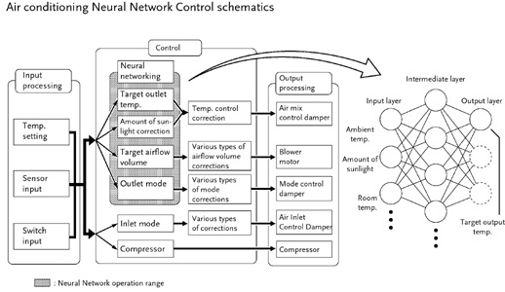

Interior air quality is constantly monitored by a nitrogen oxide sensor located in front of the air conditioning condenser. This controls the flow of air from the outside according to its quality and helps the purifier keep the air inside the car as clean as possible. A new active charcoal filter and a dust collector work to remove dust and pollen and are eight times more effective in neutralising odours than before.

Inside the cabin there are numerous air outlets linked to the system. Even air distribution is further aided by the vents in the centre of the dashboard oscillating gently when the air conditioning is activated. Each vent has its own motor and the vent on the passenger side can detect when someone is sitting next to the driver and direct air flow towards them. A dual switch enables the vents to steer air flow to the rear seats as well.

The system’s advanced neural network control simulates the way in which the human brain reacts to changes in temperature. Previous automatic air conditioning systems responded to fixed calculation from sensor information, but this system collects and stores a range of data collected in different environmental conditions to provide superior control and comfort. For example, if one side of the car is subject to hot sunshine, it will automatically deliver more cooling air to that part of the vehicle.

Efficient operation of the climate control is supported by the use of a variable capacity compressor and a damping pulley to drive the unit in place of a clutch. This helps remove the air conditioning ‘shunt’ effect that can be experienced at low driving speeds and improves energy conservation performance.

ENHANCED NAVIGATION AND COMMUNICATIONS SYSTEMS
The centrally mounted seven-inch multi-display LCD screen provides the controls for the climate control, audio and navigation functions and also transmits images from the Lexus rear view camera. Touch-screen operation makes it simple to use, but many functions can be operated hands-free, using a voice recognition system that will respond to around 300 different spoken commands.

The new LS430 also employs BluetoothTM technology to enable wireless use of personal data equipment and mobile telephones. This makes on-board communications both simpler and, above all, safer.

“Bluetooth is an integral part of the Lexus Navigation system in the LS430,” says Chief Engineer Yoshida. “The touch-sensitive central screen and voice activation are traditionally the most convenient ways of using the system, but BluetoothTM allows its functionality to extend even further. For example it allows the driver to use his or her mobile phone as a hands-free unit without any special conversion. It also enables secure transmission of data to and from lap-tops or personal organisers and the on-board system.”

THE ULTIMATE IN CAR AUDIO SYSTEMS
Standard equipment in the new LS430 is a three-band radio, cassette player and in-dash single-feed six-disc CD autochanger, feeding through a network of 11 speakers.

The LS430 in the UK offers the ultimate in car audio as standard equipment, thanks to Lexus’s collaboration with Mark Levinson, designer of exclusive home and concert sound systems. The link with Mark Levinson is based on the conviction that Lexus models alone have sufficiently fine acoustic qualities to allow occupants to appreciate the subtle details and nuances of sound reproduction that distinguish the best audio systems from those that are merely good.

The Mark Levinson audio system uses a 350W power amplifier and 11 custom designed speakers, linked to an AM/FM radio, cassette player and CD player with six-disc autochanger.

SATELLITE NAVIGATION WITH ELECTRONIC TRAFFIC AVOIDANCE
The LS430 is equipped with touch-screen DVD-based Lexus Navigator system with full mapping and Electronic Traffic Avoidance (ETA) to provide intelligent route planning that continuously monitors traffic conditions.

With ETA, live traffic information is automatically fed into the navigation system enabling the car not only to warn the driver of a traffic problem ahead on a pre-programmed route, but also to plot a way around the congestion. There should be no danger of getting lost, even if the driver is on unfamiliar territory.

ETA receives a constant stream of coded traffic information via an FM radio signal that is received even when the car radio is switched off. ETA decodes the messages from various traffic monitoring services, including police forces, to give the driver advanced warning of incidents and congestion.

If the driver is following a route using the car’s satellite navigation system, ETA will automatically offer an ‘avoid traffic’ option and work out a new route.

If the driver is not using the satellite navigation when the traffic warning is received, simply plotting a destination into the navigation system will trigger the ‘avoid traffic’ function.

ETA benefits motorists in a number of ways, not least in time saved, reduced stress and no petrol wasted sitting in traffic jams. A further benefit is that the system requires no additional handsets or subscription fees.

INCREASED STORAGE SPACE
A new location for the CD autochanger has allowed for a larger dual glove box to be fitted. Elsewhere cabin storage points have been made larger and more convenient to use. The Lexus attention to detail extended to determining the speed at which the glove compartment, coin box, overhead console and other lids and covers should open to convey the highest level of quality.

The cupholders are designed to hold 500cc cups and slots have been made in the sides to enable mugs with handles to be carried securely. The coin box in the centre console is five times bigger than before and is now brightly lit for easier use at night. It also offers extra space for credit cards, bills and other small items. A card holder is conveniently integrated into the sun visor.

A new two-level console box has been positioned between the front seats, with 2.3 litres of space in the upper section and 4.6 litres in the lower. The upper tray slides back as the lid is opened, giving access to the lower section without having to empty the top. When closed, the padded lid acts as an armrest, trimmed to match the rest of the interior. Large items can also be carried in the front door pockets, fitted with damped covers.

For rear seat passengers, a cool box is fitted in the ski-hatch in the back seat. The hatch can be used to help carry longer items, or provide access to the boot from the cabin while on the move.

THE NEW LEXUS LS430: DYNAMICS FOR GREATER DRIVING PLEASURE

The first generation Lexus LS400 was the original ‘whispering giant’, a car that combined powerful performance with unheard of levels of refinement. The new LS430 maintains that tradition with its unparalleled blend of performance, quality and efficiency. Levels of noise, vibration and harshness are lower than ever and the car enjoys even better driving dynamics and involvement for the driver. The latest developments in powertrain technology yield improved fuel consumption and lower exhaust emissions, enabling the LS430 to meet Euro IV standards without any of its components having to be changed.

The double overhead-cam, 32-valve, 4.3-litre V8 engine develops 278bhp at 5,600rpm and 417Nm of torque at 3,500rpm and is combined with the all-new Super ECT electronically-controlled six-speed sequential automatic transmission. This enables it to power the LS430 from nought to 62mph in 6.3 seconds. A link between the transmission and the engine management system allows for a momentary reduction in torque that renders gear changes almost imperceptible.

The engine uses the drive-by-wire ETCS-i (Electronic Throttle Control System-intelligent) which governs the throttle not just by pedal position, but also in relation to vehicle speed and engine rpm. It works in conjunction with the engine’s intelligent variable valve timing (VVT-i), which produces unrivalled tractability and smoothness by optimising the valve overlap throughout the engine speed range, rather than just at one or two set speeds. The result is more torque across a wider rev band, making the car feel more responsive in all driving conditions and giving the driver confidence with the power to make effortless passing manoeuvres.

Reducing the friction of moving parts has made a significant contribution to bringing down NVH levels and fuel consumption. The use of lead-free alloys in components such as valve seats and connecting rods also helps protect the environment and improved cooling in the cylinder head increases combustion efficiency and reduces exhaust emissions.

SIX-SPEED SUPER ECT-i AUTOMATIC GEARBOX
The new six-speed Super ECT-i electronically controlled intelligent automatic transmission is one of the most significant technical features of the new LS430. A first for Lexus, this transmission enhances driving dynamics by using a wider range of closer gear ratios than in the previous, five-speed automatic gearbox. This improves acceleration, quietness of operation and fuel efficiency.

Gear Ratios | New LS430 | Previous LS430
First | 3.296 | 3.357
Second | 1.958 | 2.180
Third | 1.348 | 1.424
Fourth | 1.000 | 1.000
Fifth | 0.725 | 0.753
Sixth | 0.582
Reverse | 2.951 | 3.431

The transmission can adapt its shift pattern to suit individual driving style and road conditions. It is also equipped with an advanced multi-mode facility. Moving the gearshift lever into the S position allows the driver to select the shift ranges manually. Moving the lever forwards changes the range up and backwards changes it down. Even in this mode, the transmission’s artificial intelligence capability will allow gears to be selected from a four-gear or even three-gear programme to maximise performance.

Shift range indicator | Shift range | Usable gear
D | 6 | 6th ↔5th ↔4th ↔3rd ↔2nd ↔1st
5 | 5 | 5th ↔4th ↔3rd ↔2nd ↔1st
4 | 4 | 4th ↔3rd ↔2nd ↔1st
3 | 3 | 3rd ↔2nd ↔1st
2 | 2 | 2nd ↔1st
1 | 1 | 1st

The number of parts in the transmission has been reduced, using new technology and components such as triple planetary gears. This has helped Lexus engineers create a gearbox that is almost the same size and weight as the previous five-speed unit. Smooth performance in all driving conditions has been helped by development of the friction materials and the automatic transmission fluid (ATF).

IN SEARCH OF SILENCE
In all aspects of dynamic development, Lexus has placed a particular emphasis on achieving as near silent performance as possible and ultra-low NVH characteristics. Detail changes include refinement of the air cleaner element and resonator to reduce inlet noise; revised front mountings for the engine to reduce vibration on idling; and changes to the rear engine mounts to help reduce noise from the transmission.

The exhaust system has been refined, too, with careful control of back pressure and the use of stainless steel manifolds. Cooling scoops have been added to the heat shields and the catalytic converters have been positioned to shorten their warm-up time, all of which contributes to greater efficiency. Where appropriate, exhaust components have been shaped to improve the car’s underfloor aerodynamics.

“The Lexus LS430 has a very low background noise, achieved by a totally balanced reduction in interior sound, matching characteristics such as wind noise with road noise and the sound of the engine, rather than simply trying to exclude everything,” says Jos de Boes, General Manager of Total Vehicle Assessment and Vehicle Engineering for Lexus in Europe.

AIR SUSPENSION FITTED AS STANDARD
The LS430 offers electronically controlled air suspension as standard. It is the first system in the world to use the non-linear H∞ control method, which offers nine different programmes rather than just the three provided by most other systems. These control the damping to deliver world-beating stability and ride, maintaining vehicle ride height regardless of the number of passengers or load weight. At high speed, the ride height is automatically lowered to improve stability and aerodynamic performance.
Front air suspension | Rear air suspension

The improved front and rear suspension and the LS430’s well-balanced 53/47 per cent weight distribution combine to provide an exceptionally flat ride and straight line stability. These qualities are particularly well suited to European driving conditions, where motorway cruising speeds are higher than in Japan and the USA and the density of traffic demands faster steering and braking responses.

“The suspension is perhaps the biggest change in the new LS430,” says Jos de Boes. “The previous model was designed with the emphasis on the coil-sprung version. With this model, the air suspension system is the focus of refinement and development to give enhanced driving dynamics and stability at any speed, while maintaining the legendary Lexus ‘magic carpet ride’ refinement.

“The new LS430 offers everything the European driver expects in terms of responsiveness and feedback, but from day one the target was to maintain ride refinement, too. The ‘Sport’ mode creates a firmer ride, which is flat and well damped, but not ‘busy’. In normal mode, the LS430 gives its legendary smooth ride, but maintains a higher degree of stability at speed.”

The engineering team is particularly proud of the increase in wheel diameter from 17 to 18 inches, something it has achieved without compromise in road noise or ride comfort. The change brings significant advantages in terms of handling, driver feedback and roll resistance.

The suspension design makes extensive use of lightweight aluminium and features new bearings, retuned bushes and a long wheel stroke to aid comfort and responsiveness. At the rear, the longer stroke helps improve comfort and traction on bumpy surfaces, helped by greater rigidity in the wide-span rear suspension arms. Monotube shock absorbers have been adopted, which use a combination of oil and high pressure gas as damping mediums. This helps ensure natural, linear responses to steering input, excellent grip and a flat ride.
The positive developments in handling and steering are matched by changes to the brakes. A long-stroke, small diameter master cylinder system reduces the amount of pedal stroke required to operate the brakes and provides better braking feel. The four-pot aluminium callipers at the front and two-pot versions at the rear have been made more rigid for excellent braking performance and, again, improved feel.

Larger, ventilated brake discs at the front and rear ensure excellent repeat braking performance. Cooling and heat resistance has been improved by creating larger ventilation holes in the discs. Safe and efficient braking in an emergency is optimised by electronically controlled Brake Assist, a four-channel anti-lock system and Vehicle Stability Control (VSC).

MULTIPLEX WIRING
The advanced electronics and technology used in the new LS430 have been enabled by a step forward in the application of multiplex wiring. The systems uses a CAN (Controller Area Network) that enables the car’s wiring system to cope with several different functions simultaneously. The CAN handles all the electronic communications for the engine, chassis and air suspension at the same time as the functions of the BEAN (Body Electronics Area Network), which include all the interior controls. Using this system significantly reduces the complexity and the weight of the car’s wiring harness.

“Like many Lexus improvements, it’s a hidden improvement. If you are driving the car you will never notice it, but those are the sort of the improvements in the new LS430 of which I am most proud,” says Chief Engineer Morita Yoshida.

THE NEW LEXUS LS430: RAISING THE STANDARDS IN PASSIVE AND ACTIVE SAFETY

PASSIVE SAFETY

Ten airbags as standard
Not only is the cabin of the new Lexus LS430 one of the most luxurious you will find on four wheels, it is also one of the safest. The rigid passenger cell is protected by front and rear crumple zones and features the latest generation Supplemental Restraint System (SRS) technology. For the first time in Europe, driver and front seat passenger knee airbags are offered together, among no fewer than 10 airbags.

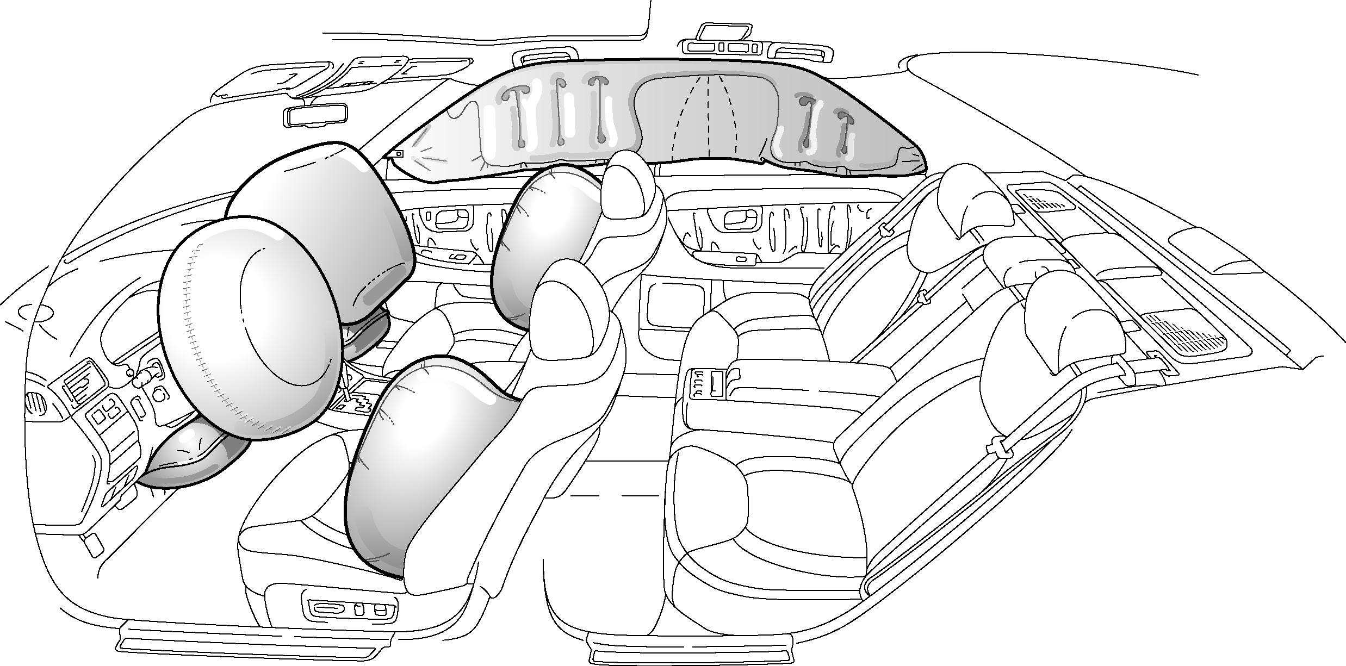

The dual front airbags have two-stage, variable force activation. Sensors determine the force of inflation in the event of a collision in order to deliver the optimum protection. These intelligent airbags, by neither under nor over-inflating greatly improve the security of drivers and passengers. Full inflation will only take place at speeds above 16mph (26km/h). The new LS430 is designed to exceed the Euro NCAP five star standard for crash safety.

Leg injuries are a common consequence of front-end impacts. The LS430 provides new protection against such injuries with the first European provision of both a driver and front seat passenger knee airbag. The airbag deploys from the lower section of the instrument panel simultaneously with the front airbag, helping protect the legs from hitting the steering column and lower part of the dashboard. It has also been found to help reduce head and chest injuries by limiting movement of the pelvis and rotation of the torso in a major impact.

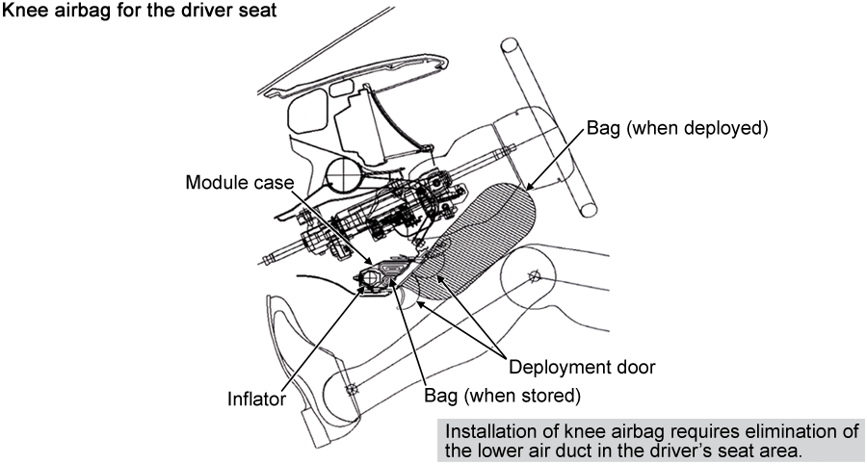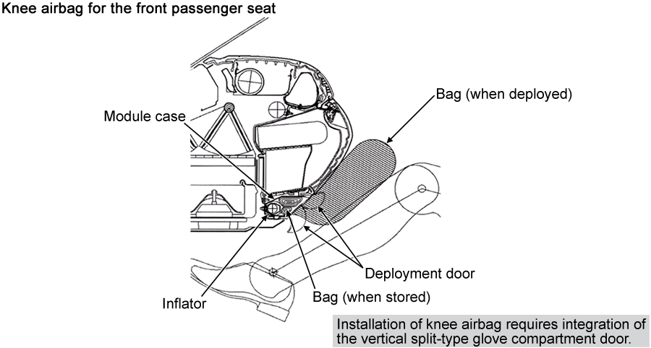

Curtain shield side airbags are also fitted as standard. Housed in the door and roof side sections, they inflate at the same time as side arbags mounted in the front seats to cover the front and rear side window areas.

Effective seatbelts and WIL seats
Both front and outer rear seats are fitted with seatbelts with pretensioners and force limiters.

In a collision, the pretensioners automatically take up any slack in the seatbelt, while the force limiters help prevent the the occupant suffering excessive force from the belt’s restraining action. Whiplash Injury Lessening (WIL) seats feature head restraints specially designed to help maintain body posture in an impact.

The front seats are designed to provide additional protection with thick seatback pads and an inner framework that work to support the occupants’ heads and backs in a secure position. Further assistance is given by the high and forward position of the head restraints. By reducing the motion between the head and torso, the WIL seats have been shown to reduce significantly the incidence of whiplash injury.

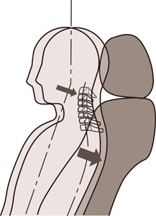

Pedestrian protection
The new LS430 has been designed and engineered for excellent passive safety performance and has achieved top class results in crash safety. Concern went beyond protection of the occupants to address the injury risks to pedestrians, too. A redesigned bonnet structure helps to reduce potential head injuries and all other areas of the car’s body have been designed to help lessen the damage to other vehicles and to pedestrians in the even of a collision.

Reinforced body structure
The new car provides a more rigid ‘survival cell’ thanks to development of welding methods, connections, components and structural design. Reinforcements in the front pillars and roof rails help prevent the cabin from deforming and reinforcements in the footwell, dashboards and cowl work to stop the cabin from breaking away from the dash in a major frontal impact.

Reinforcements in the roof, plus laser welding and special attention to the cross section of the side roof rails also work to prevent deformation of the cabin. To improve side impact protection, the centre ‘B’ pillars have been strengthened using high-tensile steel, which bears up to 100kg of tension. The rocker panels have been positioned higher and made into a crumple zone, improving their impact absorbing qualities.

Gussets on the impact bars in the rear doors help prevent intrusions into the cabin and the bars themselves in all doors have been positioned lower for better alignment with the path of potential side collisions. Passengers are offered further protection inside the car from impact absorbing pads on the doors and door trims.

Extensive use of high tensile steel in the body structure reduces the overall weight and aids efficiency. The body was carefully designed to maximise the size of the front and rear crumple zones and to take the risks of side impacts with SUVs into account.

ACTIVE SAFETY

AFS: Adaptive Front-lighting System
The new LS430 is equipped with AFS, Adaptive Front-lighting System. This provides greatly improved visibility when cornering by turning the dipped headlight beam towards the inside of the curve. This is achieved using an electronic controller which monitors vehicle speed and steering angle to calculate the optimum swivel of the lighting area.

The AFS controls the direction of each low beam headlight unit independently. Night-time vision is further enhanced by the use of high intensity discharge headlights with automatic levelling and cleaning systems.

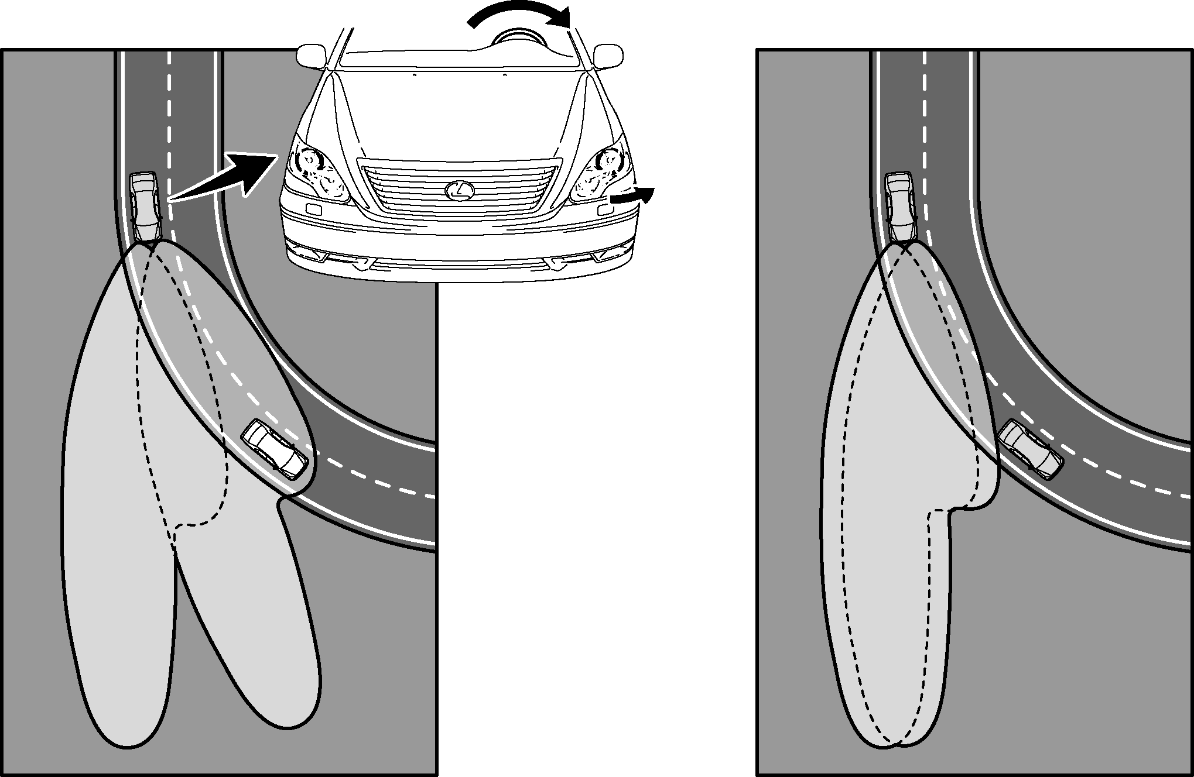

With AFS (lhd) Without AFS (lhd)

“The AFS lighting system is very important,” says Morita Yoshida, Chief Engineer of the new LS430. “We examined the details of night-time accidents and discovered that most happen because a driver simply doesn’t see a hazard until it is too late. We also found that once an accident happens, systems such as Vehicle Stability Control and passive safety protection are pretty well organised already. The big improvement in safety would come from enhancing hazard recognition. With AFS we made brighter headlamps and ensured that they pointed in the direction you are travelling. Through this device we can achieve higher hazard recognition and greater safety.”

Lexus Rear View Camera
The Lexus Rear View Camera is another example of how the new LS430 introduces advanced technology into its market segment for the first time.

The system uses a video camera mounted in the rear number plate surround. When reverse gear is selected, the view from behind the car appears on the navigation display screen, letting the driver make accurate reversing manoeuvres and minimising the risk of collision with low level objects, such as bollards and high kerbs.

The display can also superimpose guidelines over the rear view image to help the driver make accurate manoeuvres into a defined parking space. The guidelines include a vehicle width extension, which helps the driver gauge the width of the car, and a line indiciating the path of the vehicle in accordance with the steering angle.

Brake control system
The LS430 is equipped with Electronic Traction Control (TRC), with electronically controlled Brake Assist (BA) to maximise performance in an emergency, plus Electronic Brakeforce Distribution (EBD), four-channel ABS and Vehicle Stability Control (VSC).

The TRC and ABS help maintain vehicle stability under acceleration or braking and the VSC works to ensure control during cornering. The VSC system monitors the vehicle’s behaviour under cornering and, if required, uses the ABS and TRC sensors to apply small amounts of asymmetric braking to correct oversteer or understeer before they occur.

EBD uses the ABS sensors to equalise the distribution of front and rear brakeforce. BA interprets a quick push on the brake pedal as emergency braking and supplements the power applied to maximise braking, in conjunction with the ABS. This helps overcome some of the problems commonly witnessed in emergency situations, particularly with inexperienced drivers, where pressure on the brake pedal is not great enough or not sustained. BA is designed so that the driver doesn’t discern anything unusual about the braking operation. When the driver eases up on the brake pedal, the system automatically reduces the amount of assistance it applies.

Tyre pressure monitor
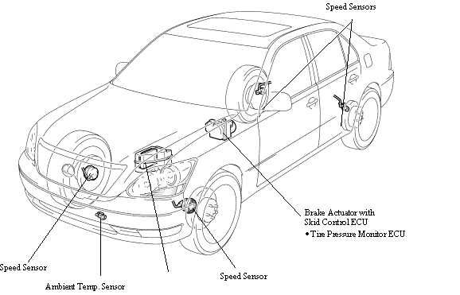
For convenience and safety, the new LS430 is equipped with a tyre pressure monitor system. This continuously checks all the tyres and sends a signal if there is a loss of pressure or if the tyre is defective. This minimises the risk of a high speed blow-out. It can be programmed for two different sets of tyres, if required.
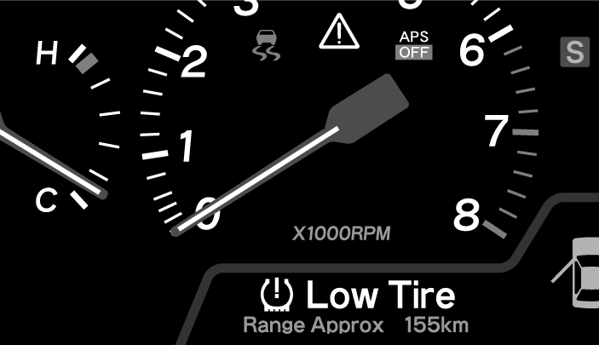

LED tail lamps
Adding both style and safety, the new LS430 uses light emitting diodes (LED) for the rear combination lamp units rather than traditional filament bulbs. In the case of the brake lights, their rapid response time is a significant safety feature. The LED elements illuminate up to 10 tiimes faster than a conventional lamp, between two and 15 milliseconds as opposed to between 150 and 200. This equates to an extra six metres of reaction time for the driver following, when travelling at 60mph.

Rain sensor
Visibility in poor weather is helped by the provision of an automatic rain-sensitive windscreen wiper system. For smoother operation and longer life, the rubber wiper blades are coated with graphite. The sensitivity of the wiper sensors can also be adjusted to suit individual preference.

Using longer wiper blades and fitting a new motor magnet has eliminated the wiper slapping noise. The delay in the wiper action after washer liquid has been sprayed on the screen is now computer controlled to match vehicle speed.

Water repellent glass
Visibility is further improved by the used of water repellent glass in the side windows. The door mirrors also have a special coating to reduce the accumulation of water droplets and are fitted with a new high performance heater to remove frost or misting quickly.

LS430 EQUIPMENT LIST

SAFETY | LS430
Driver & front passenger airbags | ✓
Driver & front passenger side airbags | ✓
Driver & front passenger knee airbags | ✓
Front and rear curtain shield airbags | ✓
Passenger airbag detection function | ✓
Fuel cut-off safety system | ✓
Anti-lock braking system with EBD and Brake Assist | ✓
Ventilated front disc brakes | ✓
Ventilated rear disc brakes | ✓
Vehicle stability control | ✓
Traction control | ✓
Speed sensitive power steering | ✓
Electronic sensing front seatbelt pre-tensioners with force limiters | ✓
Five three-point seat-belts and headrests | ✓
Seat integrated front seat belt anchorage and support | ✓
Seat belt warning system | ✓
Multi-link windscreen wiper system | ✓
Foot operated parking brake | ✓
Upper interior head impact protection | ✓
All-round double wishbone suspension | ✓
Rigid high-tensile steel cabin cage | ✓
Side impact door bars with additional protection from SUV impact | ✓
Front and rear ultrasonic parking radar sensors | ✓
Rain sensitive windscreen wipers | ✓
Heated exterior rear view mirrors | ✓
Laminated and water repellant-coated front side windows | ✓
Interior/exterior photochromic anti-glare rear view mirrors | ✓
Lexus Parking Assist Monitor | ✓
INSTRUMENTS & CONTROLS
7.0 inch LCD touch-screen multi-display | ✓
Lexus Optitron dashboard meters | ✓
Electric headlamp levelling | ✓
Digital odometer/trip meter | ✓
Lexus DVD Navigator System with voice recognition and Electronic Traffic Avoidance (ETA) | ✓
AUDIO & COMMUNICATIONS
Mark Levinson® 11-speaker audio system with three-waveband radio and Dolby cassette | ✓
RDS radio with one–touch tuning and presets | ✓
Rear passenger controls for audio system | ✓
In-dash 6 disc CD autochanger | ✓
Bluetooth® connectivity for compatible items | ✓
COMFORT & CONVENIENCE
Smart key entry system | ✓
Self levelling air suspension | ✓
Soft close facility for doors and boot lid | ✓
Rear cool box | ✓
Speed sensitive power assisted steering (PAS) | ✓
Snow mode for automatic gearbox | ✓
Electrically multi-adjustable steering column | ✓
Air conditioned front seats | ✓
Remote fuel flap release | ✓
Driver and front passenger vanity mirrors | ✓
Rear vanity mirrors | ✓
Cruise control | ✓
Front centre dual console box | ✓
Electric rear screen sunshade | ✓
Manual rear side window sunshades | ✓
Multi-function wood and leather steering wheel | ✓
Full leather steering wheel | OPT
Headlamp washer system | ✓
Rear footwell illumination | ✓

VENTILATION
Climate control air conditioning | ✓
All windows electric one touch up and down with anti-trap protection | ✓
Electric tilt/slide glass sunroof with shade and anti-trap | ✓
Rear compartment air conditioning with individual controls | ✓

SECURITY
Keyless entry system | ✓
Vehicle parts marking | ✓
Security window etching | ✓
Visible VIN | ✓
Double locking | ✓
Open/close locking facility for windows & sunroof | ✓
Steering column lock | ✓
Lockable glovebox | ✓

SEATING, UPHOLSTERY & TRIM
8-way electrically multi adjustable front seats with 4-way lumbar support | ✓
Electrically operated rear seats with memory functions | ✓
Electric vibro-massaging rear seats | ✓
Additional control for adjustment of front passenger seat | ✓
Front seat retractable arm rests | ✓
Heated driver, front passenger and rear seats | ✓
Full leather upholstery | ✓
Wood trim detailing | ✓

BODY EXTERIOR
Wave reflection High Intensity Discharge headlamps | ✓
Adaptive Front-lighting System | ✓
LED rear stop lights | ✓
Automatic light control system | ✓
18” alloy wheels with locking wheel nuts | ✓

LS430 TECHNICAL SPECIFICATIONS
ENGINE
Engine Type | 3UZ-FE
Valve Mechanism | 32 valve, DOHC, VVT-i
Block Material | Aluminium
Head Material | Aluminium
Displacement (cc) | 4293
Bore x Stroke (mm) | 91 x 82.5
Compression ratio | 10.5:1
Fuel Injection Type | EFI, L-Jetronic
Ignition System | Transistorised
Octane Rating | 95 or higher
Max. Power (bhp/rpm) | 278 @ 5,600
Max. Torque (Nm/rpm) | 417 @ 3,500
ACCELERATION (sec)
0-62mph | 6.3
Max. speed (mph) | 155
DIMENSIONS
Overall length (mm) | 5025
Overall width (mm) | 1830
Overall height (mm) | 1470
Wheelbase (mm) | 2925
Tread (mm) front | 1575
Tread (mm) rear | 1575
Overhang (mm) front | 865
Overhang (mm) rear | 1235
Coefficient of Drag (Cd) | 0.25
Minimum turning radius (m) | 5.3
Fuel tank capacity (L) Gallons | (84) 18.5

INTERIOR DIMENSIONS
Interior room length (mm) | 2080
Interior room width (mm) | 1535
Interior room height (mm) | 1165
Luggage capacity- Litres | 552
WEIGHTS (kg)
Kerb weight | 1830-1910
Gross vehicle weight | 2340
Towing capacity (w/brake) | 2000
Towing capacity (w/o brake) | 750

TRANSMISSION
Type | A761E
Gearbox type | Automatic Super ECT
Gear ratios
1st | 3.296
2nd | 1.958
3rd | 1.348
4th | 1.000
5th | 0.725
6th | 0.582
Reverse | 2.951
Differential Gear Ratio | 3.615
FUEL CONSUMPTION/EMISSIONS/VED RATING
Combined | 24.8mpg
Extra Urban | 33.2mpg
Urban | 17.3mpg
CO₂ emission (g/km) | 270g/km
VED Band | E

SUSPENSION
Front | Double wishbone
Rear | Double wishbone

BRAKES
Front (size mm) | Ventilated Disc (315x30)
Rear (size mm) | Ventilated Disc (310x16)
Parking Brake Type | Drum
Master Cylinder Type | Dual servo
Brake Booster Type | Tandem
Additional features | Four sensor, four channel Anti-lock Braking System (ABS) with Electronic Brake Distribution (EBD) and Brake Assist

STEERING
Type | Rack and pinion
Gear Ratio | 16.4
Power Steering Type | Integral-speed sensitive
Turns (lock to lock) | 3.6

TYRES AND WHEELS
Tyre size | 245/45 R18
Wheel size | Alloy 7.5 J x 18

