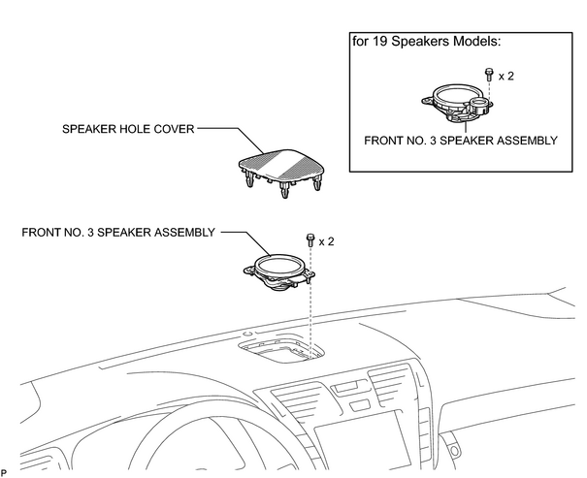
2. INSPECT FRONT NO. 3 SPEAKER ASSEMBLY
(a) Measure the resistance according to the value(s) in the table below.
Standard resistance:
Tester Connection | Condition | Specified Condition
1 - 2 | Always | Approx. 6 Ω  *1
1 - 2 | Always | 5 to 7 Ω  *2
HINT:
- *1: for standard models.
- *2: for 19 speakers models.

If the result is not as specified, replace the speaker assembly.

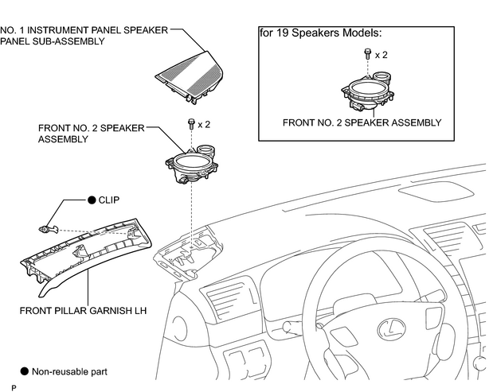

1. INSPECT FRONT NO. 2 SPEAKER ASSEMBLY  (a) Measure the resistance according to the value(s) in the table below.  Standard resistance:  HINT:  - *1: for Standard models.  - *2: for 19 speakers models.  If the result is not as specified, replace the speaker assembly. | 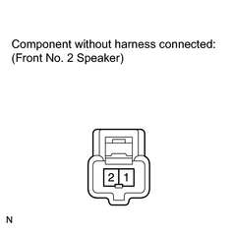
  Tester Connection | Condition | Specified Condition
  1 - 2 | Always | Approx. 6 Ω  *1
  1 - 2 | Always | 5 to 7 Ω  *2

REMOVAL
HINT:
- Use the same procedures for the LH side and RH side.
- The procedures listed below are for the LH side.
1. REMOVE COWL TOP VENTILATOR LOUVER RH
2. DISCONNECT CABLE FROM NEGATIVE BATTERY TERMINAL
CAUTION:
Wait at least 90 seconds after disconnecting the cable from the negative (-) battery terminal to prevent airbag and seat belt pretensioner activation.
NOTICE:
After the engine switch is turned off, the HDD navigation system requires approximately 6 minutes to record various types of memory and settings. As a result, after turning the engine switch off, wait 6 minutes or more before disconnecting the cable from the negative (-) battery terminal.
3. REMOVE NO. 1 SPEAKER HOLE COVER  (a) Using a screwdriver, detach the 4 clips and remove the hole cover.  HINT:  Tape the screwdriver tip before use. | 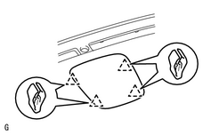
4. REMOVE FRONT NO. 3 SPEAKER ASSEMBLY
(a) Remove the 2 bolts.
(b) Remove the speaker and disconnect the speaker connector.
NOTICE:
Do not touch the cone part of the speaker.

