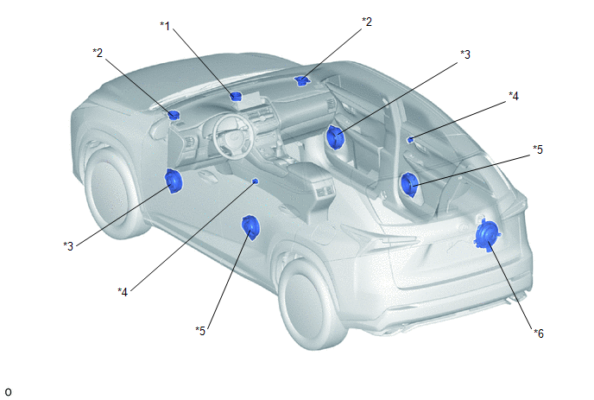
Location | Speaker Name | Quantity | Size | Impedance | Rated Input Power
*1 | Front No. 3 Speaker Assembly | 1 | 6.5 cm (2.6 in.) | 4 Ω | 20 W
*2 | Front No. 2 Speaker Assembly | 2 | 6.5 cm (2.6 in.) | 4 Ω | 20 W
*3 | Front No. 1 Speaker Assembly | 2 | 16 cm (6.5 in.) | 3 Ω | 26 W
*4 | Rear No. 2 Speaker Assembly | 2 | 2.5 cm (1.0 in.) | 4 Ω | 20 W
*5 | Rear Speaker Assembly | 2 | 16 cm (6.5 in.) | 4 Ω | 20 W
*6 | Rear No. 3 Speaker Assembly | 1 | 20 cm (7.9 in.) | 2.5 Ω | 32 W

