15-speaker System
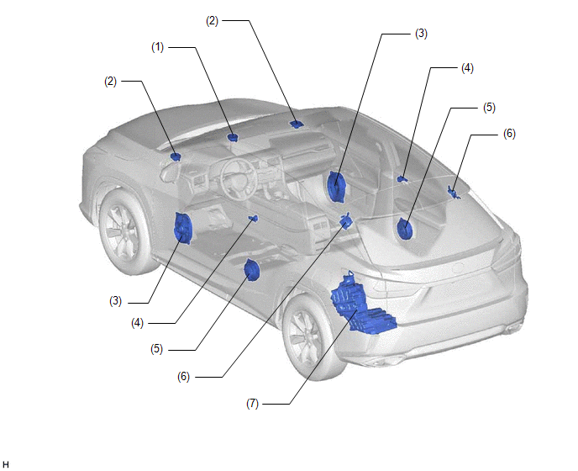
Location | Speaker Name | Quantity | Size | Impedance | Rated Input Power
(1) | Front No. 3 Speaker Assembly | 1 + 1 | 9 cm (3.5 in.) | Rated 8 Ω  (6.5 to 9.7 Ω) | 4 W
(2) | Front No. 2 Speaker Assembly | (1 + 1) x 2 | 9 cm (3.5 in.) | Rated 8 Ω  (6.5 to 9.7 Ω) | 4 W
(3) | Front No. 1 Speaker Assembly | 2 | 17 x 25 cm (7 x 10 in.) | 4.2 to 6.2 Ω | 9 W
(4) | Rear No. 2 Speaker Assembly | 2 | 2.5 cm (0.9 in.) | 4 Ω | 0.5 W
(5) | Rear Speaker Assembly | 2 | 17 cm (6.7 in.) | 3.6 to 5.6 Ω | 18 W
(6) | Quarter Side Speaker Assembly | 2 | 9 cm (3.5 in.) | Rated 8 Ω  (7 to 10.6 Ω) | 4 W
(7) | Rear No. 3 Speaker Assembly | 1 | 20 cm (7.8 in.) | 3 to 5 Ω | 12.5 W

