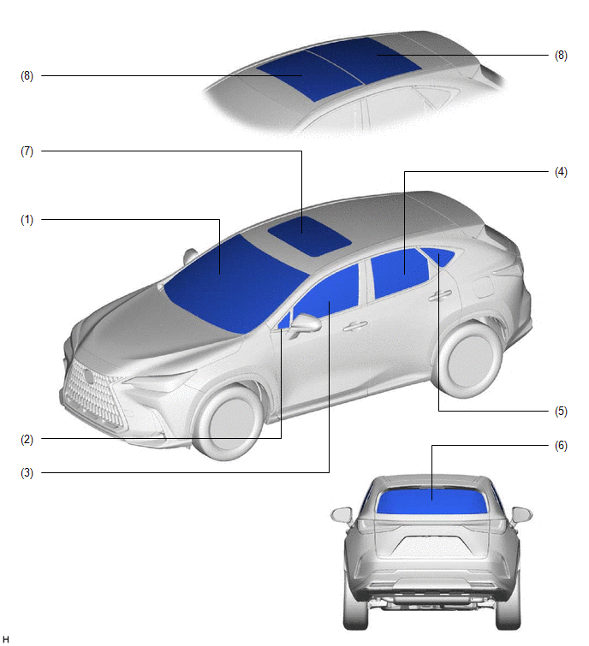
NO. | GLASS LOCATION | COLOR | GLASS TYPE | VISIBLE LIGHT TRANSMISSION RATE
*1: Except models with acoustic front door glass
*2: Models with acoustic front door glass
*3: Models with sliding roof
*4: Models with panoramic moonroof
*5: TMMC made models
(1) | Windshield Glass | Green | Laminated  - Acoustic  - Solar Energy Control*5 | Minimum 70%
(2) | Front Door Fix Window Glass | Green | Tempered  - UV Cut  - Solar Energy Control*5 | Minimum 70%
(3) | Front Door Glass | Green | Tempered*1  - UV Cut  - Solar Energy Control*5 | Minimum 70%
(3) | Front Door Glass | Green | Laminated*2  - Acoustic  - Solar Energy Control*5 | Minimum 70%
(4) | Rear Door Glass | Dark Gray | Tempered | Equivalent to 20%
(5) | Quarter Window Glass | Dark Gray | Tempered | Equivalent to 20%
(6) | Back Door Glass | Dark Gray | Tempered | Equivalent to 20%
(7) | Roof Window Glass*3 | Dark Gray | Tempered | Equivalent to 20%
(8) | Roof Window Glass*4 | Dark Gray | Tempered  - UV Cut  - IR Cut | Equivalent to 20%

