P0102
DTC P0100 Mass or Volume Air Flow Circuit
DTC P0102 Mass or Volume Air Flow Circuit Low Input
DTC P0103 Mass or Volume Air Flow Circuit High Input
DESCRIPTION
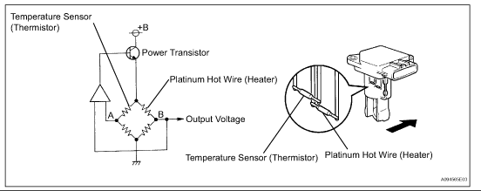
Top of Form  Bottom of Form | Top of Form  Bottom of Form
DTC Detection Condition
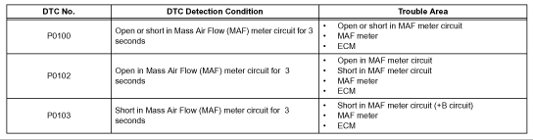
Top of Form  Bottom of Form | Top of Form  Bottom of Form
The Mass Air Flow (MAF) meter is a sensor that measures the amount of air flowing through the valve. The ECM uses this information to determine the fuel injection time and to prove appropriate air-fuel ratio. Inside the MAF meter, there is a heated platinum wire which is exposed to the flow of intake air.
By applying a specific electrical current to the wire, the ECM heats it to a given temperature. The flow of incoming air cools both the wire and an internal thermistor, affecting their resistance. To maintain a constant current value, the ECM varies the voltage applied to these components in the MAF meter. The voltage level is proportional to the airflow through the sensor, and the ECM uses it to calculate the intake air volume.
The circuit is constructed so that the platinum hot wire and the temperature sensor provide a bridge circuit, and the power transistor is controlled so that the potentials of A and B remain equal to maintain the predetermined temperature.
HINT: When any of these DTCs are set, the ECM enters fail-safe mode. During fail-safe mode, the ignition timing is calculated by the ECM, according to the engine RPM and throttle valve position. Fail-safe mode continues until a pass condition is detected.
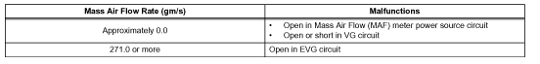
Top of Form  Bottom of Form | Top of Form  Bottom of Form
HINT: When any of these DTCs are set, check the air-flow rate by entering the given menus on the intelligent tester: DIAGNOSIS / ENHANCED OBD II / DATA LIST / PRIMARY / MAF.
MONITOR DESCRIPTION
Monitor Strategy
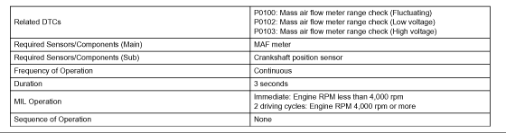
Top of Form  Bottom of Form | Top of Form  Bottom of Form
Typical Enabling Conditions
Top of Form  Bottom of Form | Top of Form  Bottom of Form
Typical Malfunctions Thresholds
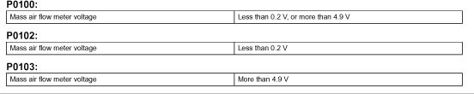
Top of Form  Bottom of Form | Top of Form  Bottom of Form
Component Operating Range
Top of Form  Bottom of Form | Top of Form  Bottom of Form
If there is a defect in the MAF meter or an open or short circuit, the voltage level deviates from the normal operating range. The ECM interprets this deviation as a malfunction in the MAF meter and sets a DTC.
Example: When the sensor output voltage remains less than 0.2 V , or more than 4.9 V , for more than 3 seconds , the ECM sets a DTC.
If the malfunction is not repaired successfully, a DTC is set 3 seconds after the engine is next started.
Wiring Diagram
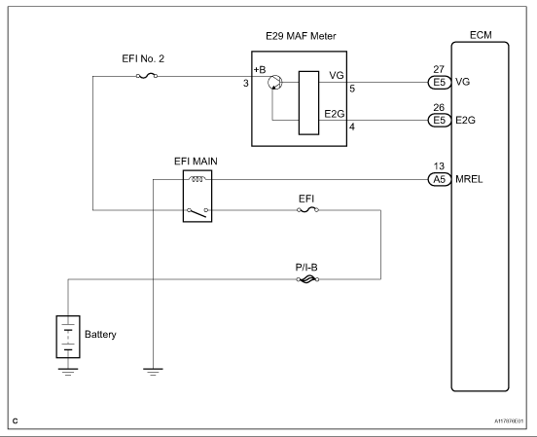
Top of Form  Bottom of Form | Top of Form  Bottom of Form
Step 1
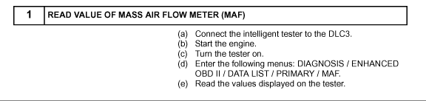
Top of Form  Bottom of Form | Top of Form  Bottom of Form
Step 1(Continued)-3
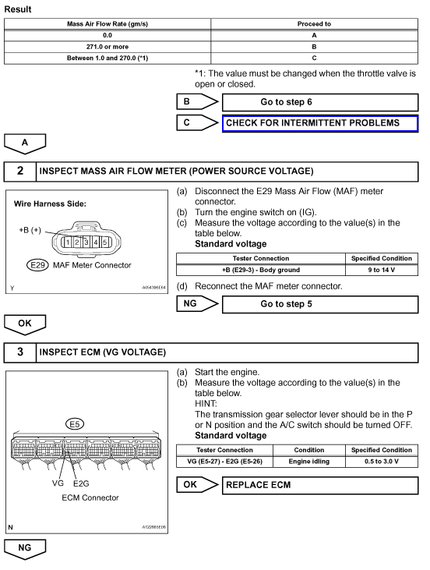
Top of Form  Bottom of Form | Top of Form  Bottom of Form
Step 4
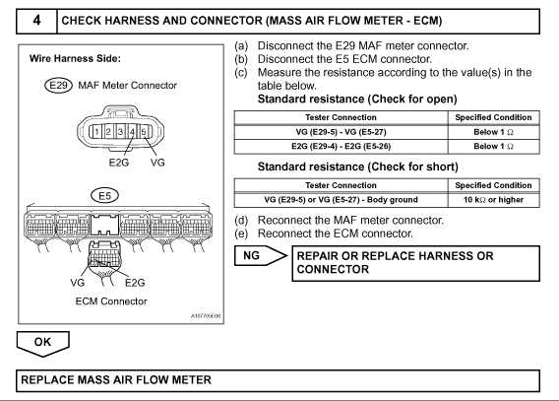
Top of Form  Bottom of Form | Top of Form  Bottom of Form
Step 5-6
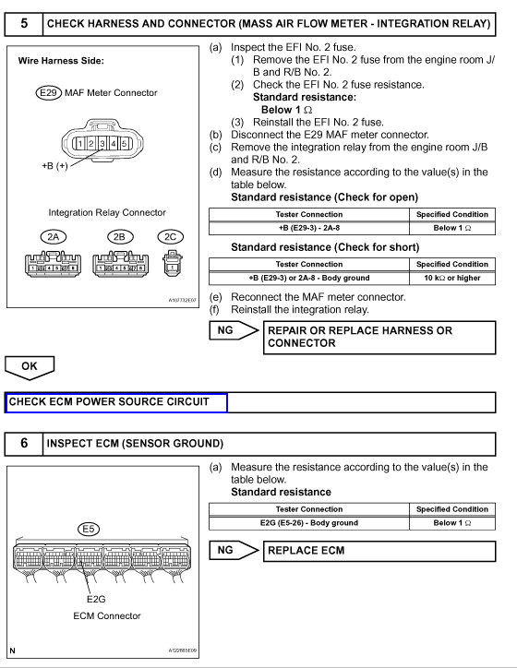
Top of Form  Bottom of Form | Top of Form  Bottom of Form
Step 6(Continued)-7
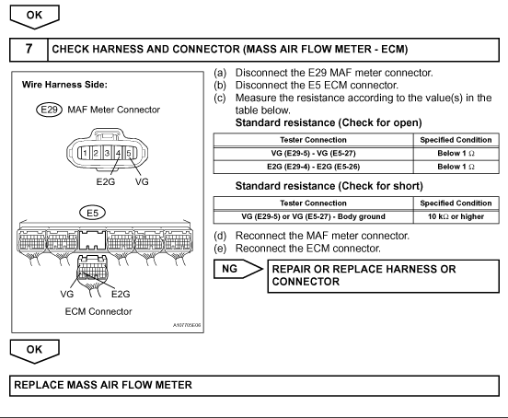
Top of Form  Bottom of Form | Top of Form  Bottom of Form
INSPECTION PROCEDURE
HINT: Read freeze frame data using the intelligent tester. The ECM records vehicle and driving condition information as freeze frame data the moment a DTC is stored. When troubleshooting, freeze frame data can be helpful in determining whether the vehicle was running or stopped, whether the engine was warmed up or not, whether the air/fuel ratio was lean or rich, as well as other data recorded at the time of a malfunction.

