Lexus RX300: OCV Oil Screens
Supplies Needed:
none
Tools Needed:
phillips screwdriver
10mm socket
long extension
socket handle
14mm socket
short extension
socket handle
Background:
There is no recommended service interval for the oil screens for the VVT oil control valves but I think it is a good idea to inspect them periodically to see if there is any indication of sludge buildup.
Procedure:
- Record odometer reading ______________ and date ____________
- ◻ Remove engine cover
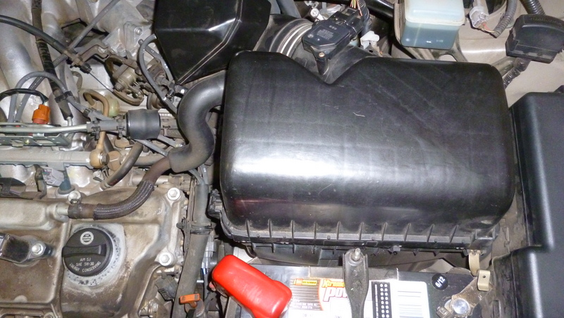
- ◻ Remove airbox
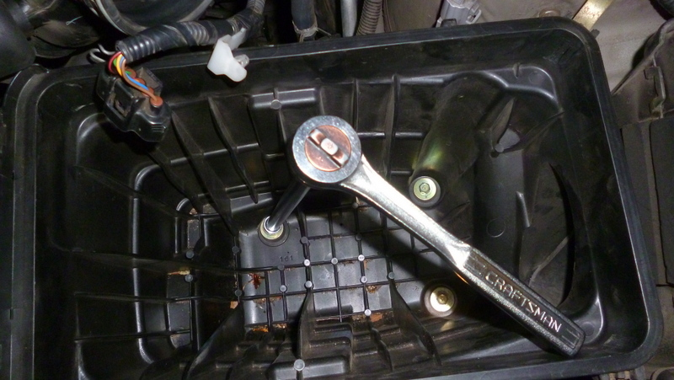

- ◻ Remove oil screen and inspect
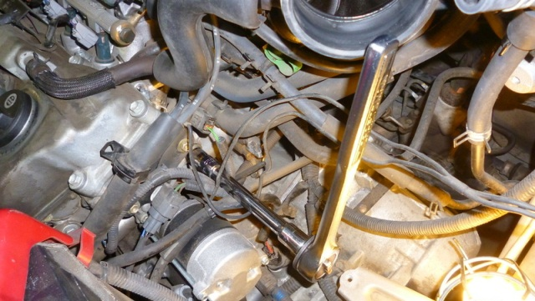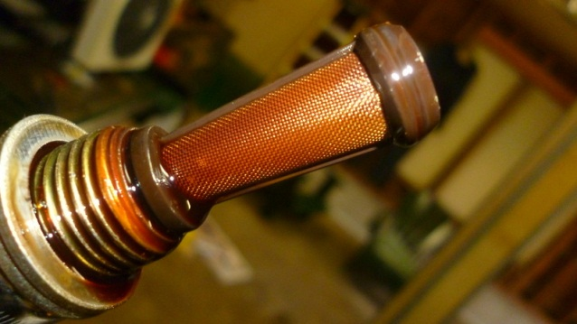
- ◻ Reinstall screen
- ◻ Reinstall airbox
- ◻ Reinstall engine cover
- ◻ Update maintenance log

