4. Because even register processing excessively it is one off, we cannot convey details, but the point a little just (laughing). The drink holder and the register are because with only checking and verifying the nail is fixed, shakily. When register installation is done in this state, pulling out the drink holder, when putting in place the beverage, it is shaky in the top and bottom. It is similar even in domestic specification, as a register for the driver's seat, but 2 place screws you stop the drink holder itself inside the dashboard and are fixed. When it tries to divert the one for driver's seat of the left handle to the one for suicide seat of domestic specification, the existing screw stop rib interferes to the harness and the glove compartment inside. Then, cutting off the existing screw stop rib, at a time inner part side 1 places front side 1 places it recreates the rib, provides new screw stop position. Inner part side the rib which is cut off was connected with [puraripea], front side modelling was administered. Always, using, you admire, but the resin adhesive, this “[puraripea]”…, it is truly firm. You think that strength above equality to the ABS resin which is the material of the drink holder itself has appeared. Because also heatproof temperature is the 100℃, there is no problem | 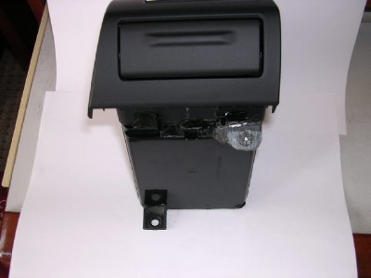
5. The installation register itself, inserting, respectively inserts the clip & the nail of 2 places. As for the inner part side screw stop rib of the new establishment producing the stay from the fixed screw of the ECU installing frame, fixing (the picture is not), the front side rib be embraced with the glove compartment locking, does the strength guaranty of the dashboard. | 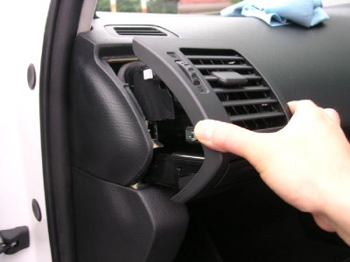
6. It is completion firm! Normally to suffer hardship, because the [chi] [ya] [tsu] it is, it emphasizes (the HKDRT) | 