Retrofit ACC (DYNAMIC CRUISE CONTROL ) ON LEXUS RX450H 2010 (APPLICABLE TO MORE )
The idea is to retrofit after study the schematics the ACC function only on those cars and NOT the complete collision system that includes changing the front seat belts and add seat belt ecu (F56,57)
1.So after studding the schematics for the RX450H I come up with the following list of parts :
-C1 ECU (DRIVING SUPPORT ECU ) 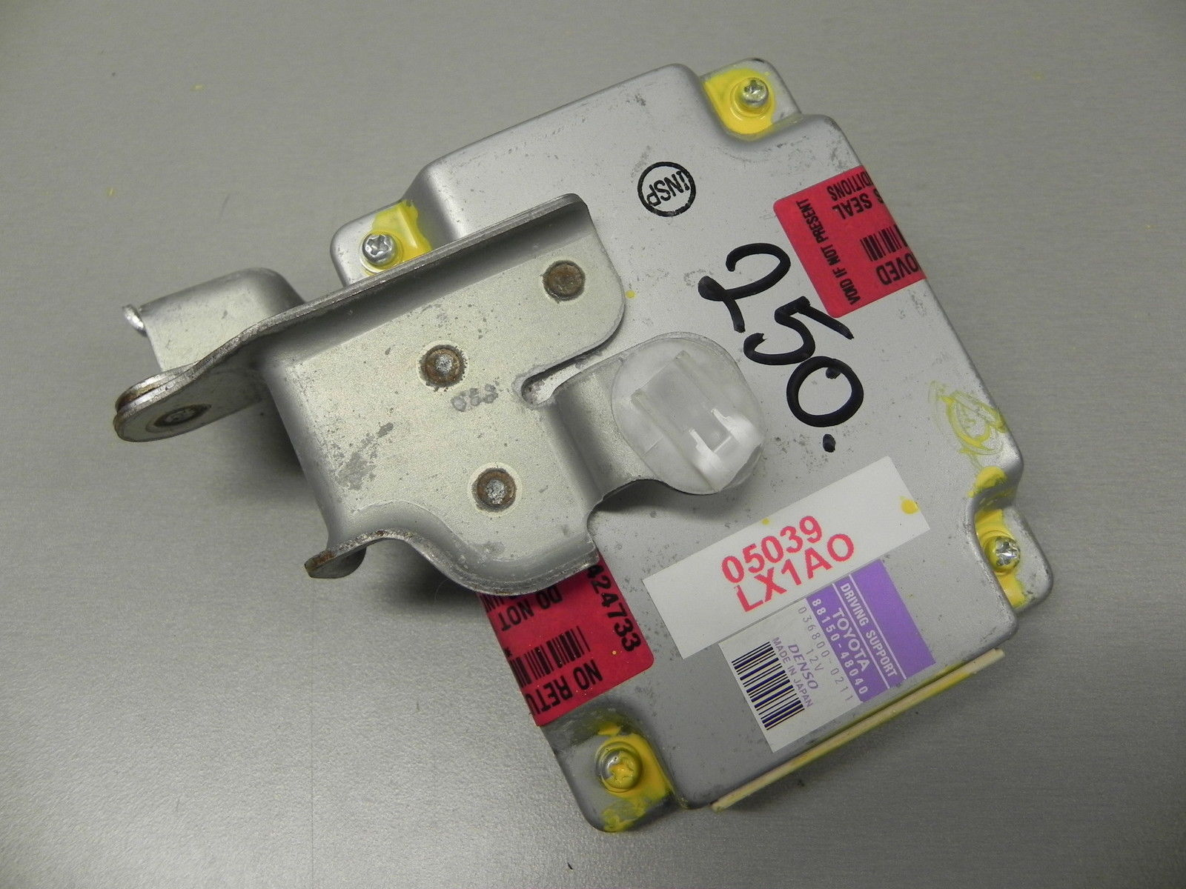
PART NO :88150-48040

-B1 MILLIMETER WAVE RADAR SENSOR
Part : 88210- ? ( not sure yet)
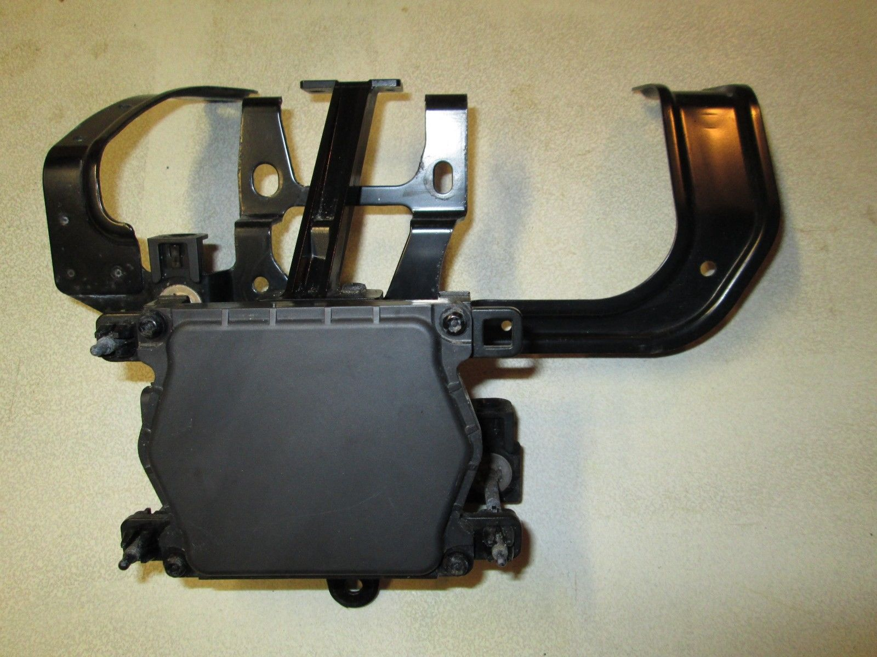
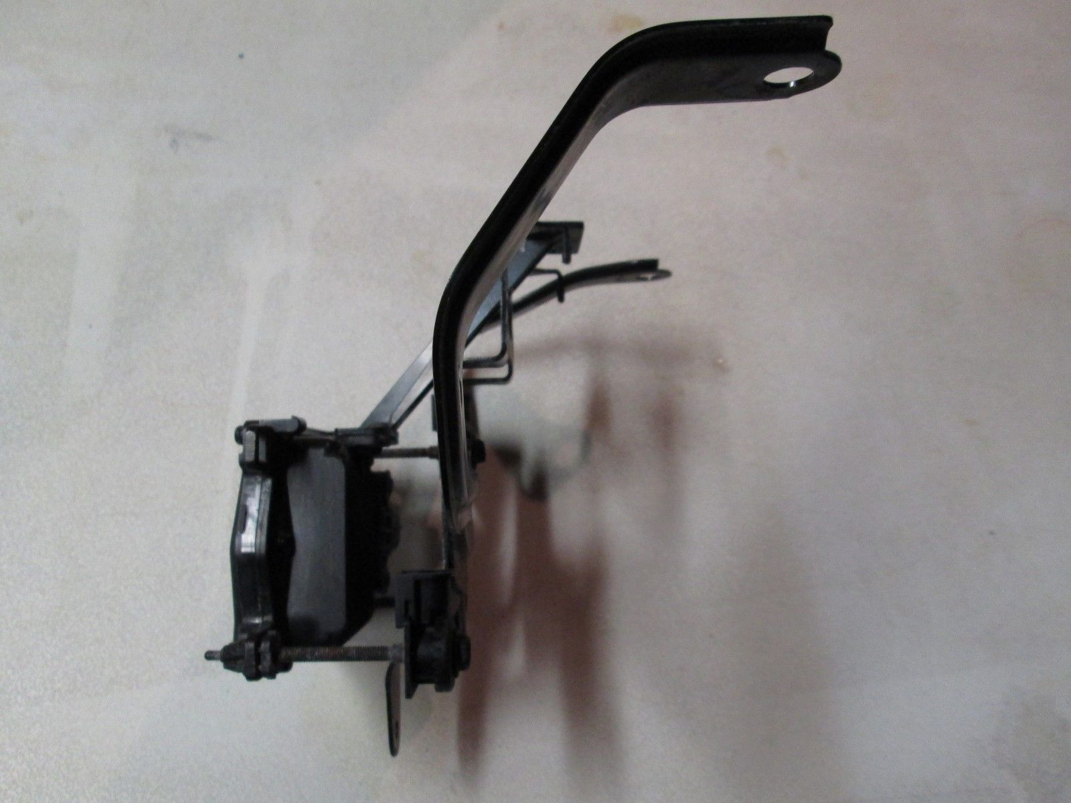
STEERING WHEEL ACC SWITCH ASSEMPLY (RIGHT ONE HAND ONLY) 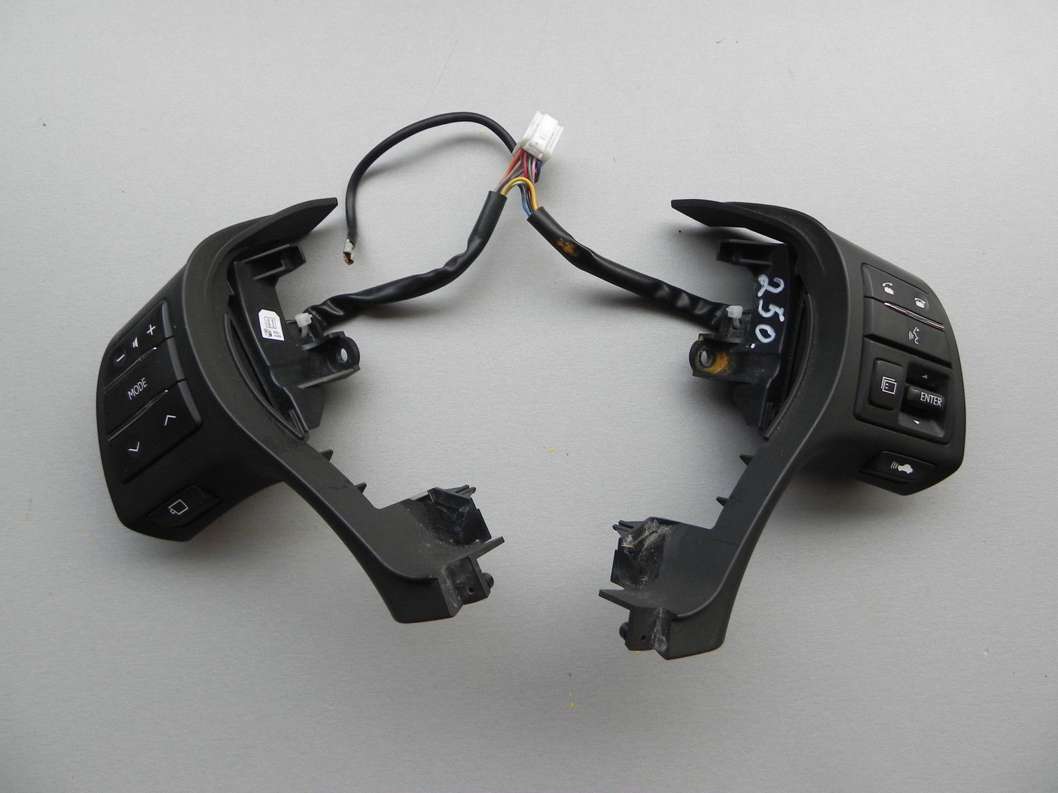
PART :75b934-0010 , 75b955-0010
CRUISE CONTROL STALK SWITCH 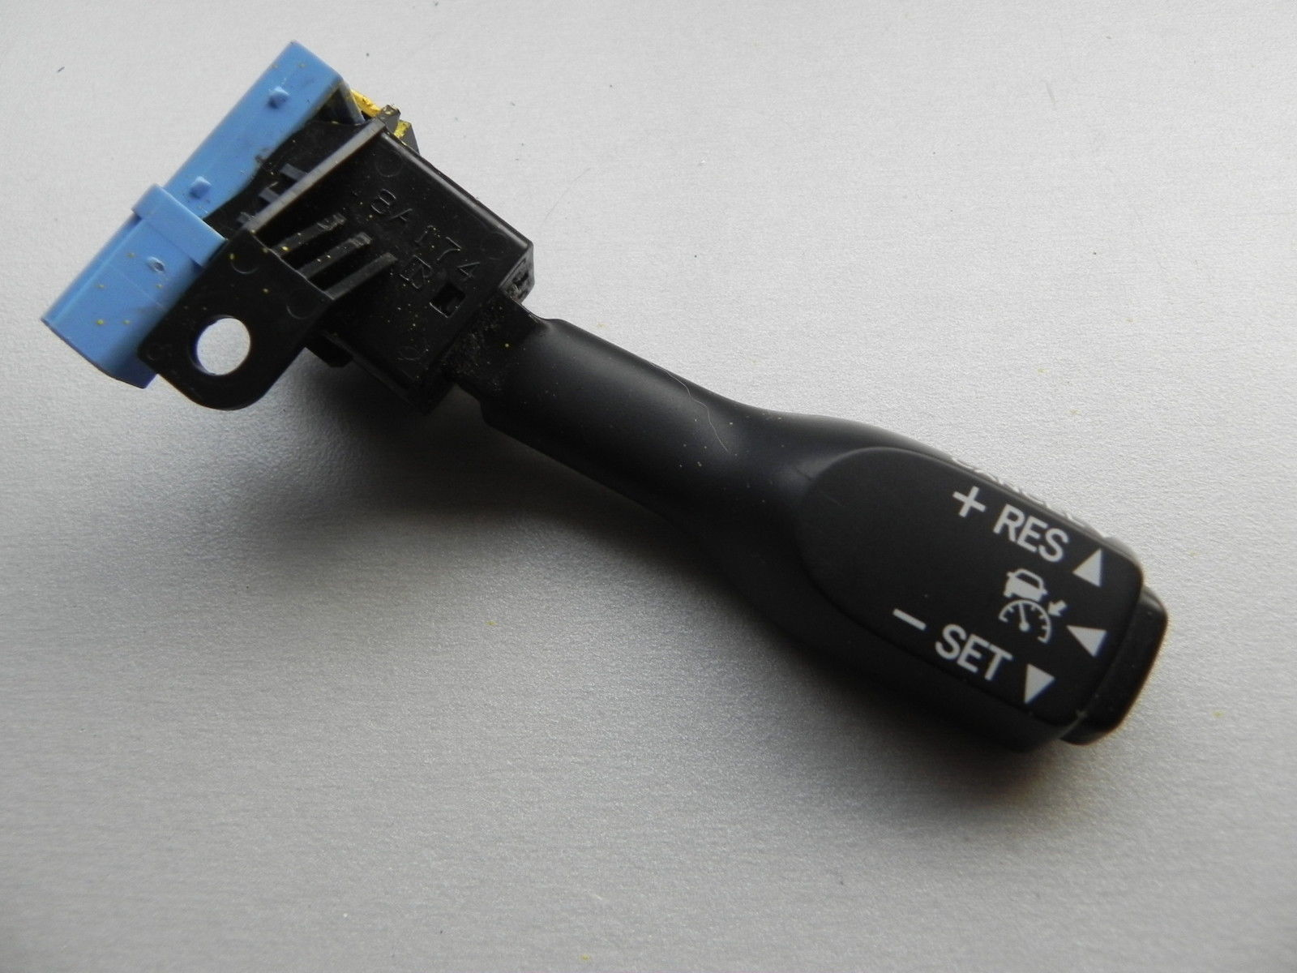
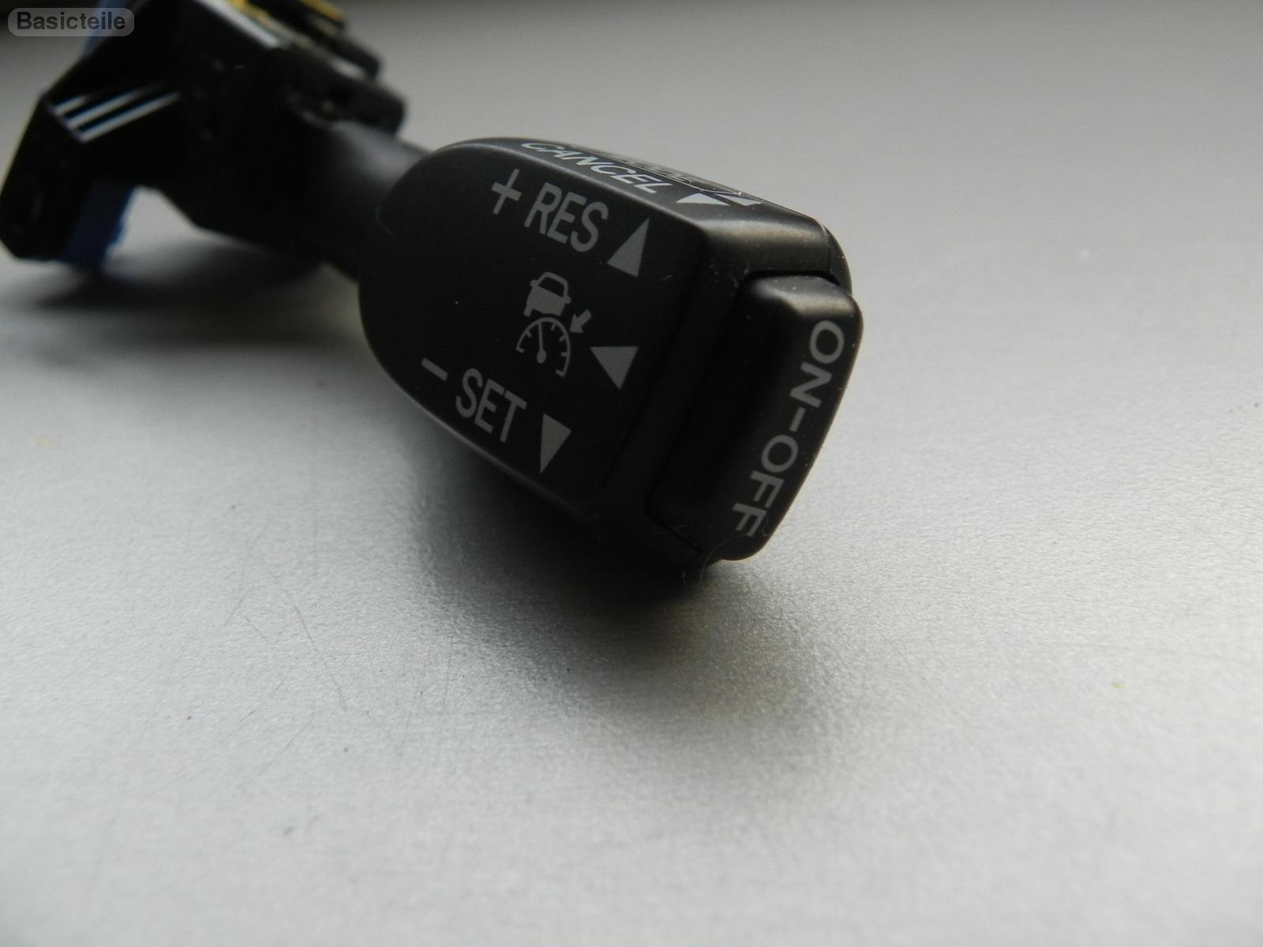

PART NO :LX1LK 05177
Front grill might need to be change as well ….

2.PLUGS AND CABLES ,FUSES
3.Connections:
Radar sensor plugs in the front of vehicle behind the front grill
There are 5 cables required via plug ab1 .power 12v comes from ab1 pin 6 gray cable that connects on pin 5 of the radar sensor ,also supply 12v on the plug ac1 pin 5 of the drivers ecu pin 30.
The supply comes from junction A62 PIN 6,and that goes to pin 1 of wire pink on IG ECU FUSE 2 10A
The rest of the wires on the sensor are ,negative power pin 2 from AB1 PLUG PIN 9 BLACK WIRE
PIN 4,3 ARE CONNECTING TO C1 DRIVING SUPPORT ECU PINS 38,15 VIA PLUG ACI PIN 16,15.
MOVING TO THE DRIVING ASSIST ECU C1 :
WIRES LEFT :
-GND PIN 25 VIA AC1 PIN 12 ,PIN 32 VIA AC1 PIN 1 THAT may or may not be connected to ground via an on off switch for bypass the module ( pre collision activation)
-pin 17 ( CAN BUS LOW) and 39 ( CAN BUS HIGH) via AC1 PLUG PINS 17 ,8 connect to the POWER MANAGEMENT CONTROL ECU F97 A
TO PINS 35A ,34A .(FIND A JUNCTION CONNECTOR SUCH AS F68 AND F67IF RHDRIVE)(CAN BUS )
THERE is a pin 22b from ccs of power management ecu that is for cruise control only.
Disconnect this as the acc feeds now from f93 junction 53/52 to plug af2 pin 2
There are 3 cables coming from steering wheel spiral cable sub-Assembly (f40 ) for the acc :
Pin 7a gray to plug AF8 PIN 8 ( MODE ON OFF ),PIN1A TO AF2 PIN 2 ,PIN 11A (DISTANCE CONTROL RH)
THOSE CABLES CONNECT TO DRIVERS ASSIST ECU AS FOLLOWS :
AC1 PLUG PIN 11 TO PIN 7 IS YOUR DISTANCE, PIN 3 AC1 IS CCS ,AND PIN 6 AC1 ON 10 IS YOUR ON OFF MODE.
I BELIEVE with the above connections and recoding the system with xhorse mvci it should be working .
ARIS DANIKAS
Electrical Engineer
Greece/S.Africa

