1. REMOVE BACK WINDOW UPPER PANEL TRIM
(a) Disengage the 4 claws, 5 clips and 4 guides to remove the back window upper trim panel as shown in the illustration.
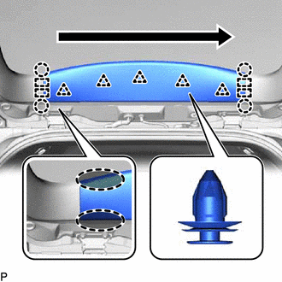
 | Place Hand Here
 | Order of Removal
2. REMOVE BACK DOOR TRIM COVER LH
(a) Disengage the 2 clips, 2 claws and 2 guides to remove the back door trim cover LH as shown in the illustration.
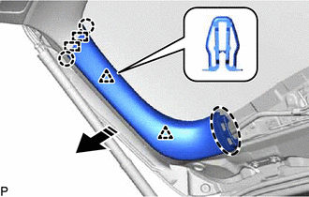
 | Place Hand Here
 | Remove in this Direction
3. REMOVE BACK DOOR TRIM COVER RH
HINT:
Use the same procedure as for the LH side.
4. REMOVE BACK DOOR LOCK COVER
(a) Disengage the 4 claws to remove the back door lock cover.
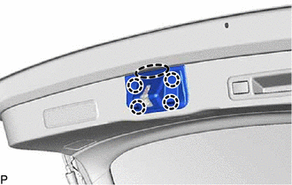
Place Hand Here
5. REMOVE BACK DOOR TRIM BASE
(a) Using a moulding remover, disengage the 4 claws to remove the back door trim base.
  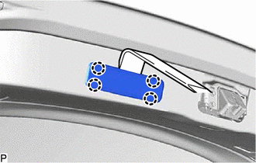
6. REMOVE DOOR PULL HANDLE
(a) Using a moulding remover, disengage the 6 claws.
  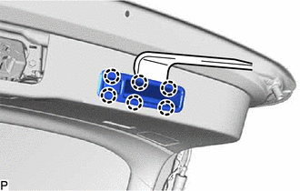
(b) Disconnect the connector to remove the door pull handle.
7. REMOVE NO. 1 LUGGAGE COMPARTMENT LIGHT ASSEMBLY
Click here
8. REMOVE BACK DOOR TRIM PANEL ASSEMBLY
(a) Disengage the 16 clips to remove the back door trim panel assembly as shown in the illustration.
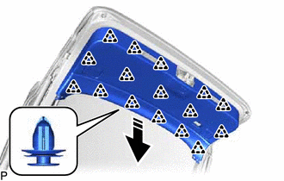
Remove in this Direction
9. REMOVE BACK DOOR LOCK ASSEMBLY
Click here
10. REMOVE BACK DOOR LOWER STAY REINFORCEMENT LH
(a) Remove the 2 bolts.
  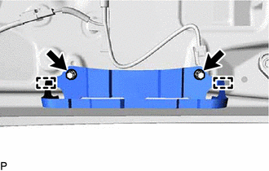
(b) Disengage the 2 guides to remove the back door lower stay reinforcement LH.
11. REMOVE BACK DOOR LOWER STAY REINFORCEMENT RH
HINT:
Use the same procedure as for the LH side.
12. REMOVE BACK DOOR LOWER STOPPER
(a) Remove the bolt.
  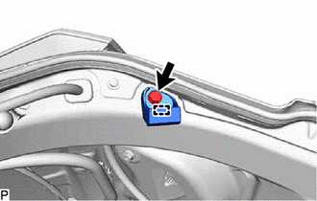
(b) Disengage the guide to remove the back door lower stopper.
HINT:
Use the same procedure for the RH side and LH side.
13. REMOVE POWER BACK DOOR SENSOR ASSEMBLY LH
Click here
14. REMOVE POWER BACK DOOR SENSOR ASSEMBLY RH
HINT:
Use the same procedure as for the LH side.
15. REMOVE SIDE REAR SPOILER PROTECTOR SUB-ASSEMBLY LH
Click here
16. REMOVE SIDE REAR SPOILER PROTECTOR SUB-ASSEMBLY RH
HINT:
Use the same procedure as for the LH side.
17. REMOVE REAR WIPER MOTOR AND BRACKET ASSEMBLY
Click here
18. REMOVE BACK DOOR OUTSIDE GARNISH SUB-ASSEMBLY
Click here
19. REMOVE BACK DOOR OPENER SWITCH ASSEMBLY
Click here
20. REMOVE LICENSE PLATE LIGHT ASSEMBLY LH
Click here
21. REMOVE LICENSE PLATE LIGHT ASSEMBLY RH
HINT:
Use the same procedure as for the LH side.
22. REMOVE MULTIPLEX NETWORK DOOR ECU
Click here
23. REMOVE POWER BACK DOOR WARNING BUZZER
Click here
24. REMOVE REAR LIGHT ASSEMBLY LH
Click here
25. REMOVE REAR LIGHT ASSEMBLY RH
HINT:
Use the same procedure as for the LH side.
26. REMOVE REAR TELEVISION CAMERA ASSEMBLY
Click here
27. REMOVE BACK DOOR LOWER STOPPER CUSHION
(a) Disengage the 2 claws to remove the back door lower stopper cushion.  HINT:  Use the same procedure for the RH side and LH side.
  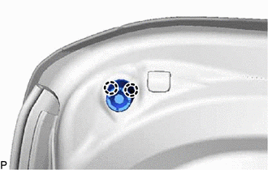
28. REMOVE BACK DOOR DUST PROOF SEAL
(a) Disengage the 2 claws and guide to remove the back door dust proof seal.  HINT:  Use the same procedure for the RH side and LH side.
  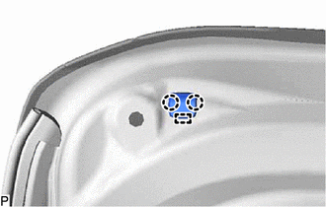
29. REMOVE POWER BACK DOOR UNIT SET ASSEMBLY LH
NOTICE:
Do not apply any horizontal load to the power back door unit set assembly in order to prevent the piston rod from deforming.
(a) Disconnect the connector.
  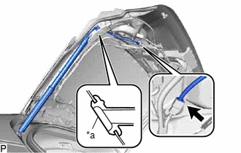
  *a | Grommet
(b) Disengage the grommet.
(c) Remove the 4 bolts and power back door unit set assembly.  NOTICE:  Remove the power back door unit set assembly while supporting the back door by hand.
  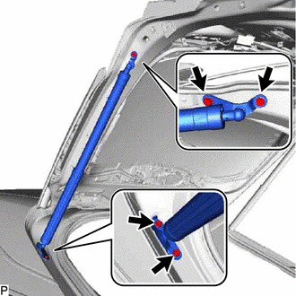
30. REMOVE POWER BACK DOOR UNIT SET ASSEMBLY RH
HINT:
Use the same procedure as for the LH side.

