This guide is for all of you out there that want a ipod/mp3 etc. installed in your car with high quality sound through your original ML stereo. Presented by James Khan.

My car:
SC430 2002

Interface purchased:
- Vaistech SLU Kit
- Harman Kardon Drive + Play
- A drill (don’t worry its not a big deal;)
- 2 quality AUX cables

Tools needed:
10mm socket and ratchet
Patience

1. Start by lifting the center storage box and remove the seat heater control by pressing it forward, from the inside of the storage box, using your both thumbs. It simply pops out. Remove the wire beneath it.

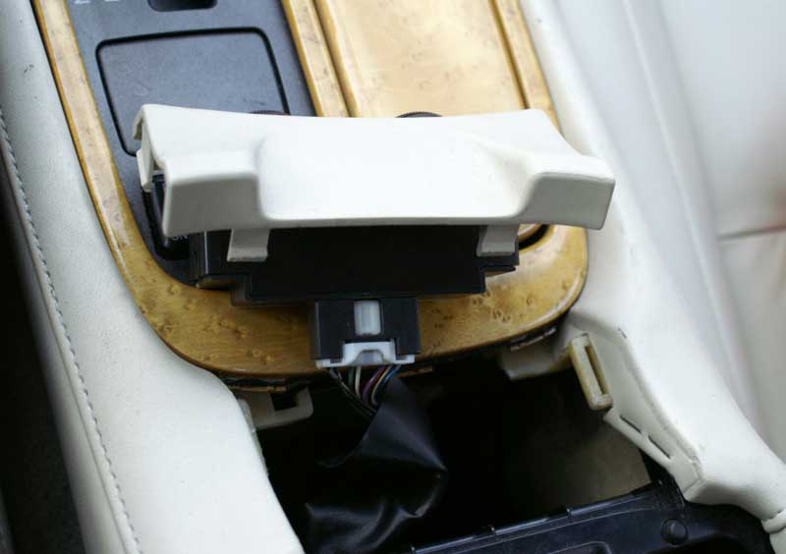

2. Make sure to set the parking brake and shift the gear to neutral (by holding the shift lock button).

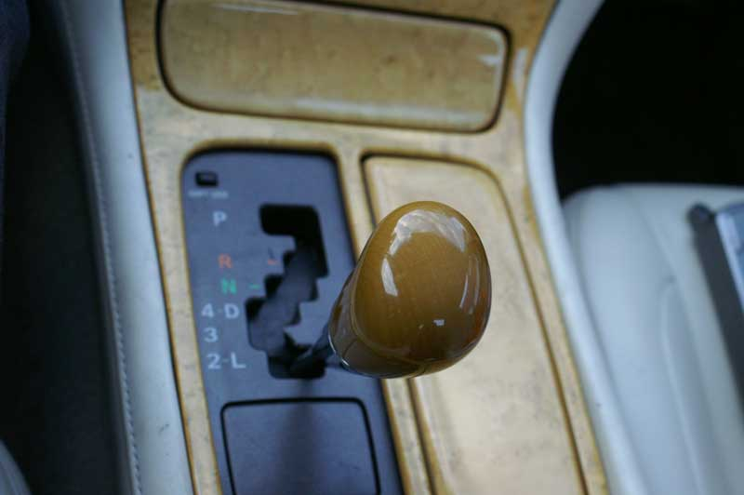

3. Pop out the center console (wood grain assembly) starting from the seat heat control location. Disconnect the wire (focused in below picture):

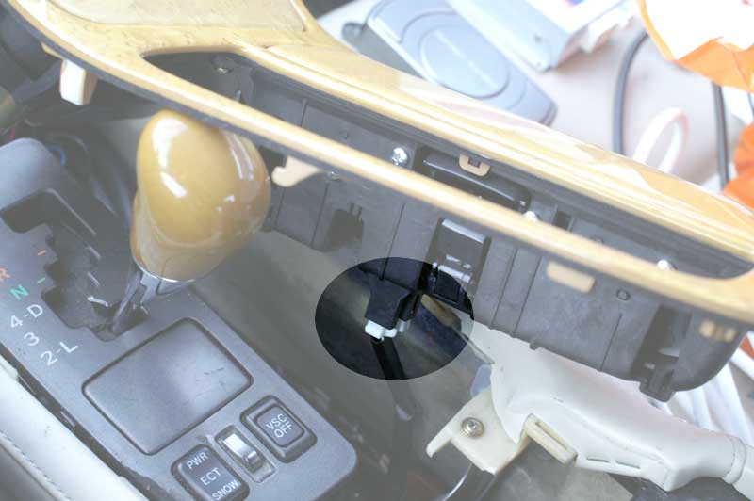

4. Carefully put it aside as shown in pic:

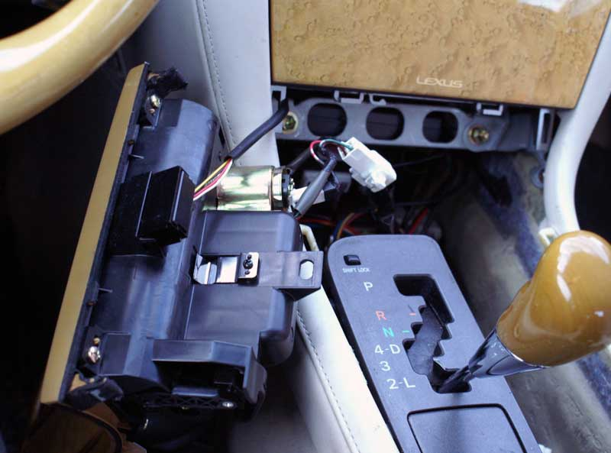

5. Remove the two bolts using the 10mm socket wrench. Make sure the bolts don’t fall!

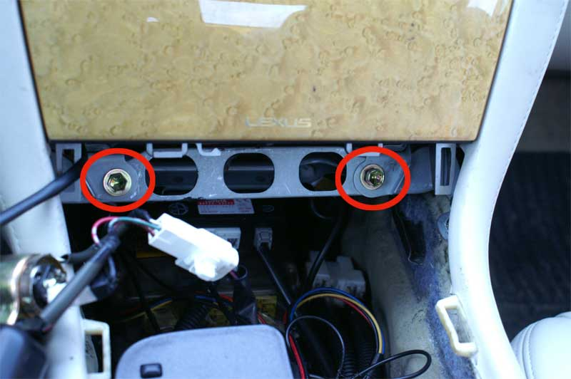
6. Grab the AC control with two hands and rock it back and forth until it pops out. Disconnect the 3 wires.

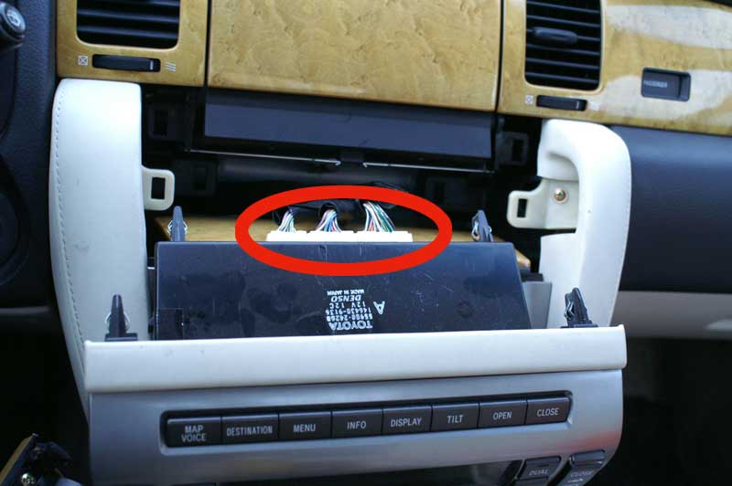

7. Remove the two bolts using the 10mm socket wrench. Remember, don’t drop the bolts!

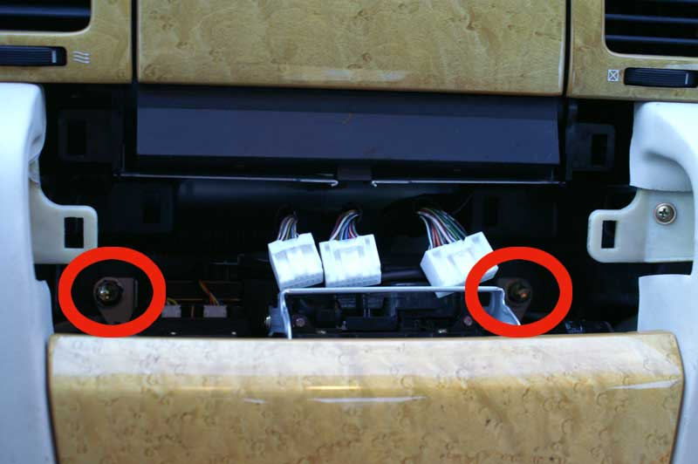

8. Now you can easily take out the radio and simply disconnect the red marked wire, plug it into the Vaistech SLU unit wire and plug in the other Vaistech SLU wire. Llook at the instructions that comes along with the Vaistech unit. It is very easy to follow step by step.

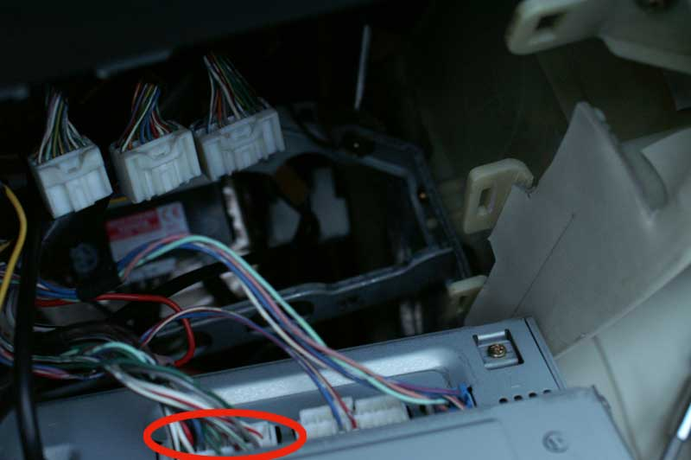

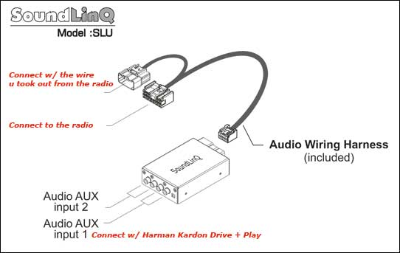

9. Put the radio back in its original position and place the Vaistech SLU unit beneath the radio. Bolts back on, then AC controller back to its place. The SLU unit comes with 2 aux inputs so I decided to use both of them. One for the H/K Drive + Play and the other just as an extra cable for example using a friends mp3.

10. Now drill a small whole in the center storage box just beside the cig. lid. The whole should be just big enough to take through the 2 aux cables, the display cable (about 2mm broad) and the H/K steering knob cable. I have chosen to put the H/K Drive + Play in the center storage box simply because it’s simple:p

11. The H/K Drive + Play comes with a display and a control knob:
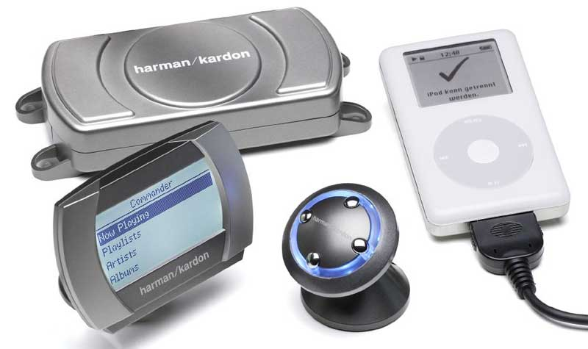

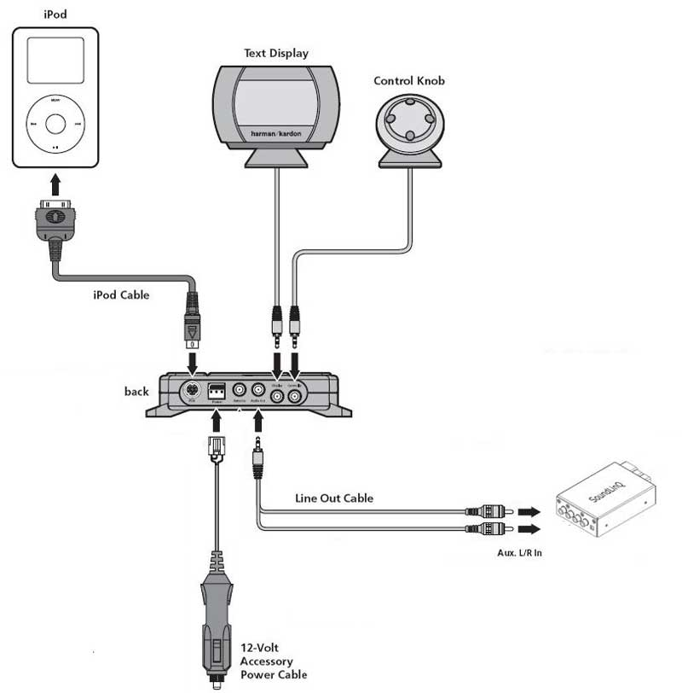
And should be installed like this:

12. I’ve placed the display like pic and couldn’t find a better place for it. Hide the wires in the spots shown below:

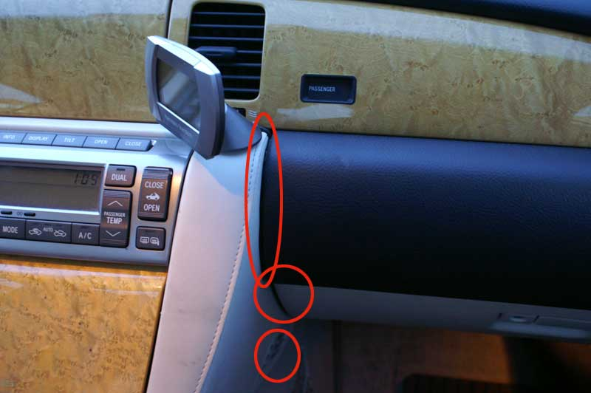

13. The control knob is placed on the coin box. It do not interfere with the gear box though it can be a little picky to have coins in them.
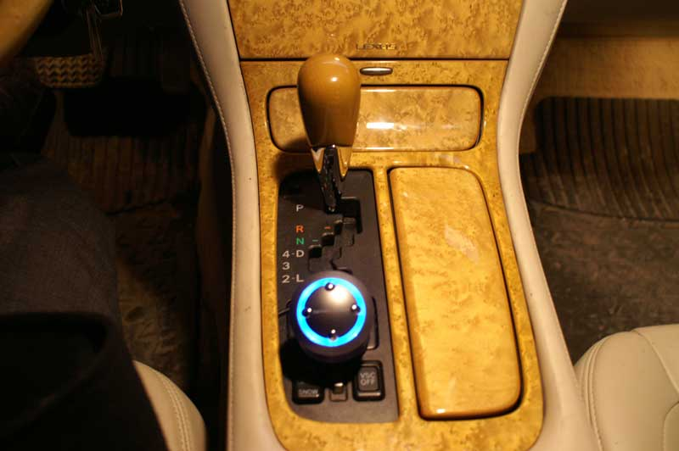
14. Put the wires from the H/K display, control knob, 2 aux cables through the drilled whole into the center storage box where you place the H/K unit and your ipod. Put back the center console (wood grain assembly) and voilá! The result:

