RESET VSC LIGHTS

1. Turn off ignition.
2. Look for the OBD-II connector under the dash, it has a black plastic cover which can be pulled out.
3. Using a 4-inch wire, insert ends on two pins (holes) of the OBD-II connector. Which ones? The connector has two rows of holes with pins inside. The connector's shape is basically rectangle but there's a little wedge shape to it. Like this:
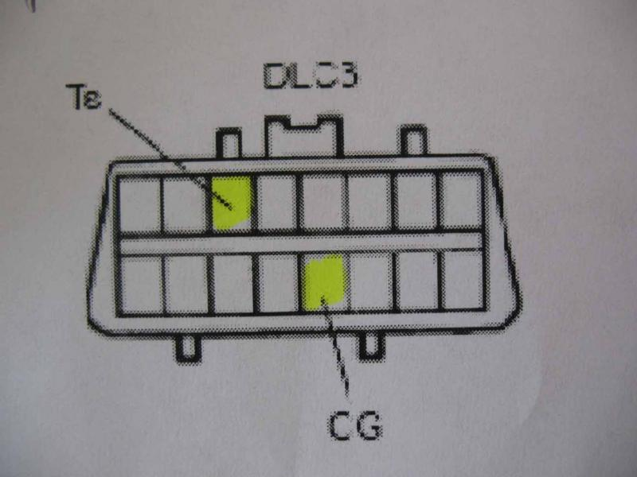
I will call the narrower side of the connector the top row, and the wider side to be the lower row. Jump the following pins:
a) on the top row, counting from the left, where the first pin is 1, insert on pin number 3
b) on the bottom row, counting from the left, insert on pin
number 5.
4. Turn ON the ignition, do not start.
5. VSC and Check Engine lights turn ON. That's normal.
6. Wait for the VSC light to rapidly flash.
7. Turn OFF ignition.
8. Pull jumper wire out, cover the OBD-II connector.
9. Turn ignition ON, don't start, wait about 15 seconds to make sure everything has initialized.
10. Start car. Test drive. You've just saved yourself couple of thousand dollars.

