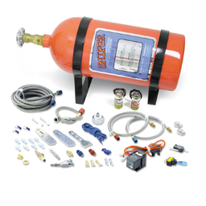
SINGLE FOGGER WET KITS – UNIVERSAL

SNIPER UNIVERSAL WET KIT

PART #: 07006NOS

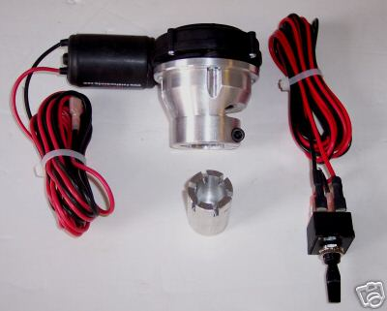
REMOTE NITROUS BOTTLE VALVE OPENER QUICK RELEASE NEW ( 200400181270 )

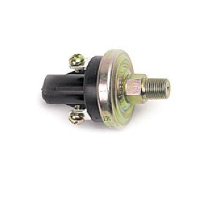
Sniper 15686NOS Fuel Pressure Switch
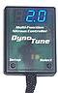
NOS Nitrous oxide Progressive Controller with RPM window switch & TPS WOT NX ( 390477482158 )

